DIGITECH
Needs Analysis Report

Introduction of innovative technologies in digitalization of technological processes and production

Programme: Erasmus+ (CBHE – LS Type II)
Call: ERASMUS-EDU-2025-CBHE
Type of Action: ERASMUS-LS
Acronym: DIGITECH
Duration: 36 months
Grant Agreement No.: 101237882
Project acronym: DIGITECH


Duration: 36 months (1st November 2025 – 31st October 2028)
Disclaimer: Views and opinions expressed are those of the author(s) only and do not necessarily reflect those of the European Union or the European Education and Culture Executive Agency. Neither the EU nor the granting authority can be held responsible for them.

Approval log:
Version: | Approved on | Approved by | Remarks
1.0 | 24th April, 2026 | JCC | Peer review not requested  QAG sign-off not requested

Оглавление
Table of abbreviations 5
Preface 6
Part I — Cross-University Findings 10
Overview and Methodology 10
Cross-Institutional Convergence Summary 10
Findings 12
Implications for Curriculum Design: Industry 4.0 and Applied Learning 17
Implementation Roadmap 18
Minimum Outputs and Prerequisites per Roadmap Action 19
What Not To Do — Implementation Guardrails 20
Comparability and Limitations 21
Part II — Institutional Reports 23
Osh Technological University (OshTU) – Osh, Kyrgyzstan 23
Executive Summary 23
1. Introduction 24
2. Institutional Context and Data Coverage Overview 25
2.1. Four-layer triangulation Framework 25
3. Digital Tool Competency - Technical Program Students 27
3.1 Tool Confidence Profile 27
Key Findings: 28
3․2 Student Digital Skill Gaps in Business Administration Programs 29
3.3 Student Soft Skills Gaps 30
4. Student AI Competence and Usage Readiness 31
5. Industry 4.0 Readiness in Students 33
6. Employer-Identified Skill Gaps 35
7. Challenges in Technology-Enhanced Teaching 36
7.1 Structural and Infrastructure Barriers 37
7.2. Lecturer Upskilling Gaps 38
8. Strategic Prioritization Matrix for Skills Development 39
9. Recommendations for Actions 42
10. Conclusion 43
Standardized Reporting Annex 46
Kyrgyz-German Institute of Applied Informatics (INAI) – Bishkek, Kyrgyzstan 48
Executive Summary 49
1. Institutional Context and Data Coverage Overview 49
1.1. Four-layer triangulation Framework 49
1.2. Sample composition 49
2. Students’ Skill Gap Analysis 51
2.1. Tool Confidence profile 51
2.2. Task and soft skill confidence 51
2.3. Confidence -Usage Gap 52
2.4. Industry 4.0. Readiness 53
2.5. Tool usage Frequency 54
3. Lecturer Perspectives 55
3.1. Lecturer Profile 55
3.2. Observed Students Struggle Frequency 56
3.3. Curriculum Design Confidence 59
4. Industry Employer Assessment 60
4.1. Day-1 Skill Readiness Requirements 60
4.2. Technologies Active in Production 61
4.3. Hiring Signal Priorities 61
4.4. What Employers Wish Universities Taught Better 62
5. Workshop Scenario Performance 63
5.1. Lecturer Prediction Accuracy 63
6. Strategic Priority Analysis 65
6.1. Strategic Implications for Curriculum Development 65
7. Conclusion 67
Standardized Reporting Annex 68
Yerevan State University — Ijevan Branch (YSU) – Ijevan, Armenia 71
1. Executive Summary / Institutional Context and Data Coverage 71
2. Institutional Context and Data Coverage Overview 71
3. Students’ Skill Gap Analysis 73
3․1 Student Digital Skill Gaps in IT Programs 73
3․2 Student Digital Skill Gaps in Business Administration Programs 75
3.3 Student Soft Skills Gaps 80
4. Student AI Competence and Usage Readiness 84
5. Industry 4.0 Readiness in Students 86
6. Employer-Identified Skill Gaps 89
7. Challenges in Technology-Enhanced Teaching 90
7.1 Structural and Infrastructure Barriers 91
7.2. Lecturer Upskilling Gaps 91
8. Strategic Prioritization Matrix for Skills Development 91
9. Recommendations for Actions 93
Standardized Reporting Annex 94
Armenian State University of Economics (ASUE) – Yerevan, Armenia 96
Executive Summary 96
1. Introduction and methodology 96
2. Students skill gap analysis 97
3. Student Usage Industry Readiness, 4.0 Readiness in Students 98
4. Key Findings: Academic Staff 99
5. Position of the Business Representatives 100
6. Key Findings and Recommendations 101
7. Key Outcomes 102
8. Recommendations / Next Steps 102
Conclusion/Recommendation 102
Standardized Reporting Annex 103
Georgian Technical University (GTU) – Tbilisi, Georgia 106
Executive Summary 106
1. Introduction and methodology 106
2. Students skill gap analysis 107
3. Key Findings: Academic Staff 108
4. Employer-Identified Skill Gaps 110
5. Key Findings and Recommendations 111
Standardized Reporting Annex 113
Business and Technology University (BTU) - Tbilisi, Georgia 116
Executive Summary 117
1. Methodology and Sample 117
2. Digital Tool Competency — Technical Program Students 119
3. Digital Tool Competency — Business Program Students 124
4. AI Literacy and the Hype-Readiness Gap 126
5. Lecturer Perspectives 129
6. Industry Employer Assessment 131
7. Workshop Scenario Performance 137
8. Strategic Priority Analysis 139
9. Recommendations 144
Appendix A: Methodology Notes 147
Part III — Needs Analysis Methodology 149
1. Overview 151
2. Target Groups 151
3. Skills Taxonomy 152
4. Student Questionnaire 156
5. Lecturer Questionnaire 160
6. Employer Focus Group Protocol 164
7. Workshop Component 165
8. Analysis Framework 167
9. Implementation Timeline (3 Weeks) 168
10. Local Adaptation Guidelines 168
Appendix A: Detailed Skills Reference Tables 170

Table of abbreviations

Abbreviations | Definition
PA | Partnership Agreement
EC | European Commission
GA | Grant Agreement
JCC | Joint Coordination Council
NCC | National Coordination Council
QAG | Quality Assurance
QA | Quality Assurance
RP | Reporting Period
WG | Working Group
WP | Work Package
GDPR | General Data Protection Regulation
EU | European Union
OECD | The Organisation for Economic Co-operation and Development's Development Assistance Committee
DAC | European Network for Quality Assurance in Higher Education
ENQA | The Standards and guidelines for quality assurance in the European Higher Education Area

Preface

The needs analysis under WP2 aims to systematically identify skills gaps and training needs across partner institutions through workshops, focus group discussions and online questionnaires. It serves as the foundation for designing targeted capacity-building activities, particularly the development of a tailored set of trainings delivered by European partner universities, ensuring relevance to academic, institutional and labor market requirements.

This document brings together the complete outputs of the DIGITECH Erasmus+ project’s needs analysis, conducted across six partner institutions in Kyrgyzstan, Armenia and Georgia. It is composed of three parts. Part 1 presents Cross-University Findings, synthesising results across all institutions and identifying convergent patterns in digital skill gaps. Part 2 consists of individual institutional reports, each prepared independently by the respective partner institution and attached as separate documents rather than as a continuation of this report. However, each institutional report applies the common methodology to its local data and context. Part 3 presents the common Methodology for Needs Analysis, which defines the shared framework, skills taxonomy, questionnaire design and triangulation approach used by all partner institutions.

Part I | Cross-University Consolidated Findings  (6 partner institutions · Armenia · Georgia · Kyrgyzstan)
Part II | Institutional Reports  OshTU · INAI · YSU · ASUE · GTU · BTU
Part III | Needs Analysis Methodology
Coverage | Students n=809 · Lecturers n=142 · Employers n≈35 · Workshop groups n=9+

Partner Institutions
Osh Technological University (KG) · HAW Hamburg (DE) · University of Maribor (SI) · Kyrgyz-German Institute of Applied Informatics (KG) · Yerevan State University (AM) · Armenian State University of Economics (AM) · Georgian Technical University (GE) · Business and Technology University (GE)

Executive Summary
The DIGITECH Needs Analysis was conducted across six partner universities in Armenia, Georgia and Kyrgyzstan, combining student surveys, lecturer questionnaires, employer focus groups and scenario-based workshops. This summary presents the top cross-university competency gaps, the employer-identified day-1 requirements for graduates and a prioritized set of actions for curriculum reform and capacity building.

Top Cross-University Gaps
The following gaps are confirmed across the consortium through triangulation of student surveys, lecturer questionnaires, employer focus groups and scenario-based workshops.
Gap | Evidence
AI chatbot overreliance | Technical students use AI chatbots routinely, most daily or weekly, yet their reported confidence in the tools is considerably lower than their actual reliance on them. This pattern was confirmed at every partner institution, indicating a structural overconfidence risk: students are making consequential decisions using tools they themselves do not feel proficient in.
AI as default problem solver | When students encounter a technical problem during coursework, turning to an AI chatbot is now the single most common first action ahead of searching online, asking an instructor or consulting a classmate. This behaviour holds even among students who rate their AI confidence at the lowest level, signalling that AI tools have become embedded in student problem-solving workflows regardless of proficiency.
Git & SQL — largest verified employer gap | Version control (Git) and database querying (SQL) are rated as Must Have day-1 requirements by the majority of surveyed employers, yet a substantial share of technical students score low on both and roughly one third of technical students never use Git in their coursework. This represents the largest documented gap between employer expectations and student capability.
AI evaluation confidence without verification habits | Students consistently rate AI evaluation, ethics and prompt engineering among their strongest competencies. However, workshop evidence shows they do not spontaneously apply a verification workflow, and only a small share of students have systematically applied AI in academic projects despite widespread regular use. The issue is one of workflow discipline rather than knowledge.
Self-learning dominates skill acquisition | The majority of students cite self-learning — YouTube, online tutorials, articles and books as their main source for developing digital and AI skills, outweighing both formal university courses and university-provided training. Employer focus groups consistently note that self-taught skills lack the structured, reproducible quality professional environments require.
No formal digital or AI training for most students | Most respondents across the consortium report having received no specific training in digital or AI skills and where training did occur it was typically narrow in scope. When asked what they would most like to develop, students across all partner universities point to AI-related skills first, followed by programming, cybersecurity and data science.
Theory–practice gap observed by lecturers | Across all partners, lecturers report that students demonstrate adequate theoretical knowledge but falter when applying it to realistic tasks — particularly in programming logic under real problem conditions, independent problem-solving, documentation and critical evaluation of AI-generated outputs. Lecturers themselves report significant upskilling needs in AI tools, digital pedagogy and project-based learning.
Infrastructure and capacity constraints | Insufficient laboratory equipment, limited access to licensed software and restricted cloud resources were cited by lecturers across all institutions as barriers to effective practical teaching. These constraints disproportionately affect the applied, project-based approaches most effective for closing the theory-practice gap.
Industry 4.0 coverage insufficient | A large majority of technical students report that current courses cover Industry 4.0 applications only somewhat, minimally or not at all, and a similar majority rate their preparedness for highly automated environments as moderate or lower. Familiarity with industrial automation concepts — PLC, SCADA and process control is particularly low across the consortium.

Top Employer Day-1 Requirements
Employer focus groups and the industry questionnaire reveal a consistent day-1 readiness profile across Armenia, Georgia and Kyrgyzstan. Seven competencies stand out as most critical for graduates at the point of entry into employment:
Requirement | Description
Understanding AI limitations | Graduates must recognize where AI systems are unreliable, identify hallucinations and errors, and understand the boundaries of what AI tools can and cannot do in a professional context.
Knowing when not to use AI | Judgment in selecting the right tool for the task — graduates should identify situations where AI outputs should not be relied upon and where human reasoning, verification or traditional methods are required.
Time management | Ability to plan, prioritize and deliver work within deadlines in a production environment — rated on par with core technical competencies by employers.
Teamwork and collaboration | Working effectively in cross-functional teams, contributing to shared deliverables, and communicating across technical and non-technical roles.
SQL and database queries | Writing queries, reading and manipulating data from relational databases — a foundational engineering workflow skill expected from day one, widely deployed across employer production environments (PostgreSQL/MySQL).
Git and version control | Collaborative development practices using Git/GitHub — branching, committing, merging, resolving conflicts. A foundational workflow competence reflecting international software engineering standards.
Independent learning | Capacity to continuously acquire new skills in rapidly evolving technology environments without formal instruction, keeping pace with changing tools, frameworks and platforms.
These requirements converge on three capability clusters: applied digital skills using technical tools to solve real business or engineering problems in production conditions; critical evaluation and AI judgment — assessing AI outputs, identifying errors and limitations; and professional execution — teamwork, communication, time management and independent problem-solving. Employers report that AI adoption has changed their skill expectations for graduates, with several noting that they now hire fewer junior staff.

Prioritized Actions
The following six actions are prioritized to address the confirmed gaps and align curricula with employer day-1 requirements.
Priority | Action
Critical | Close the Git and SQL day-1 gap by deepening applied coverage of Big Data processing, SQL databases, Git-based version control, API integration and cloud command-line tools. Treat Git and SQL as foundational workflow prerequisites — curriculum-mandated, not elective.
Critical | Integrate an AI Verification Protocol across courses. Students should consistently follow a verify → understand → use workflow when working with AI tools, formalized as an explicit, assessed learning outcome.
High | Shift assessment from knowledge recall toward decision-making practice through scenario-based, case-driven assessments that reward process, reasoning transparency and error identification. Strengthen security-first thinking across programming courses.
High | Establish a faculty development and AI training programme for lecturers covering AI tools, digital pedagogy, Industry 4.0 technologies, and curriculum design literacy — learning outcome specification, competency alignment and scenario-based assessment.
High | Conduct an infrastructure readiness assessment and invest in laboratory equipment, licensed software and cloud access before rolling out applied curriculum reforms. Infrastructure investment is a prerequisite for curriculum reform, not a consequence of it.
High | Strengthen Industry 4.0 practical integration within existing curricula by increasing applied exposure to automation systems, cloud environments, and data-driven processes. Evidence shows low student preparedness and limited course coverage, requiring a shift from conceptual teaching to hands-on, practice-oriented learning.

Part I — Cross-University Findings
Consolidated analysis across all six universities
Context This section presents consolidated findings across all six partner universities. Individual institutional reports are provided in Part II. Findings are classified as Confirmed (✓) when corroborated by two or more independent evidence layers, or Partial (P) for single-source signals requiring further validation.

Cross-University Findings of Needs Analysis

Overview and Methodology
The needs analysis research was conducted across institutions in Armenia, Georgia and Kyrgyzstan using a common methodological framework. Data collection combined quantitative student surveys (n=809), lecturer questionnaires (n=142), employer focus groups and scenario-based workshops. The student questionnaire captured self-assessed confidence in digital tools (stated competence), actual tool usage frequency (revealed behaviour), Industry 4.0 readiness and learning preferences. The lecturer questionnaire assessed observed student deficits and teaching challenges.
A core analytical principle was the distinction between stated needs and revealed behaviour, designed to reduce hype-driven bias and ensure that curriculum recommendations are grounded in demonstrated gaps rather than aspirational self-reports. The complete methodological framework, including the skills taxonomy, questionnaire design rationale and triangulation approach, is provided in Part III of this report.
Table 1: Student Survey Responses by Program Type and University
University | Technical (full) | Technical (limited)* | Other Programs | Total
Armenian State University of Economics | 77 | 9 | 6 | 92
Business and Technology University | 75 | 6 | 122 | 203
Georgian Technical University | 29 | 16 | 5 | 50
Kyrgyz State Technical University | 25 | 0 | 1 | 26
Kyrgyz-German Institute of Applied Informatics | 40 | 5 | 0 | 45
Osh Technological University | 163 | 89 | 0 | 252
Yerevan State University | 18 | 19 | 104 | 141
Grand Total | 427 | 144 | 238 | 809
* Limited data responses do not include answers to questions allocated only for technical program students.

Cross-Institutional Convergence Summary
The table below summarises which findings are confirmed, partially evidenced, or not identified at each partner institution. A finding is treated as confirmed at a given institution when corroborated by two or more independent evidence sources (survey, workshop, employer, or lecturer observation). Partial evidence indicates single-source signals that are consistent with the finding but require further validation.

 | Finding | ASUE | BTU | GTU | KSTU | INAI | OshTU | YSU
F1 | AI chatbot overreliance | ✓ | ✓ | ✓ | ✓ | ✓ | ✓ | ✓
F2 | Data tools confidence-usage gap | ✓ | ✓ | ✓ | ✓ | ✓ | ✓ | P
F3 | Git/SQL low but reliable | ✓ | P | P | P | ✓ | P | P
F4 | Programming self-report gap | P | P | P | ✓ | ✓ | ✓ | P
F5 | AI eval confidence vs. practice | P | ✓ | P | P | P | ✓ | ✓
F6 | AI as default problem solver | ✓ | ✓ | ✓ | ✓ | ✓ | ✓ | ✓
F7 | Self-learning dominates | ✓ | ✓ | ✓ | ✓ | ✓ | ✓ | ✓
F8 | No formal AI training received | ✓ | ✓ | ✓ | ✓ | ✓ | ✓ | ✓
F9 | Theory-practice gap (lecturers) | ✓ | P | ✓ | P | ✓ | ✓ | P
F10 | Infrastructure/capacity deficit | P | P | ✓ | P | P | ✓ | P
F11 | Employer priority convergence | ✓ | ✓ | P | P | P | ✓ | P
✓ Confirmed P Partial evidence – Not identified / not assessed

In this Traceability Matrix, each finding is mapped to the evidence sources that support it across the consortium.
# | Finding | Students Survey | Lecturers Survey | Employers Focus Group | Workshops | Recommendation
F1 | AI chatbot overreliance | ✓ | ✓ | – | ✓ | Reward reasoning and error-checking in assessments; treat AI as a design and integrity issue.
F2 | Data tools confidence-usage gap | ✓ | ✓ | – | ✓ | Increase applied, curriculum-driven practice to turn tool usage into demonstrated mastery.
F3 | Git/SQL low but reliable | ✓ | ✓ | ✓ | – | Mandate Git and SQL as foundational prerequisites rather than optional electives.
F4 | Programming self-report gap | ✓ | ✓ | – | ✓ | Pair theory with practical implementation to align stated skills with actual capability.
F5 | AI eval confidence vs. practice | ✓ | ✓ | – | ✓ | Embed a "Verify → Understand → Use" protocol as a core, assessed learning outcome
F6 | AI as default problem solver | ✓ | – | ✓ | – | Assume AI usage and require students to demonstrate the reasoning behind the final answer.
F7 | Self-learning dominates | ✓ | – | ✓ | – | Focus formal instruction on structured feedback and professional habits that self-learning lacks.
F8 | No formal AI training received | ✓ | – | ✓ | – | Launch a consortium-wide AI literacy module focused on judgment and verification.
F9 | Theory-practice gap (lecturers) | – | ✓ | ✓ | ✓ | Prioritize faculty training in process-focused pedagogy over simple AI tool tutorials.
F10 | Infrastructure/capacity deficit | – | ✓ | – | – | Complete tech and software readiness assessments before launching new applied modules.
F11 | Employer priority convergence | – | – | ✓ | – | Pair AI instruction with critical evaluation to ensure graduates remain independent problem-solvers
Note: ✓ Confirmed indicates the source contributed direct evidence supporting the finding; – indicates the source did not contribute to or assess this finding.

Findings
Finding 1 . Students are systematically more reliant on AI tools than their confidence justifies – a consortium-wide pattern indicating structural overconfidence risk

Among technical program students (n=571), mean confidence in generative AI chatbots is 3.61 out of 5 – yet 55% use them daily and a further 26% weekly. When usage frequency is rescaled to a comparable 1–5 metric, the mean usage score (4.07) clearly exceeds the mean confidence score (3.55). Students routinely depend on AI tools even when they do not feel proficient in using them effectively.
This pattern holds across non-technical students (39% daily usage), and recurs consistently at the institutional level: BTU identifies a similar confidence–readiness gap; YSU notes that students actively use AI while acknowledging their competencies are not fully developed; and the ASUE workshop concluded that students' AI use is not structured within a methodical framework, meaning proficiency is unverified rather than absent.

Implication . The gap between usage and confidence is not reassuring – it indicates that students are making consequential decisions using tools they themselves do not trust. This is an assessment design and academic integrity risk, not just a curriculum gap.

Finding 2. AI has become the default first recourse for technical problem-solving across all proficiency levels – with direct implications for pedagogy and critical thinking development

When students encounter a technical problem during coursework, 36% turn to an AI chatbot first – the single most common first action, ahead of searching online (30%), asking an instructor (17%), or asking a classmate (16%). This is not a high-confidence behaviour: even among students who rate their AI chatbot confidence at 1 out of 5, 20% still turn to AI first. Among those with the highest confidence, the figure rises to 44%.
This finding signals that AI tools have become embedded in students' problem-solving workflows irrespective of proficiency. The GTU employer focus group explicitly flagged the risk: employers require graduates who can critically evaluate AI-generated results and identify potential risks, not graduates who have automated away the evaluation step.

Implication. Instructors designing assessments should assume AI is the starting point for most students. Assessments that reward process, reasoning transparency, and error identification are more diagnostic than those that reward final answers, which AI can generate without student understanding.

Finding 3. Data analysis tools show a confidence-usage asymmetry similar to AI chatbots, but narrower – students engage frequently despite incomplete mastery

Students report moderate confidence in data analysis tools and their usage is comparably frequent, making data tools the second area where engagement outpaces demonstrated competence. BTU data highlights that data analysis tools, alongside AI chatbots, attract the highest confidence scores among technical students – yet assessed performance reveals that self-assessment does not fully translate into applied capability. At OshTU, data-driven decision-making was identified as insufficient for business students despite moderate self-assessment scores.
Unlike AI chatbots, the data analysis confidence-usage gap is narrower and more evenly distributed, suggesting that engagement with data tools is more deliberately curriculum-driven and less dominated by consumer-facing familiarity.

Finding 4. For infrastructure tools – Git and SQL – self-assessment is a reliable indicator of actual competence, but proficiency across the consortium remains low and adoption is inconsistent

Unlike AI chatbots and data analysis tools, version control (Git) and database querying (SQL) show meaningful correlations between stated confidence and actual usage (r = 0.41 and r = 0.38, respectively). Students who do not use Git tend not to claim confidence in it, and vice versa. This reliability makes them the most accurate self-reported competencies in the survey.
However, reliability in the measurement does not mean proficiency in the skill. Overall confidence in both tools remains low across the consortium, and approximately one third of technical program students never use Git in their coursework. At BTU, this gap was flagged as critical: five of seven surveyed employers rate Git as a Must Have day-1 requirement, and five of seven list SQL as a day-1 requirement – yet 43–44% of technical students score low on both, creating the largest verified gap between employer expectation and student capability in the analysis.

Implication. Git and SQL are the clearest cases where the gap is structural and the evidence is unambiguous. They require explicit, curriculum-mandated instruction – self-directed adoption will not close them. Both should be treated as foundational workflow prerequisites, not elective technical skills.

Finding 5 . Programming confidence is moderate and self-assessment is less reliable than for infrastructure tools – practical performance lags stated capability across multiple institutions

Technical students report a mean programming confidence of 3.09, and the correlation between confidence and usage is moderate (r = 0.37) – slightly lower than for Git and SQL, indicating greater variability. Some students claim confidence without proportionate usage, while others use programming tools regularly but rate themselves modestly. This heterogeneity makes aggregate scores less actionable without disaggregation by program and task type.
The OshTU data specifically documented that students demonstrated high self-assessment in Python programming but only medium workshop performance – reinforcing that self-reports in programming overstate applied capability more than for infrastructure tools. At INAI, lecturers similarly observed that students understand programming concepts theoretically but struggle with practical implementation.

Finding 6. Students report high confidence in AI evaluation and ethics tasks, but systematic verification habits are absent – a convergent signal across institutions with exploratory workshop evidence from one site

Across all universities, evaluating AI-generated information, applying AI ethics principles, and creating effective prompts are among the highest-rated task-level competencies in the student survey. This self-assessment is, however, consistently contradicted by practical evidence.
At BTU, all three workshop groups correctly identified AI hallucination in a diagnostic scenario – but no group demonstrated a coherent verification workflow. This observation is exploratory: the BTU workshop involved three groups at a single institution and the results are indicative rather than generalisable. At GTU, lecturers noted that students use AI tools but often fail to arrive at correct answers. The OshTU data found that only 23% of students have systematically applied AI in academic projects despite 78% reporting regular use. The ASUE workshop characterised students’ AI skills as unstructured – meaning the skills exist but are not applied within a rigorous or reproducible framework.
This is a specific type of competency gap: not a knowledge deficit but a workflow discipline deficit. Students can identify AI errors when prompted; they do not spontaneously apply a verification process. The distinction matters for curriculum design – the response is not more AI literacy content but embedded, assessed verification practice.

Implication. The finding is consistent with a Dunning-Kruger pattern: students with higher AI tool confidence are more likely to skip verification. Curriculum interventions should formalise the verify → understand → use workflow as an explicit, cross-course learning outcome – not a standalone module.

Finding 7 . Self-learning dominates digital skill acquisition – formal curricula are not the primary vehicle through which students develop the competencies employers require

Across the full sample (n=809), 61% of students cite self-learning – YouTube, online tutorials, articles and books – as a main source for developing digital and AI skills. This exceeds university courses (46%) and university-provided training or workshops (20%). The pattern is consistent across technical and non-technical programs, though non-technical students rely less on university courses. Social media and peer learning also play significant roles.
This finding presents a structural tension. Students are motivated and resourceful: self-directed learning has produced functional AI tool familiarity at scale. But employer focus groups at INAI and across all three countries consistently noted that self-taught skills lack the structured, reproducible quality that professional environments require. The gap between what students can do ad-hoc and what employers need them to do reliably is not closed by motivation alone.

Implication . Curriculum design should not compete with self-learning for content delivery – students are already learning tool use independently. The comparative advantage of formal instruction is precisely what self-learning cannot provide: structured practice, feedback, assessment, and the development of systematic professional habits.

Finding 8 . Most students have received no formal digital or AI training – and AI-related skills are the most urgently and consistently requested area across all seven institutions

Of 809 respondents, 68% did not report receiving any specific training in digital or AI skills. Among those who did, training was typically narrow in scope – covering basic programming or introductory spreadsheet use. When asked what additional skills they would most like to develop, AI-related topics dominate responses across all partner universities, followed by programming, cybersecurity and data science.
The YSU analysis emphasises the need to develop AI literacy beyond basic chatbot usage – specifically in critical evaluation and ethical application. At INAI, the gap between stated learning priorities and actual course coverage was identified as a structural issue requiring curriculum reform, not incremental addition. Employer representatives across all three countries reinforced this demand, consistently identifying AI integration, data analysis and critical digital thinking as priority competencies for graduates.

Implication. The 68% with no formal AI training figure is an opportunity, not just a gap. A well-designed AI literacy module – focused on judgment and verification rather than tool operation – would address a genuine unmet need across the entire consortium cohort.

Finding 9 . Lecturers consistently identify a theory-practice gap – students possess adequate theoretical knowledge but struggle systematically when applying it to realistic tasks

Across all partner institutions, lecturers report that students demonstrate adequate theoretical knowledge but falter when applying it to practical problems. The most frequently observed student deficits include: programming logic under real problem conditions, independent problem-solving without instructor guidance, documentation and reporting, and critical evaluation of AI-generated outputs.
This observation is consistent across country contexts and is corroborated by workshop performance data. At OshTU, students showed high self-assessment in Python but only medium workshop performance. At INAI, lecturers observed that students understand concepts but struggle with implementation. The BTU workshop data provided the most precise formulation of this gap: students can identify the correct answer but cannot demonstrate the reasoning process that produced it.
Lecturers themselves also report upskilling needs – particularly in AI tools, digital pedagogy and Industry 4.0 technologies. At OshTU, 65% of lecturers have not received formal AI training and 47% experience difficulties implementing project-based learning. The YSU analysis characterises continuous professional development of academic staff as an essential prerequisite for effective technology-enhanced teaching.

Implication . The lecturer upskilling deficit and the student theory-practice gap are compounding each other. Institutions cannot address the latter without addressing the former. Faculty development programmes should prioritise pedagogical approaches – scenario-based assessment, structured project work, process-visible assignments – over content-focused AI tool training.

Finding 10. Infrastructure and capacity constraints are reinforcing the competency deficit – equipment shortages, limited software access and lecturer upskilling gaps are structural, not marginal

Insufficient laboratory equipment, limited access to licensed software and restricted cloud resources were cited by lecturers across all institutions as barriers to effective practical teaching. GTU and OshTU report particularly acute equipment shortages. At ASUE, limited access to advanced digital infrastructure compounds slow curriculum adaptation, creating a situation where even well-designed courses cannot be delivered at the required practical depth.
These constraints disproportionately affect the applied, project-based teaching approaches that are most effective for closing the theory-practice gap identified in Finding 9. A curriculum that requires students to work with cloud platforms, version control systems and data pipelines cannot be delivered effectively without access to those environments.

Implication. Infrastructure investment is a prerequisite for curriculum reform, not a consequence of it. Institutions planning significant curriculum changes – particularly toward applied AI, data engineering or Industry 4.0 content – should conduct an infrastructure readiness assessment before designing new modules.

Finding 11. Employers across all three countries converge on three capability clusters – and AI adoption is elevating two of them beyond their historically perennial status

Employer focus groups and questionnaires across Armenia, Georgia and Kyrgyzstan reveal a consistent priority profile that transcends national context. Three capability clusters emerge:
- Applied digital skills – the ability to use technical tools to solve real business or engineering problems in production conditions, not demonstrate them in isolation
- Critical evaluation and AI judgment – the ability to assess AI-generated outputs, identify errors and limitations, and know when not to use AI – elevated from a desirable skill to a day-1 requirement by AI adoption
- Professional execution – teamwork, communication, time management, and independent problem-solving – elevated by AI adoption because these are precisely what AI cannot replicate
The employer signal is specific: critical evaluation and professional execution have been elevated, not simply listed. At BTU, problem-solving and communication ranked above university credentials as hiring signals. GTU's employer group emphasised graduates who can make decisions based on incomplete or imperfect data. INAI's employer participants identified full software development cycle competence and systems thinking as gaps. OshTU's employers noted that 82% of surveyed companies require additional training for new hires – indicating that graduates are not arriving job-ready even by employer-adjusted expectations.
The perennial employer complaint – 'graduates lack communication and critical thinking' – is not what is being measured here. The new signal is that AI tool availability has raised the threshold for both clusters: employers now expect graduates to know when to trust AI outputs and when to override them, and to demonstrate independent reasoning precisely because AI has automated the retrievable part of technical work.

Implication. Curriculum reforms that expand AI tool coverage without simultaneously strengthening critical evaluation, verification habits and independent problem-solving will produce graduates who are more dependent on AI, not more employable because of it.

Implications for Curriculum Design: Industry 4.0 and Applied Learning
Two additional patterns from the data inform curriculum design decisions without themselves constituting competency gap findings. They are presented separately because they concern prospective curriculum investments rather than documented deficits.
Industry 4.0 coverage is insufficient and student preparedness is low
Among technical program students (n=427), 78% report that their current courses cover Industry 4.0 applications only somewhat, minimally or not at all. Correspondingly, 72% rate their preparedness for highly automated environments as only moderately, slightly or not at all prepared. Familiarity with industrial automation concepts – PLC, SCADA and process control – is particularly low across the consortium. This gap reinforces rather than contradicts the broader finding that theory-practice alignment is weak: students who have not been exposed to applied industrial systems cannot assess their own readiness for them.
Interest in Digital Twins laboratory courses is strong and not contingent on prior automation exposure
Among technical students, 43% express high interest (very or extremely interested) in a specialised Digital Twins laboratory course. Critically, this interest is not concentrated among students with existing automation knowledge. Among the 169 students who report being not familiar at all with industrial automation concepts, 48% still express high interest. The BTU correlation analysis confirmed no meaningful relationship between automation familiarity and Digital Twins interest.
This finding has a specific curriculum implication: a Digital Twins laboratory track would attract a broad student base and could function as an entry point for Industry 4.0 competency development rather than requiring prior exposure as a prerequisite. The combination of low current coverage, high student interest and entry-point accessibility makes this a well-evidenced candidate for a medium-term curriculum investment.

Note on evidence classification: Interest in a Digital Twins course is not the same as a demonstrated gap in Digital Twins competency. No employer in the consortium currently lists Digital Twins as a day-1 requirement, and the technology is not in production at any partner company surveyed. The recommendation for a Digital Twins track is based on forward-looking student demand and industry trajectory – not current employer deficit signals – and should be treated as a medium-term investment rather than an immediate structural priority.

Implementation Roadmap
The six actions below consolidate the cross-institutional findings into a sequenced work programme. EU partners (HAW/UM) will develop an extended action plan with milestones and deliverable specifications; final owner designations are subject to JCC approval. Findings references (F1–F11, DT) link each action to the evidence base in the Traceability Matrix above.
Horizon | Action | Owner | Expected Output
Immediate | Embed the verify → understand → use protocol as an explicit, assessed learning outcome across all technical courses — not a standalone module. (F1, F5, F6, F8) | Academic departments at each partner university | AI Verification Protocol spec; updated cross-course learning outcome statements; assessed verification exercises.
Immediate | Mandate Git and SQL as curriculum prerequisites in all technical programs. Self-directed adoption will not close these gaps. (F3, F4) | Academic departments at each partner university | Practical Data Engineering module outline; SQL & Git teaching materials; assessed workflow exercises.
Immediate | Standardize institutional reporting: each partner produces a minimum evidence package (sample sizes, response rates, top-5 gap matrix, employer summary) for the D2.1 revision. (R2, R9) | Academic departments at each partner university | Revised institutional sections meeting the minimum comparable evidence standard.
Next cycle | Shift to process-visible, scenario-based assessments consortium-wide. Assume AI is the starting point; reward reasoning and error-checking, not final answers. (F1, F2, F7) | Academic departments at each partner university | Process-visible assessment bank; revised course-level formats; pilot in ≥1 course per partner.
Next cycle | Launch consortium lecturer upskilling programme prioritising pedagogical approaches — scenario-based assessment, structured project work, process-visible assignments — over content-focused AI tool tutorials. (F9, F11) | EU coordinator universities + Academic departments at each partner university | Upskilling course(s) with materials; certified faculty; faculty development plan per institution.
12 months | Conduct infrastructure readiness assessments at each partner, then invest in Digital Twins / Industry 4.0 lab environments. Infrastructure is a prerequisite for curriculum reform, not a consequence of it. (F10, DT) | Institutional management at each partner university | Infrastructure readiness report; procurement plan; Digital Twins lab course outline and materials.

Minimum Outputs and Prerequisites per Roadmap Action
The table below complements the roadmap above by specifying, for each action, a single-line minimum output definition and the prerequisites that must be in place.
Action | Minimum Output Definition | Prerequisites (incl. infrastructure)
Immediate — AI Verification Protocol embedded across courses (F1, F5, F6, F8) | Assessment bank of at least 10 verify → understand → use scenarios per technical program, integrated into ≥ 3 courses each, with reasoning‑visible rubrics. | Faculty briefing on the protocol; agreed course‑level learning outcome statements; minimal infrastructure (access to the AI tools already in student use).
Immediate — Git and SQL mandated as curriculum prerequisites (F3, F4) | Git/SQL foundational module with at least 8 assessed assignments (4 Git workflows + 4 SQL query/join sets), positioned in year 1–2 of every technical programme and required for progression. | Lab workstations with Git client and database server access; shared repository hosting (GitLab/GitHub instance); curriculum committee approval to amend programme prerequisites.
Immediate — Standardise institutional reporting (R2, R9) | Every institutional section in Part II contains: sample sizes & response rates, top‑5 confidence–usage–demonstrated gap table, employer day‑1 summary and one standardised prioritisation matrix on shared scales. | Agreed template (shared scales as in Part III taxonomy); access to local survey/workshop data tables; no infrastructure prerequisite.
Next cycle — Process‑visible, scenario‑based assessments (F1, F2, F7) | Shared assessment bank with at least 15 scenario‑based items reused across partners; pilot in ≥ 1 course per partner with documented student reasoning artefacts. | Lecturer rubric‑design training (links to faculty upskilling action below); learning‑management platform able to capture process artefacts.
Next cycle — Consortium lecturer upskilling programme (F9, F11) | Faculty training programme on process‑focused pedagogy with at least 5 certified lecturers per partner institution and documented post‑training course revisions. | EU‑partner trainer capacity, institutional release time for participating faculty; no new infrastructure prerequisite.
12 months — Infrastructure readiness and Digital Twins / Industry 4.0 lab (F10, DT) | Per‑partner infrastructure readiness report; Digital Twins / Industry 4.0 lab outline with at least 3 hands‑on scenarios and a procurement plan. | Completed readiness assessment first (this is the hard prerequisite); cloud‑platform credits or on‑premises lab capacity; licensed simulation software (e.g. PLC/SCADA toolchain) where applicable.
Note: F1–F11 refer to the findings in Part I; DT refers to the Digital Twins curriculum implication. R2 and R9 refer to QA reviewer recommendations. Owner designations are provisional.

What Not To Do — Implementation Guardrails
The following guardrails are intended to prevent common mis-implementation of the roadmap actions.
- Do not run AI tool trainings without an assessed verification component. F1, F5 and F6 show that the deficit is workflow discipline, not tool familiarity. AI literacy modules that teach prompting or tool operation without an assessed verify → understand → use exercise will reproduce the confidence–readiness gap rather than close it.
- Do not launch applied cloud, DevOps or Industry 4.0 modules before an infrastructure readiness assessment. F10 identifies equipment shortages, limited licensed software and restricted cloud access as structural barriers at several partners (acute at GTU and OshTU). Cloud command-line, SCADA/PLC and Digital Twins content cannot be delivered at the required practical depth without the underlying environments; deploying these modules first produces theoretical-only courses that worsen, not improve, the theory–practice gap (F9).
- Do not treat Digital Twins as a day-1 employer gap. No employer in the consortium currently lists Digital Twins as a day-1 requirement, and the technology is in production at only one of the surveyed employers (INAI ecosystem). The Digital Twins track is justified by forward-looking student demand and industry trajectory, not by current employer deficit signals, and should be sequenced as a medium-term investment behind the confirmed Git/SQL/AI-verification gaps (F3, F4, F5, F11).
- Do not draw curriculum conclusions from single-layer signals as if they were confirmed gaps. The Confirmed (✓) vs Partial (P) classification in the Convergence Summary exists precisely to prevent this. Findings marked P at a given institution (e.g. F10 at most partners, F11 at GTU, KSTU, INAI and YSU) are directional signals only and require further validation before they justify structural curriculum changes; treating them as confirmed risks committing resources to deficits that the evidence does not yet support.
- Do not generalise employer focus-group signals to national labour markets. Employer samples are small (7–8 per institution) and represent the ecosystems of partner universities rather than nationally representative employer panels (see Comparability and Limitations). Curriculum decisions should be anchored in the convergent F11 pattern across institutions, not in any single employer’s stated preference.
- Do not substitute lecturer AI tool training for pedagogical retraining. F9 identifies the lecturer deficit as primarily pedagogical — process-focused assessment, scenario-based learning, project-based delivery — not a gap in awareness of AI tools. Faculty upskilling that defaults to tool tutorials addresses the symptom and leaves the underlying theory–practice gap intact.

Comparability and Limitations
The findings presented in Part I draw on evidence collected independently at each partner institution using a shared methodological framework. While this ensures conceptual comparability across the consortium, several factors introduce variation in evidence depth and should inform how broadly individual findings can be generalized. This sub-chapter summarizes those factors and the precautions that should accompany interpretation of the Part I results.
A Primary Target Group of technical programs was identified and engaged at every partner university, in line with the common methodology. In several institutions, however, meaningful numbers of responses were also received from Secondary Target Group programs — notably from programs in business administration, economics, etc. Findings that reach across both groups are therefore more strongly evidenced than findings drawn from a single target group and care should be taken when generalizing patterns observed in secondary-group responses to the primary audience of the project.
Student and lecturer data were collected via online questionnaires. The instruments were relatively complex and structured for quantitative comparability, which combined with the online format may not fully capture the depth of respondents' reasoning. Open-ended responses were not consistently submitted at the same level of detail across institutions, meaning qualitative nuance is unevenly represented in the dataset. Quantitative patterns in the Part I findings are therefore more robust than fine-grained interpretations drawn from individual free-text responses.
Employer focus groups and the industry questionnaire engaged organizations from the ecosystems of the partner universities — companies that are current or likely future employers of partner-university graduates. This makes the employer input highly relevant to the project's aims and to curriculum-alignment decisions at the partner institutions. It does not, however, constitute a nationally representative sample of employers in Armenia, Georgia or Kyrgyzstan, and employer findings should therefore be read as directional signals from engaged partners rather than as generalizations to the national labour markets.
The scenario-based workshops were attended by students who, in many cases, self-selected on the basis of interest in the subject area. This means workshop performance data may reflect a more engaged or motivated subset of the student population rather than the full audience of technical programs. Workshop observations should therefore be treated as exploratory particularly where they come from a single institution or a small number of groups and read in combination with the broader survey evidence rather than in isolation.
The methodology requires a minimum 15 percent response rate from the Primary Target Group at each partner university. The table below summarises the engaged audiences, the responses received from the primary group, the total responses used in the analysis and whether the 15 percent threshold was met. The threshold was met at every partner institution for both students and lecturers.
University | Primary target group | Student responses from the primary target group | Lecturer responses from the primary target group | Total students’ responses | Total lecturers’ responses | 15% threshold in the primary target group | Secondary target group note
Osh Technological University | Students and lecturers from the following programs: Computer Science and Engineering (BA); Applied Informatics (BA and MA); Software Engineering (BA); Computational Linguistics (BA). Total: 300 students and 30 lecturers. | 252 / 300 (84.0%) | 21 / 30 (70.0%) | 252 | 21 | Met | No secondary target group available
Kyrgyz German Institute of Applied Informatics | IT program  Lecturers: 8; Students: 45  Automation program  Lecturers: 2; Students: 26 | 45 / 210 (21,4%)  26/103  (25.0%) | 8 / 30 (27.0%)  2/8  (25.0%) | 71 | 10 | Met | No secondary target group available
Yerevan State University | Faculty of Informatics and Applied Mathematics — lecturers: 33; students: 129 | 37 / 129 (28.7%) | 14 / 33 (42.4%) | 141 | 33 | Met | Substantial number of responses from economics and business administration directions
Armenian State University of Economics | Faculty of Information Technologies and Data Science — Lecturers: 60; Students: 550 | 87 / 550 (15.8%) | 15 / 60 (25.0%) | 92 | 15 | Met | Few additional responses from economics programs
Georgian Technical University | Faculty of Transportation Systems and Mechanical Engineering — Lecturers: 30; Students: 250 | 45 / 250 (18.0%) | 10 / 30 (33.3%) | 50 | 17 | Met | Few additional responses from business administration programs
Business and Technology University | BA Programs of Information Technology, Computer Science and AI — students previously engaged in similar project activities: 220; lecturers: 88 | 82 / 220 (37.3%) | 16 / 88 (18.2%) | 203 | 46 | Met | Substantial number of responses also from business administration programs

Part II — Institutional Reports
Individual needs analysis reports by partner institution — appendices preserved in-place

Osh Technological University (OshTU) – Osh, Kyrgyzstan

252  OshTU Students  Survey respondents |  | 21  OshTU Lecturers  Survey respondents | 10  Industry Partners  Employer questionnaires | 2  Workshop Groups  2 scenarios

Executive Summary
This Needs Analysis Report presents the findings of the DIGITECH project conducted at Osh Technological University (OshTU). The study aimed to evaluate the digital, AI, Industry 4.0, and professional competencies of students enrolled in IT-related educational programs.

The analysis is based on student surveys, lecturer observations, practical experiences, and self-reported digital readiness indicators. The collected evidence demonstrates that OshTU students possess strong motivation toward AI technologies, programming, and digital transformation. However, considerable gaps remain in advanced technical competencies such as Cloud Computing, DevOps, Machine Learning, Big Data Analytics, API integration, cybersecurity, and industrial automation.

The findings also reveal that students actively use Generative AI tools such as ChatGPT, Gemini, and Claude in their studies. Nevertheless, their practical understanding of responsible AI usage, data engineering, software lifecycle management, and advanced technical workflows remains limited.
The report identifies several institutional priorities:
- Modernization of curricula;
- Expansion of practical and laboratory-based learning;
- Strengthening Industry 4.0 components;
- Development of soft skills and project-based learning;
- Integration of AI, cloud technologies, and data analytics into all IT programs;
- Enhancement of lecturer digital competencies;
- Improvement of university infrastructure.

The overall analysis confirms that OshTU has strong potential for digital transformation but requires curriculum redesign, infrastructure modernization, and stronger university-industry collaboration to fully align with labor market requirements.

1. Introduction
The global transition toward digital economies has fundamentally transformed the role of higher education institutions. Universities are no longer expected solely to transfer theoretical knowledge; instead, they must prepare graduates capable of operating effectively within complex digital ecosystems characterized by:
- artificial intelligence,
- automation,
- cloud infrastructure,
- data-driven decision-making,
- cybersecurity,
- and interdisciplinary innovation.

The Fourth Industrial Revolution (Industry 4.0) has accelerated the integration of digital technologies into virtually all sectors of economic and social activity. Consequently, employers increasingly prioritize graduates who demonstrate not only academic knowledge but also practical engineering capabilities, adaptive thinking, digital fluency, and collaborative problem-solving skills.

Within this rapidly evolving environment, Osh Technological University faces the strategic challenge of modernizing its educational ecosystem to ensure alignment with:
- international educational standards,
- regional labor market demands,
- technological innovation trends,
- and emerging AI-driven professional environments.

The DIGITECH Erasmus+ project provides an important framework supporting this transformation process through evidence-based curriculum modernization and digital competency development initiatives.

The present Needs Analysis represents a foundational strategic document designed to:
- identify institutional strengths and weaknesses,
- assess current student competencies,
- evaluate lecturer readiness,
- analyze employer expectations,
- and establish priorities for future curriculum transformation.

Unlike traditional educational evaluations based solely on academic performance indicators, this study employs a triangulated analytical model integrating:
- Student self-assessment,
- Lecturer observations,
- Employer evaluations,
- Practical workshop diagnostics.

This multi-layered approach enables deeper identification of hidden competency gaps and structural inconsistencies that may remain undetected within conventional assessment systems.

2. Institutional Context and Data Coverage Overview
Osh Technological University is one of the leading technological universities in southern Kyrgyzstan, playing a central role in preparing specialists in engineering, information technologies, applied informatics, and technical sciences.
In recent years, OshTU has demonstrated increasing institutional engagement with:
- digital education modernization,
- innovation-oriented learning,
- AI integration,
- and Industry 4.0 transformation initiatives.

However, the transition toward digitally enhanced higher education remains complex. The analysis reveals that OshTU currently operates within a transitional educational environment where:
- digital technologies are increasingly present,
- yet systematic integration remains incomplete.

Several structural challenges continue to limit full-scale digital transformation:
- insufficient laboratory modernization,
- limited cloud infrastructure access,
- restricted availability of licensed software,
- limited exposure to real engineering workflows,
- and uneven faculty readiness for AI-enhanced pedagogy.

At the same time, the university possesses several important strengths:
- strong student motivation,
- positive lecturer attitudes toward innovation,
- active participation in international projects,
- and growing awareness of Industry 4.0 trends.

These strengths provide a favorable foundation for future strategic transformation.

2.1. Four-layer triangulation Framework
The DIGITECH Needs Analysis employed a four-layer evidence model designed to compare:
Layer | Description
Layer 1 — Student Survey | Self-reported tool confidence and usage frequency. n=252 OshTU students. Captures perceived capability and revealed usage behaviour.
Layer 2 — Lecturer Assessment | Lecturers rate how frequently their OshTU students struggle with specific skills. n=21. Captures observed classroom performance.
Layer 3 — Industry Questionnaire | Student practical experiences and coursework barriers
Layer 4 — Workshop Scenarios | Industry-oriented competency alignment analysis

OshTU student data were filtered from the consortium-wide DIGITECH survey dataset (total n = 809 respondents) using the institutional identifier for Osh Technological University. The final OshTU sample consisted of 252 student respondents representing both technical academic programs, including undergraduate and master’s level students.
The OshTU technical student cohort was divided into two analytically relevant groups:
- Technical Program students (full data) — n = 163
- Technical Program students (limited data) — n = 89
Students in the “full data” category completed all core sections of the questionnaire and were therefore included in detailed competency, AI readiness, and Industry 4.0 analyses.
Respondents categorized under “limited data” provided incomplete responses in one or more key competency sections. While these responses contributed to general demographic and participation statistics, they were excluded from skill-specific comparative analyses to ensure analytical consistency, statistical reliability, and accurate cross-layer triangulation within the DIGITECH methodology. Data collection was conducted using three instruments:
  - Quantitative surveys (Student & Lecturer Questionnaires)
  - Scenario-based workshop (real-world practical tasks)
  - Focus group discussions

The questionnaires were developed in alignment with the DIGITECH project taxonomy. The seminar was conducted on February 25, 2026.
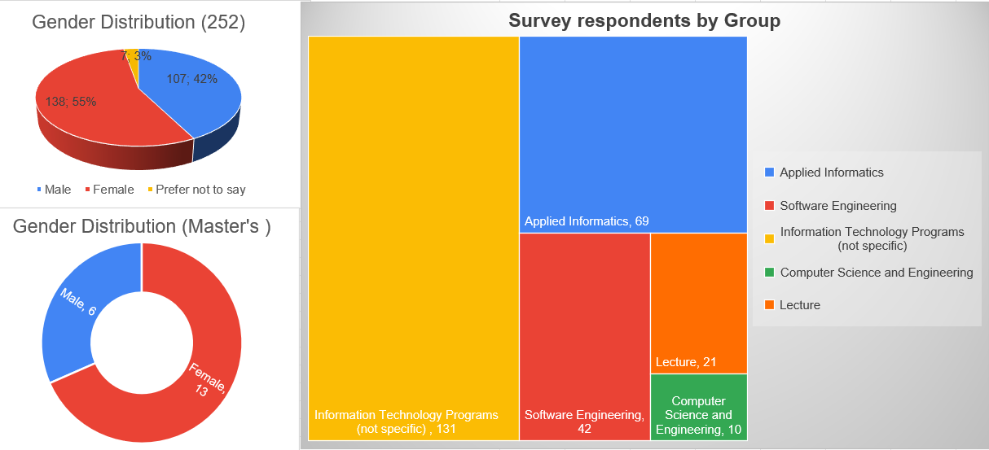
Figure 1.1 OshTU survey respondents by segment and gender distribution.
The diagram below presents the demographics of the students who participated in the survey: the number of participants by age, educational level, and type of program.
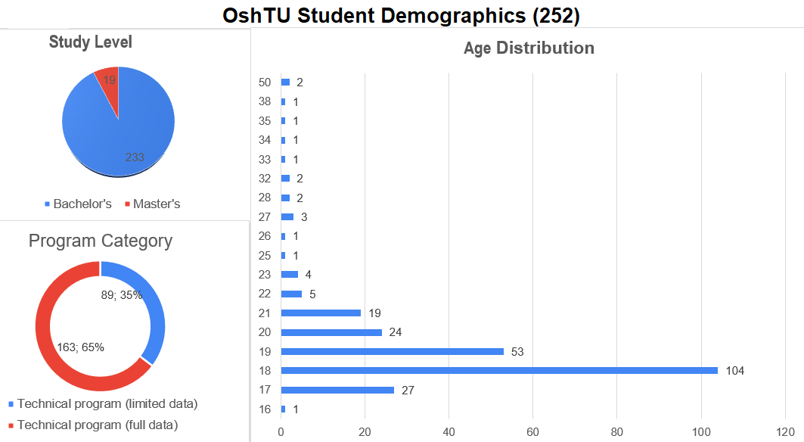
▸ Figure 1.2 OshTU student demographics: age, study level and program category.

3. Digital Tool Competency - Technical Program Students

3.1 Tool Confidence Profile
Technical program students at Osh Technological University (n = 252) demonstrate a distinctly uneven digital competency profile characterized by relatively high confidence in consumer-oriented digital tools and substantially lower confidence in professional engineering technologies.
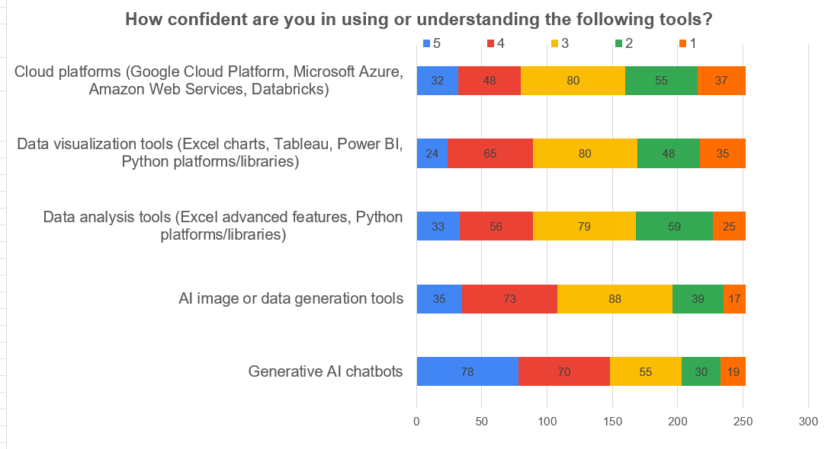
Figure 2.1 Tool confidence diverging bar — OshTU Technical students (n=252). Sorted by mean; bars show % Low (1–2), Neutral (3), High (4–5).

Key Findings:
Competency | Self-Assessment | Workshop Performance
Python Programming | High | Medium
Machine Learning | Medium | Low
API Integration | Medium | Low
Cloud Deployment | Low | Very Low
Data Visualization | High | Medium

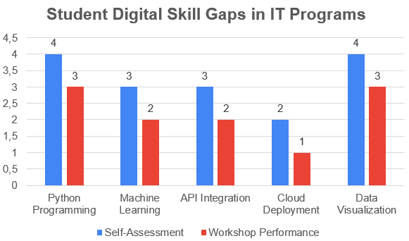
Analysis:
- Students demonstrate theoretical understanding.
- Difficulties were observed in practical task execution.
- Limited experience with Git, Docker, and REST API implementation.
- Insufficient exposure to real-world project-based development.

3․2 Student Digital Skill Gaps in Business Administration Programs
(based on the Student Questionnaire – Sections B, C, and F; Lecturer Questionnaire – Section C; and Workshop data)

Findings:
- Advanced Excel functions – moderate level
- Data-driven decision-making – insufficient
- Use of AI tools in business analytics – low
- Limited practical experience with CRM and ERP systems
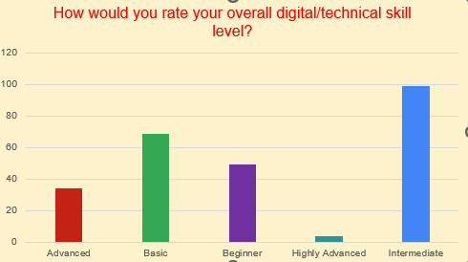

Analytical Conclusion:
Business students understand the concept of digital transformation; however, their competence in data-driven decision-making remains underdeveloped.

3.3 Student Soft Skills Gaps
(based on the Student Questionnaire – Section B; Lecturer Questionnaire – Section C; Workshop and Focus Group Data)
Identified by Employers:
- Problem-solving skills
- Analytical thinking
- Teamwork
- Presentation skills
During scenario-based tasks:
- Students were able to complete technical tasks but struggled to justify and articulate their solutions.
- Structural thinking in case analysis was insufficient.
The majority of surveyed students demonstrated moderate to high confidence in basic digital tools, programming environments, and AI chatbot usage. Students from Software Engineering, Applied Informatics, and Computer Science programs showed stronger digital readiness compared to students from generalized IT programs.
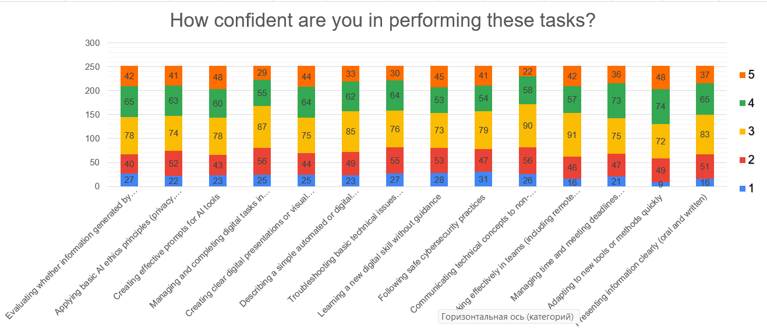
▸ Figure 3.3 Task and soft skill confidence diverging bar — OshTU Technical students (n=252).
The strongest competencies identified include:
- Generative AI chatbot usage;
- Python programming basics;
- SQL/database querying;
- Digital presentations and teamwork;
- Independent learning motivation.

However, several critical weaknesses were identified:
- Weak understanding of Machine Learning frameworks;
- Low familiarity with DevOps and cloud infrastructure;
- Limited API integration skills;
- Poor cybersecurity practices;
- Insufficient experience with Git workflows;
- Limited Industry 4.0 exposure.

Students actively use AI tools daily, but this usage often focuses on task completion rather than deep technical understanding.

4. Student AI Competence and Usage Readiness
(based on the Student Questionnaire – Section B and additional sources)

The analysis conducted within the DIGITECH Erasmus+ project indicates that students of Osh Technological University demonstrate growing interest in Artificial Intelligence (AI) technologies and actively use AI tools in the educational process.
Survey results show that:
78% of students use AI tools such as ChatGPT for:
- information search,
- assignment preparation,
- idea generation,
- and academic support.
However, only 23% of students have systematically applied AI tools in academic projects or practical technical tasks.
The findings indicate that AI usage among students remains primarily:
- text-oriented,
- assistive,
- and consumer-focused,
rather than:
- analytical,
- engineering-oriented,
- or project-based.
Students mainly use AI technologies for:
- preparing textual materials,
- searching for information,
- and supporting routine academic activities.
Relatively few students use AI for:
- data analysis,
- automation,
- programming support,
- or solving technical problems.
Identified Issues
The analysis identified several important competency gaps:
Limited understanding of AI ethics
Students demonstrate insufficient awareness of:
- responsible AI usage,
- data privacy,
- academic integrity,
- and risks related to AI-generated misinformation.
Minimal knowledge of prompt engineering
Most students use AI tools through simple queries and lack competencies in:
- structured prompting,
- contextual AI interaction,
- and optimization of AI-generated outputs.
Weak critical evaluation of AI-generated information
Workshop observations revealed that students often:
- accept AI-generated answers without verification,
- struggle to evaluate reliability,
- and demonstrate limited analytical skepticism.
Overall, the findings demonstrate that OshTU students show strong motivation to use AI technologies; however, further development of:
- AI literacy,
- critical thinking,
- ethical awareness,
- and practical AI application skills
is necessary to ensure responsible and effective use of AI in educational and professional environments.

5. Industry 4.0 Readiness in Students
(based on the Student Questionnaire – Section D)
The assessment of Industry 4.0 readiness among students of Osh Technological University was conducted based on the analysis of responses collected in Section D of the DIGITECH student questionnaire. The analysis focused on evaluating students’ conceptual understanding, technological awareness, and practical preparedness related to modern Industry 4.0 ecosystems and digital transformation technologies.
Industry 4.0 represents the integration of:
- artificial intelligence,
- automation,
- cloud computing,
- Internet of Things (IoT),
- cybersecurity,
- big data analytics,
- and cyber-physical systems
into industrial, engineering, and digital production environments.
In modern labor markets, Industry 4.0 competencies are increasingly considered essential for graduates in technical, engineering, information technology, and applied informatics programs. Consequently, assessing the readiness of OshTU students in this area represents a strategically important component of institutional digital transformation planning.
The analysis demonstrates that OshTU students possess moderate conceptual awareness of Industry 4.0 technologies; however, practical engineering readiness remains significantly underdeveloped across several key domains.
5.1 Industry 4.0 Readiness Results
Component | Readiness Level
Understanding of Automation | Medium
Internet of Things (IoT) | Low
Big Data | Medium
Cybersecurity Awareness | Medium
Cloud Systems | Low

The findings indicate that students generally understand the theoretical significance of Industry 4.0 technologies, but lack sufficient exposure to:
- real industrial applications,
- practical engineering workflows,
- and production-oriented digital systems.

5.2 Understanding of Automation
The analysis demonstrates that OshTU students possess a moderate conceptual understanding of automation technologies and digital transformation processes.
- Many students are familiar with:
- basic automation concepts,
- AI-supported systems,
- robotics terminology,
- and smart manufacturing ideas.

This reflects growing awareness of global technological transformation trends and increasing exposure to digital technologies within educational and online environments.
However, practical competency remains limited. Students demonstrate insufficient familiarity with:
- industrial automation systems,
- programmable logic controllers (PLC),
- sensor integration,
- industrial process monitoring,
- and cyber-physical production systems.

The findings suggest that automation is currently understood primarily at:
- a theoretical,
- informational,
- or conceptual level,
- rather than through:
- hands-on engineering practice,
- laboratory experimentation,
- or industrial simulation environments.

This gap limits students’ ability to apply automation concepts within real engineering contexts.
This suggests that OshTU students are currently positioned closer to: “digital technology users”
rather than: “digital engineering professionals.”

The findings additionally indicate that:
- theoretical learning significantly exceeds practical implementation opportunities,
- laboratory exposure remains limited,
- and real-world engineering simulation environments are insufficiently integrated into the curriculum.

The Industry 4.0 readiness assessment demonstrates that OshTU students generally understand digital transformation concepts at a theoretical level; however, practical engineering readiness remains insufficient across several strategically important domains.
The most critical competency gaps were identified in:
- IoT systems,
- cloud infrastructure,
- practical cybersecurity,
- and large-scale data engineering environments.

At the same time, students demonstrate:
- strong technological interest,
- openness toward innovation,
- and willingness to engage with emerging technologies.

These strengths provide a valuable institutional foundation for future digital transformation initiatives.
However, sustainable alignment with Industry 4.0 labor market requirements will require OshTU to move beyond:
- theory-oriented education
- toward:
- practice-oriented digital engineering ecosystems,
- competency-based learning,
- and industry-integrated technological education models.

6. Employer-Identified Skill Gaps
(based on focus group data and additional sources)

To evaluate the alignment between the educational programs of Osh Technological University and labor market requirements, employer surveys and focus group discussions were conducted within the DIGITECH Erasmus+ project framework.

The results indicate that employers generally provide a positive assessment of OshTU graduates. According to employers, graduates demonstrate:
- sufficient theoretical knowledge,
- work discipline,
- responsibility,
- teamwork skills,
- and basic digital literacy.

Employers also emphasized that OshTU graduates are capable of adapting to workplace environments and effectively using basic information technologies.
However, several important skill gaps were identified. Employers noted that many graduates still lack:
- practical engineering experience,
- analytical problem-solving abilities,
- professional communication skills,
- cloud and AI-related competencies,
- and real-world software engineering workflow experience.

Particular weaknesses were observed in:
- SQL and database usage,
- Git and collaborative development,
- cloud technologies,
- and interdisciplinary project work.

Employers additionally highlighted that graduates often require additional workplace training before becoming fully operational in modern digital environments.
The analysis also revealed the importance of strengthening:
- project-based learning,
- industry collaboration,
- practical laboratories,
- AI-enhanced education,
- and lecturer professional development.

Overall, the findings demonstrate that while OshTU students possess strong professional potential, further curriculum modernization and practical competency development are necessary to improve graduate readiness for Industry 4.0 and AI-driven labor markets.

7. Challenges in Technology-Enhanced Teaching
(based on the Lecturer Questionnaire – Section B)

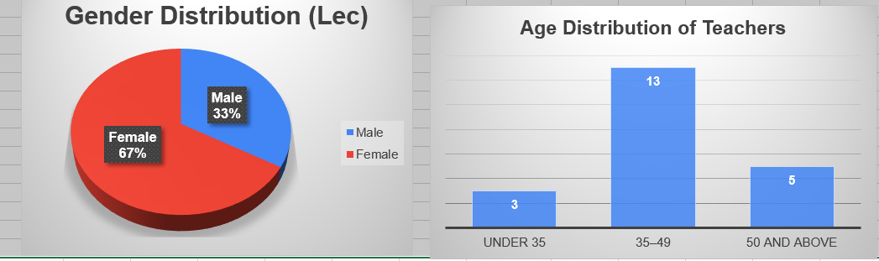The analysis of responses from lecturers of Osh Technological University conducted within the framework of the DIGITECH Erasmus+ project indicates that technology-enhanced teaching is generally viewed positively across the university. Lecturers recognize that the integration of digital technologies into the educational process can significantly improve:
- teaching effectiveness,
- student engagement,
- practical learning opportunities,
- and students’ digital competencies.
At the same time, the analysis identified several challenges affecting the effective implementation of technology-enhanced education at OshTU. These challenges are associated with:
- limited laboratory and cloud infrastructure,
- insufficient access to licensed software and modern digital tools,
- uneven digital readiness among lecturers,
- and the need for continuous professional development in emerging technologies.
Lecturers additionally emphasized that successful integration of:
- artificial intelligence,
- cloud technologies,
- Industry 4.0 tools,
and project-based digital learningrequires both technical modernization and institutional support mechanisms.
The findings further indicate that sustainable development of technology-enhanced teaching at OshTU depends on:
- continuous lecturer upskilling,
- modernization of educational infrastructure,
- expansion of practical digital laboratories,
and implementation of innovative teaching methodologies aligned with modern digital and engineering education standards.
These institutional and pedagogical challenges are discussed in more detail in the following subsections.

7.1 Structural and Infrastructure Barriers
(based on the Lecturer Questionnaire – Sections B and D)

The analysis of lecturer responses at Osh Technological University demonstrates that technology-enhanced teaching is generally viewed positively; however, several structural, infrastructural, and pedagogical challenges continue to limit its effective implementation within the educational process.
Lecturers emphasized that the integration of digital technologies, artificial intelligence, cloud systems, and Industry 4.0 tools can significantly improve:
- teaching quality,
- student engagement,
- practical learning opportunities,
- and students’ digital competencies.
At the same time, the analysis identified several important barriers that restrict the broader adoption of innovative teaching approaches.
The analysis conducted within the framework of the DIGITECH Erasmus+ project demonstrates that lecturers at Osh Technological University generally possess a strong foundation in curriculum design and instructional organization.
Lecturers reported the highest confidence levels in:
- designing assessment and grading methods,
- selecting appropriate teaching methods,
- defining course objectives,
- and calculating ECTS-based student workload.

These findings indicate that OshTU lecturers have substantial experience in traditional teaching and assessment practices.
At the same time, the analysis identified several areas requiring further development. In particular, comparatively lower confidence levels were observed in:
- horizontal integration of courses,
- vertical curriculum progression,
- and overall study program structuring.

This suggests that current curricula still demonstrate limited:
- interdisciplinary integration,
- competency alignment,
- and long-term curriculum planning.

Overall, the findings indicate that while OshTU lecturers are well-prepared within their individual subject areas, additional development is needed in:
- curriculum integration,
- outcome-based education,
- and interdisciplinary program design
- to better align educational programs with Industry 4.0 and competency-based education requirements.

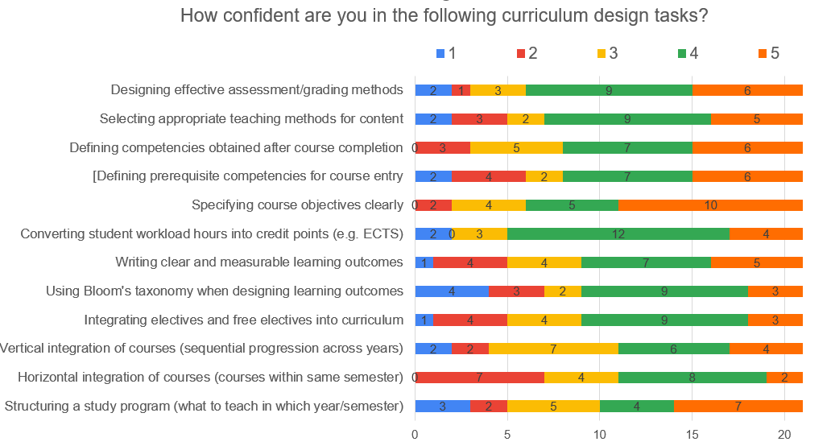

7.2. Lecturer Upskilling Gaps
(based on the Lecturer Questionnaire – Sections C and E)

The findings indicate that the implementation of technology-enhanced education at OshTU is affected by several institutional and infrastructural limitations, including:
- Insufficient laboratory infrastructure
Existing laboratories are not always adequately equipped to support advanced digital engineering, cloud computing, cybersecurity simulations, and Industry 4.0-oriented practical activities.
- Limited access to licensed software
Lecturers reported restricted availability of specialized professional software required for practical engineering, data analytics, AI, and programming-related courses.
- Restricted access to cloud resources
Limited cloud infrastructure and insufficient access to cloud platforms reduce opportunities for:
  - cloud deployment practice,
  - distributed computing activities,
  - and real-world digital engineering simulations.
- Lack of formal mechanisms for AI integration into teaching
Although interest in artificial intelligence is growing, the university currently lacks systematic institutional frameworks for:
  - AI-enhanced pedagogy,
  - AI-supported assessment,
  - and structured integration of AI tools into curricula.
These limitations partially restrict the effective implementation of modern technology-enhanced teaching methodologies and reduce students’ exposure to real-world digital environments.

8. Strategic Prioritization Matrix for Skills Development
(based on the two-dimensional analysis of skill gaps and employer demand)

The strategic prioritization matrix for Osh Technological University was developed based on the results of the DIGITECH Needs Analysis, including:
- student surveys,
- lecturer assessments,
- employer consultations,
- and workshop observations.

The analysis was based on two key criteria:
- Labor market demand
- Existing student skill gaps

The findings indicate that modern employers increasingly require graduates who possess:
- digital competencies,
- analytical thinking,
- practical engineering skills,
- AI literacy,
- and problem-solving abilities.

At the same time, OshTU students generally demonstrate:
- basic digital literacy,
- theoretical understanding of technologies,
- and motivation to work with digital tools.
However, significant competency gaps remain in:
- practical implementation,
- cloud technologies,
- AI application,
- cybersecurity,
- and collaborative engineering workflows.

High Priority Areas
The highest strategic priorities identified for curriculum modernization are:
- Applied Artificial Intelligence
- Data Analytics
- Cloud Technologies
- Cybersecurity
- Project-Based Learning
These areas show both:
- high employer demand,
- and significant student competency gaps.

Medium Priority Areas
The following areas were identified as medium priorities:
- IoT
- ERP Systems
- DevOps
These competencies are becoming increasingly important within Industry 4.0 ecosystems and should be gradually integrated into future educational programs.

Low Priority Area
Expansion of purely theoretical modules without practical application was identified as a low strategic priority.
Overall, the analysis demonstrates that future educational development at OshTU should focus on:
- strengthening digital and technological competencies,
- expanding practical learning opportunities,
- integrating AI and Industry 4.0 technologies,
- and improving alignment between curricula and labor market requirements.

Skill Area | Labor Market Demand | Skill Gap (OshTU Evidence) | Priority Level | Analytical Evaluation
Application of digital tools and technologies | High | Medium | High | Students actively use digital tools (Excel, AI chatbots, programming environments), but practical integration into real engineering and problem-solving workflows remains inconsistent. Digital literacy exists, yet applied execution remains moderate.
Data analysis and digital data processing (SQL / Data Engineering / Analytics) | High | High | Very High | Student confidence remains relatively low (SQL mean ≈2.85; 44% low confidence), while employers identify data handling as a Day-1 requirement. Lecturer observations confirm difficulties in data logic, query reasoning, and structured workflow execution.
Application of artificial intelligence tools (Applied AI / ML / AI verification) | High | High | Very High | Although 78% of students actively use AI tools, Machine Learning confidence remains low (M≈2.17; 64% low confidence). Students demonstrate high exposure but weak validation, reasoning, and practical implementation competence.
Practical application of IT skills (Programming, Git, engineering workflow) | High | High | Very High | Git/version-control confidence remains low (M≈2.85; 43% low confidence). Lecturer evidence highlights weak project collaboration, insufficient repository management, and limited real engineering workflow exposure.
Cloud Computing / DevOps competencies | High | High | Very High | Cloud competency remains underdeveloped (M≈2.77; ~40% low confidence). Infrastructure limitations, weak curriculum integration, and lack of deployment-oriented practical environments constrain readiness.
Teamwork and communication skills | High | Medium | High | Students report moderate confidence in teamwork and communication; however, lecturers repeatedly identify weaknesses in interdisciplinary communication, collaborative problem-solving, and professional presentation.
Problem-solving and analytical thinking | High | High | Very High | Lecturer responses indicate students frequently struggle with independent problem-solving, reasoning, troubleshooting, and explaining technical decisions despite moderate self-confidence. Employers rank this among top employability requirements.
Cybersecurity awareness and secure digital practices | High | Medium | High | Students report moderate cybersecurity confidence, but structured security workflow practice remains limited. Lecturers note inconsistent understanding of responsible digital behavior and verification practices.
Leadership and initiative | Medium | Low–Medium | Medium | Students demonstrate moderate motivation and interest in emerging technologies; however, structured leadership, initiative-taking, and self-management competencies remain inconsistently developed.
Interdisciplinary collaboration | High | Medium | High | Lecturer feedback highlights difficulty communicating technical concepts to non-technical audiences and integrating interdisciplinary perspectives into projects.
Industry 4.0 / Automation / IoT readiness | High | High | Very High | Practical readiness remains weak due to limited laboratory exposure and insufficient integration of automation-related systems. Students demonstrate conceptual familiarity but limited engineering execution.
Academic English, technical writing and presentation skills | Medium–High | Medium | Medium–High | Lecturer evidence indicates that technical communication, documentation, reporting, and academic presentation continue to limit student performance in advanced technical learning environments.

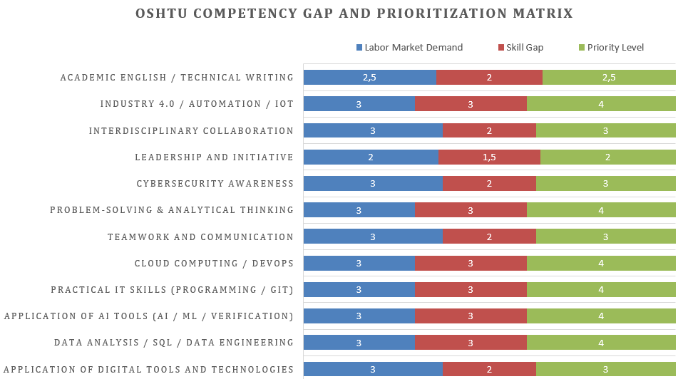

9. Recommendations for Actions
Short-Term Recommendations (1 Year)
To strengthen digital transformation and improve practical competency development at Osh Technological University, the following short-term actions are recommended:
- Establish an Applied AI Laboratory for practical training in artificial intelligence, machine learning, and AI verification.
- Introduce a Data Analytics module into technical and applied informatics curricula.
- Organize AI and digital technology training programs for lecturers to improve technology-enhanced teaching capacity.
Mid-Term Recommendations (2–3 Years)
For sustainable educational modernization, OshTU should:
- Implement a dual education model integrating academic learning with industry practice.
- Develop industry-based capstone projects focused on real-world engineering and digital problems.
- Expand and modernize cloud infrastructure to support practical cloud computing and Industry 4.0 learning environments.
Long-Term Recommendations
To strengthen institutional competitiveness and regional leadership in digital education, OshTU should:
- Establish a DIGITECH Innovation Center supporting AI, digital transformation, and interdisciplinary innovation.
- Implement an AI-driven Smart Campus concept integrating intelligent digital systems into university management and learning environments.
- Introduce international certification programs in AI, cloud technologies, cybersecurity, and data analytics.

The DIGITECH Needs Analysis demonstrates that digital transformation at Osh Technological University is actively progressing; however, systematic integration of modern digital ecosystems remains insufficient.

The analysis additionally reveals:
A significant gap between student self-assessment and demonstrated practical competencies.
Insufficient practical readiness in key Industry 4.0 domains such as AI, cloud systems, cybersecurity, and collaborative engineering workflows.

The urgent need to align curricula with:
- Industry 4.0 requirements,
- AI Readiness models,
- and competency-based digital education approaches.
Overall, the findings indicate that future educational transformation at OshTU should focus on:
- strengthening practical engineering competencies,
- integrating AI-enhanced learning,
- expanding industry collaboration,
and developing competency-oriented digital learning ecosystems aligned with modern labor market demands.

10. Conclusion

The results of the DIGITECH Needs Analysis conducted at Osh Technological University indicate that although students demonstrate growing interest in digital technologies and artificial intelligence, significant gaps remain between current competency levels and the requirements of the modern digital economy and Industry 4.0 labor market.

The analysis reveals that students possess basic theoretical knowledge and general digital literacy; however, practical engineering readiness, AI literacy, cloud technologies, cybersecurity competencies, and collaborative software development skills remain insufficiently developed.
To address these challenges, the following strategic actions are proposed:

  - Curriculum Modernization
Current courses related to Artificial Intelligence, Data Analytics, SQL, Cloud Technologies, Programming, and Industry 4.0 require modernization and stronger practical orientation. Existing curricula should be updated to better align with labor market requirements, emerging technologies, and applied engineering practices. [Linked findings: F1 (high AI adoption but limited applied AI competence), F3 (SQL/Data Engineering gap), F4 (Git and software engineering workflow gap), F5 (AI evaluation confidence vs. practice), F9 (theory–practice gap), F11 (employer demand for applied digital competencies). Evidence layers: student survey + lecturer survey + employer questionnaire + workshop. Status: addresses Confirmed competency deficits at OshTU across AI, SQL, Git, cloud technologies, and practical engineering readiness.]

  - Faculty Development and Pilot Teaching
To ensure effective implementation of modernized curricula, lecturers should participate in:
- specialized AI and digital technology training,
- project-based learning workshops,
- and pilot teaching activities organized within the DIGITECH project framework.
This will strengthen lecturers’ readiness to integrate innovative teaching methodologies and advanced technologies into the educational process. [Linked findings: F6 (lack of systematic AI integration into teaching), F8 (lecturer upskilling needs in AI, Cloud Computing, Data Analytics, and Industry 4.0), F10 (institutional readiness constraints). Evidence layers: lecturer survey + curriculum design assessment + employer consultation. Status: addresses Confirmed deficits at OshTU in AI-enhanced pedagogy and lecturer digital competence; pedagogical retraining should precede advanced AI tool adoption.]

- Transition Toward Applied and Project-Based Learning
OshTU educational programs should gradually shift from theory-oriented instruction toward:

- Project-Based Learning (PBL),
- interdisciplinary engineering projects,
- and real-world problem-solving environments.
Practical learning should cover the full engineering and software development lifecycle. [Linked findings: F4 (practical programming gap), F7 (self-learning and AI assistance dominate), F9 (theory–practice gap), F11 (employer convergence on practical engineering readiness). Evidence layers: student survey + lecturer survey + employer questionnaire + workshop. Status: addresses a Confirmed deficit at OshTU in applied learning, practical implementation, and professional workflow readiness.]

- Strengthening Soft Skills Development
Students, employers, and lecturers consistently identified soft skills as one of the most important developmental priorities. Future curricula should place stronger emphasis on:
- critical thinking,
- analytical reasoning,
- communication,
- teamwork,
- leadership,
- and professional work-readiness competencies.
[Linked findings: F5 (weak AI-generated information evaluation), F9 (problem-solving and analytical thinking gaps), F11 (employer priority convergence on teamwork, communication, and professional execution). Evidence layers: student survey + lecturer survey + employer focus group. Status: addresses Confirmed deficits at OshTU in communication, teamwork, critical thinking, and employability readiness.]
- Infrastructure Modernization and Industry-Oriented Laboratories
To reduce the competency gap in:
- Cloud Computing,
- Cybersecurity,
- Industrial Automation,
- IoT,
- and Data Engineering,
OshTU should modernize laboratory infrastructure and expand access to:
- cloud platforms,
- AI laboratories,
- cybersecurity simulation environments,
- and Industry 4.0 equipment.
Modern practical infrastructure is essential for developing industry-relevant competencies. [Linked findings: F10 (infrastructure/capacity deficit), F12 (limited exposure to cloud deployment, industrial automation, and practical engineering environments), DT (Digital Twins and Industry 4.0 readiness gap). Evidence layers: lecturer survey + employer questionnaire + workshop observations. Status: addresses a Confirmed institutional constraint at OshTU; infrastructure readiness assessment should precede large-scale module rollout.]

- Development of a Competency-Oriented Educational Model
Within the DIGITECH project framework, future educational programs at OshTU should be structured around the following strategic pillars:
- Applied Artificial Intelligence,
- Advanced Programming and Software Engineering,
- Data Analytics and Big Data,
- Cloud Technologies and Cybersecurity,
- Project-Based Learning,
- and Soft Skills Development.
[Linked findings: F1 (AI literacy gap), F3 (SQL/Data Engineering deficit), F4 (Git/software engineering workflow gap), F9 (theory–practice mismatch), F10 (technology infrastructure constraints), F11 (labor market competency convergence). Evidence layers: student survey + lecturer survey + employer questionnaire + workshop. Status: structural redesign addressing multiple Confirmed competency gaps at OshTU.]

- Strengthening Industry Collaboration
Based on focus group discussions and employer consultations, OshTU should continue expanding partnerships with industry stakeholders through:
- advisory boards,
- internship programs,
- industry-led capstone projects,
- and mentorship initiatives involving employers and technical experts.
Such collaboration will significantly improve graduate employability and ensure stronger alignment between educational outcomes and labor market needs. [Linked findings: F7 (self-learning dominates — structured workplace learning needed), F9 (limited exposure to real engineering workflows), F11 (employer convergence on practical and professional competencies). Evidence layers: employer questionnaire + lecturer survey + student feedback. Status: addresses a Confirmed employability gap at OshTU and supports continuous validation of curriculum relevance against labor market demand.]

Overall Strategic Conclusion
Overall, the Needs Analysis demonstrates that OshTU possesses strong institutional potential for becoming a leading regional center for digital and technological education. However, achieving this objective will require systematic curriculum transformation, faculty upskilling, infrastructure modernization, and stronger integration of Industry 4.0 and AI-oriented competencies into the educational ecosystem.

Standardized Reporting Annex

- Sample sizes and response rates
Evidence layer | Engaged audience | Responses analysed | Response rate (primary target group)
Students (survey) | 300 OshTU students (technical programmes — undergraduate + master’s level students) | 252 total (163 technical full-data + 89 limited-data respondents) | 84% (252 / 300)  Institutional target met
Lecturers (survey) | 30 OshTU academic staff (technical and engineering disciplines) | 21 | 70% (21 / 30) Institutional target met
Employers (focus group / questionnaire) | OshTU partner employers / regional labour-market stakeholders | 10 questionnaires | n/a
Workshop groups | OshTU students & lecturers (DIGITECH scenarios, Feb–Apr 2026) | 2 groups / 2 scenarios | n/a

- Top-5 gap table (confidence vs. usage vs. demonstrated)
Competency | Stated confidence (1–5) | Usage / curriculum exposure | Demonstrated (workshop / lecturer)
Machine Learning / Applied AI | Mean ≈2.17; 64% technical students low confidence (1–2/5) | High AI tool interest, but limited structured ML integration and applied implementation | Workshop and lecturer evidence show weak practical implementation and inconsistent reasoning
SQL / Database Engineering | Mean ≈2.85; 44% low confidence | Limited project-based exposure despite employer Day-1 expectations | Lecturers report practical difficulty; students struggle with applied database logic and workflow
Git / Version Control | Mean ≈2.85; 43% low confidence | Weak collaborative software development integration in curriculum | Limited demonstrated project collaboration and engineering workflow competence
Cloud Technologies / DevOps | Mean ≈2.77; ~40% low confidence | Restricted cloud infrastructure and limited practical exposure | Weak cloud-supported engineering readiness; lecturers report limited practical implementation
Critical AI Evaluation & Verification | AI evaluation ≈3.75 mean confidence; AI ethics ≈3.44 | 78% students use AI tools (e.g., ChatGPT), but only 23% systematically apply AI in academic projects | Workshop findings confirm students identify AI issues but fail to demonstrate coherent verification workflows

C. Employer day-1 requirements summary
- Applied programming and engineering problem-solving - expected as operational competencies rather than theoretical understanding alone.
- SQL, database workflows, Git, and collaborative software engineering - identified as essential Day-1 technical requirements.
- Critical evaluation and responsible use of AI-generated outputs - employers expect graduates to validate AI results, assess risks, and make informed decisions rather than passively accept outputs.
- Soft skills - communication, teamwork, time management, deadline discipline, and independent learning remain among the highest employer expectations.
- Cybersecurity awareness and secure digital practices - increasingly viewed as baseline professional responsibility.
- Presentation skills, professional ethics, and technical communication - necessary to support effective workplace integration and interdisciplinary teamwork.
- Real-world project execution - employers emphasised that graduates should be capable of applying digital technologies to solve real engineering and business tasks rather than only retrieving information.
D. Standardised prioritization matrix
Quadrant | OshTU competencies (mapped from triangulated analysis)
Critical Gap (high gap + high demand) | Applied AI verification & critical reasoning; SQL / Database Engineering; Git & collaborative software development; Cloud technologies / DevOps — consistently convergent across student, lecturer, employer, and workshop evidence
Curriculum Gap (high gap + moderate demand) | Industry 4.0 competencies (automation, IoT, applied cloud systems, cybersecurity workflows) — high student gap and lecturer concern but constrained by infrastructure and limited practical integration
Monitor (moderate gap + high demand) | Problem-solving and analytical reasoning; communication and teamwork; technical presentation skills; academic English and technical writing; cybersecurity awareness
Relative Strength | Strong student interest in AI and emerging technologies; 78% active AI tool use; moderate digital literacy; positive student readiness for project-based and applied digital learning

Kyrgyz-German Institute of Applied Informatics (INAI) – Bishkek, Kyrgyzstan

NEEDS ANALYSIS REPORT
DIGITECH
March 17th 2026

Students  Survey respondents | Lecturers  Survey respondents | Industry Partners  Focus group | Students  Workshop Groups | Lecturers  Workshop Groups
45  INAI.KG | 8  INAI.KG | 8  Industry Partners | 26  INAI.KG | 7  INAI.KG
26  KSTU | 2  KSTU | 8  Industry Partners | 12  KSTU | 1  KSTU

Executive Summary
Need Analysis provide to identify skills gaps. The data were gathered by surveys, workshops and focus group.
Key findings at a Glance
Current assessments reveal that the Automation program significantly fails to meet the demands of the modern digital economy. To remain competitive and relevant to the local labor market, develop new curriculum, a comprehensive overhaul of infrastructure, and teaching methodologies is required.

Institutional Context and Data Coverage Overview

1.1. Four-layer triangulation Framework
To identify gaps between perceived and actual skills, the INAI DIGITECH needs analysis uses a four-tier evidence framework. By collecting different types of data at each stage, the model confirms findings through consistency. Conversely, any conflicting data points highlight areas of overconfidence, curriculum deficiencies, or technical errors.
Layer | Description
Layer 1 — Student Survey | Captures perceived capability and revealed usage behaviour.
Layer 2 — Lecturer Assessment | Captures observed classroom performance.
Layer 3 — Industry Questionnaire | 8 employers assess day-1 skill requirements, hiring signal priorities, and AI impact on hiring. Captures labour market demand.
Layer 4 — Workshop Scenarios | 2 student groups complete live diagnostic scenarios. Captures demonstrated performance.

The analytical framework relies on differentiating verified skill shortages from speculative trends. Validation requires corroboration from at least two distinct evidence layers.

1.2. Sample composition
Students from two universities and two programs participated in the needs analysis:
- “Software technology”, Kyrgyz German institute of informatics (INAI);
- “Automation of technological processes and production”, Kyrgyz state technical university (KSTU).

Name program | Total |  | Survey |  | Workshop
Name program | Students | Teachers | Students | Teachers | Students | Teachers
IT program | 300 | 30 | 45 | 8 | 26 | 7
Automation program | 103 | 8 | 26 | 2 | 13 | 1

With a response rate of over 15% from the selected sample, the representativeness of the findings was achieved. Specifically, the INAI primary target group (third-year students with a basic understanding of artificial intelligence: 60 students, 10 lecturers) returned 45 of 60 student responses (75.0%) and 8 of 10 lecturer responses (80.0%), well above the methodology threshold. The 15% minimum was met for both students and lecturers (see Part I Comparability table for the full consortium-level figures).
Focus Group participants represent 8 companies consistent with the target range of 5-8 participating organizations:
- Large organizations (250+ employees): 3 representatives;
- SMEs (10-249 employees): 3 representatives;
- Startups (<10 employees): 2 representatives;
- Public sector: 2 representatives.

№ | Participant name | Position | Name of company
 | Soroka Dmitriiv | Head of Data Department | JSC “Eldikbank “
 | Karimova Jansay | Recruitment and Adaptation Manager | JSC “Eldikbank “
 | Borchubaev Emil | IT Department Manager | CJSC "Kumtor Gold Company"
 | Ajimamatova Tunuk | HRD | JSC “Tunduk”
 | Neimyshev Vasilii | Director | LLC “Zhanar Elektronik”
 | Tilekov Urmat | Teamlead Flutter | LLC “ElTech”
 | Nurlanova Aliy, | Internal Communications Manager | LLC “Mdigital”
 | Musaev Meder | Talent Manager | LLC “Mdigital”
 | Mendekeeva Nargiza | Regional Development Director of the Women in Tech Kyrgyzstan network | LLC “NurBata” и Women in Tech Kyrgyzstan
 | Botobaeva Jyrgal | director/co-founder | Tekaiym Public Foundation

2. Students’ Skill Gap Analysis

2.1. Tool Confidence profile
Automation program students generally report lower confidence in using or understanding digital tools compared to their IT counterparts, with the notable exception of Industrial Automation. While both groups exhibit high confidence in Generative AI chatbots and image/data generation tools, IT students demonstrate additional proficiency in SQL/Database queries and Cloud platforms.
Proficiency in GenAI reflects high AI literacy, yet struggles with Machine Learning and Big Data reveal a reliance on ready-made interfaces over technical depth. This represents a classic 'hype-driven signal': a readiness to use AI for routine tasks without the hard skills necessary for a true data-driven transformation or deep analytical work.
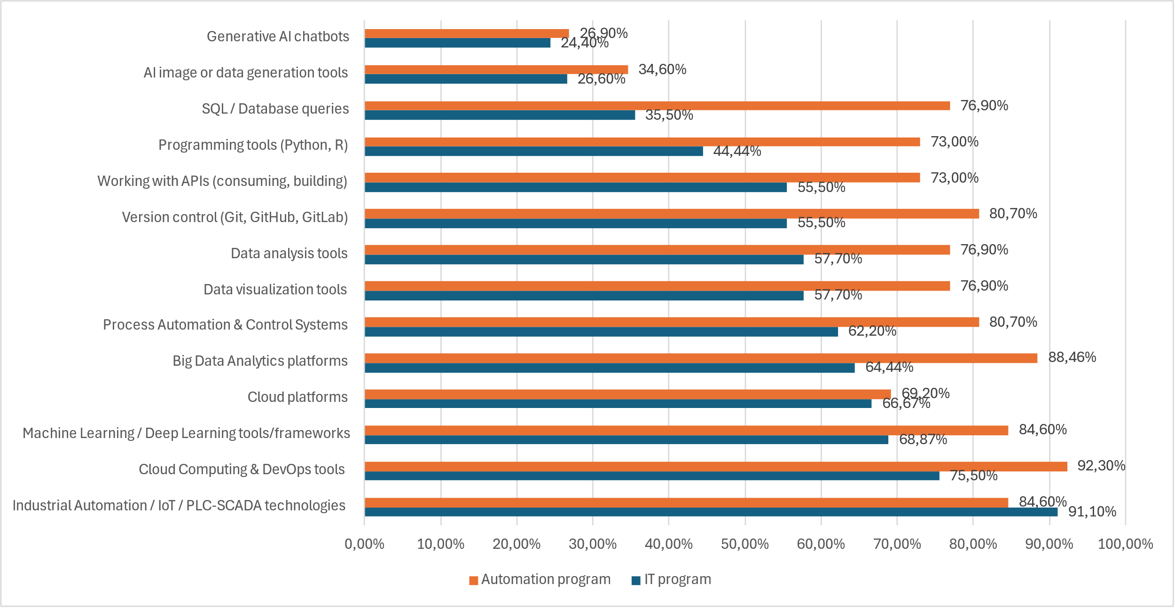
Figure 2.1. Tool confidence diverging bar

Critical Tool Gaps – IT Students:
A major misalignment exists in core technical domains. Despite the fact that nearly all employers (7/8) require immediate readiness, a large portion of students lack confidence in their abilities, specifically in Data Science (43.3%), Machine Learning (31.13%), and Cloud Platforms (33.33%), scoring themselves between 1 and 3.

Critical Tool Gaps – Automation students
There is a notable gap between employer expectations and graduate performance in the Automation Program. While industry partners require immediate proficiency in digital equipment, graduates report significant difficulties with core areas such as Industrial Automation, IoT, PLC-SCADA, and process automation during their initial transition to the workplace.

2.2. Task and soft skill confidence
Overall, IT students exhibit higher task-level confidence and soft skills than their Automation counterparts. Over 70% of IT students are proficient in applying basic AI ethics, creating effective prompts, and learning new digital skills independently. However, more than 50% still struggle with following safe cybersecurity practices.
In the Automation program, over 50% of students show competence in AI prompting, adapting to new methods, effective teamwork (including remote collaboration), and independent time management.

Figure 2.2. Task and soft skill confidence diverging bar

Critical Tool Gaps:
Despite students' positive self-assessment of their soft skills, feedback from industry partners tells a different story. Employers specifically identified teamwork, the ability to explain technical ideas to non-specialists, and self-directed deadline management as areas requiring improvement.

2.3. Confidence -Usage Gap
Usage patterns students both programs indicate that students gravitate toward software and technologies where they perceive their own proficiency to be highest.
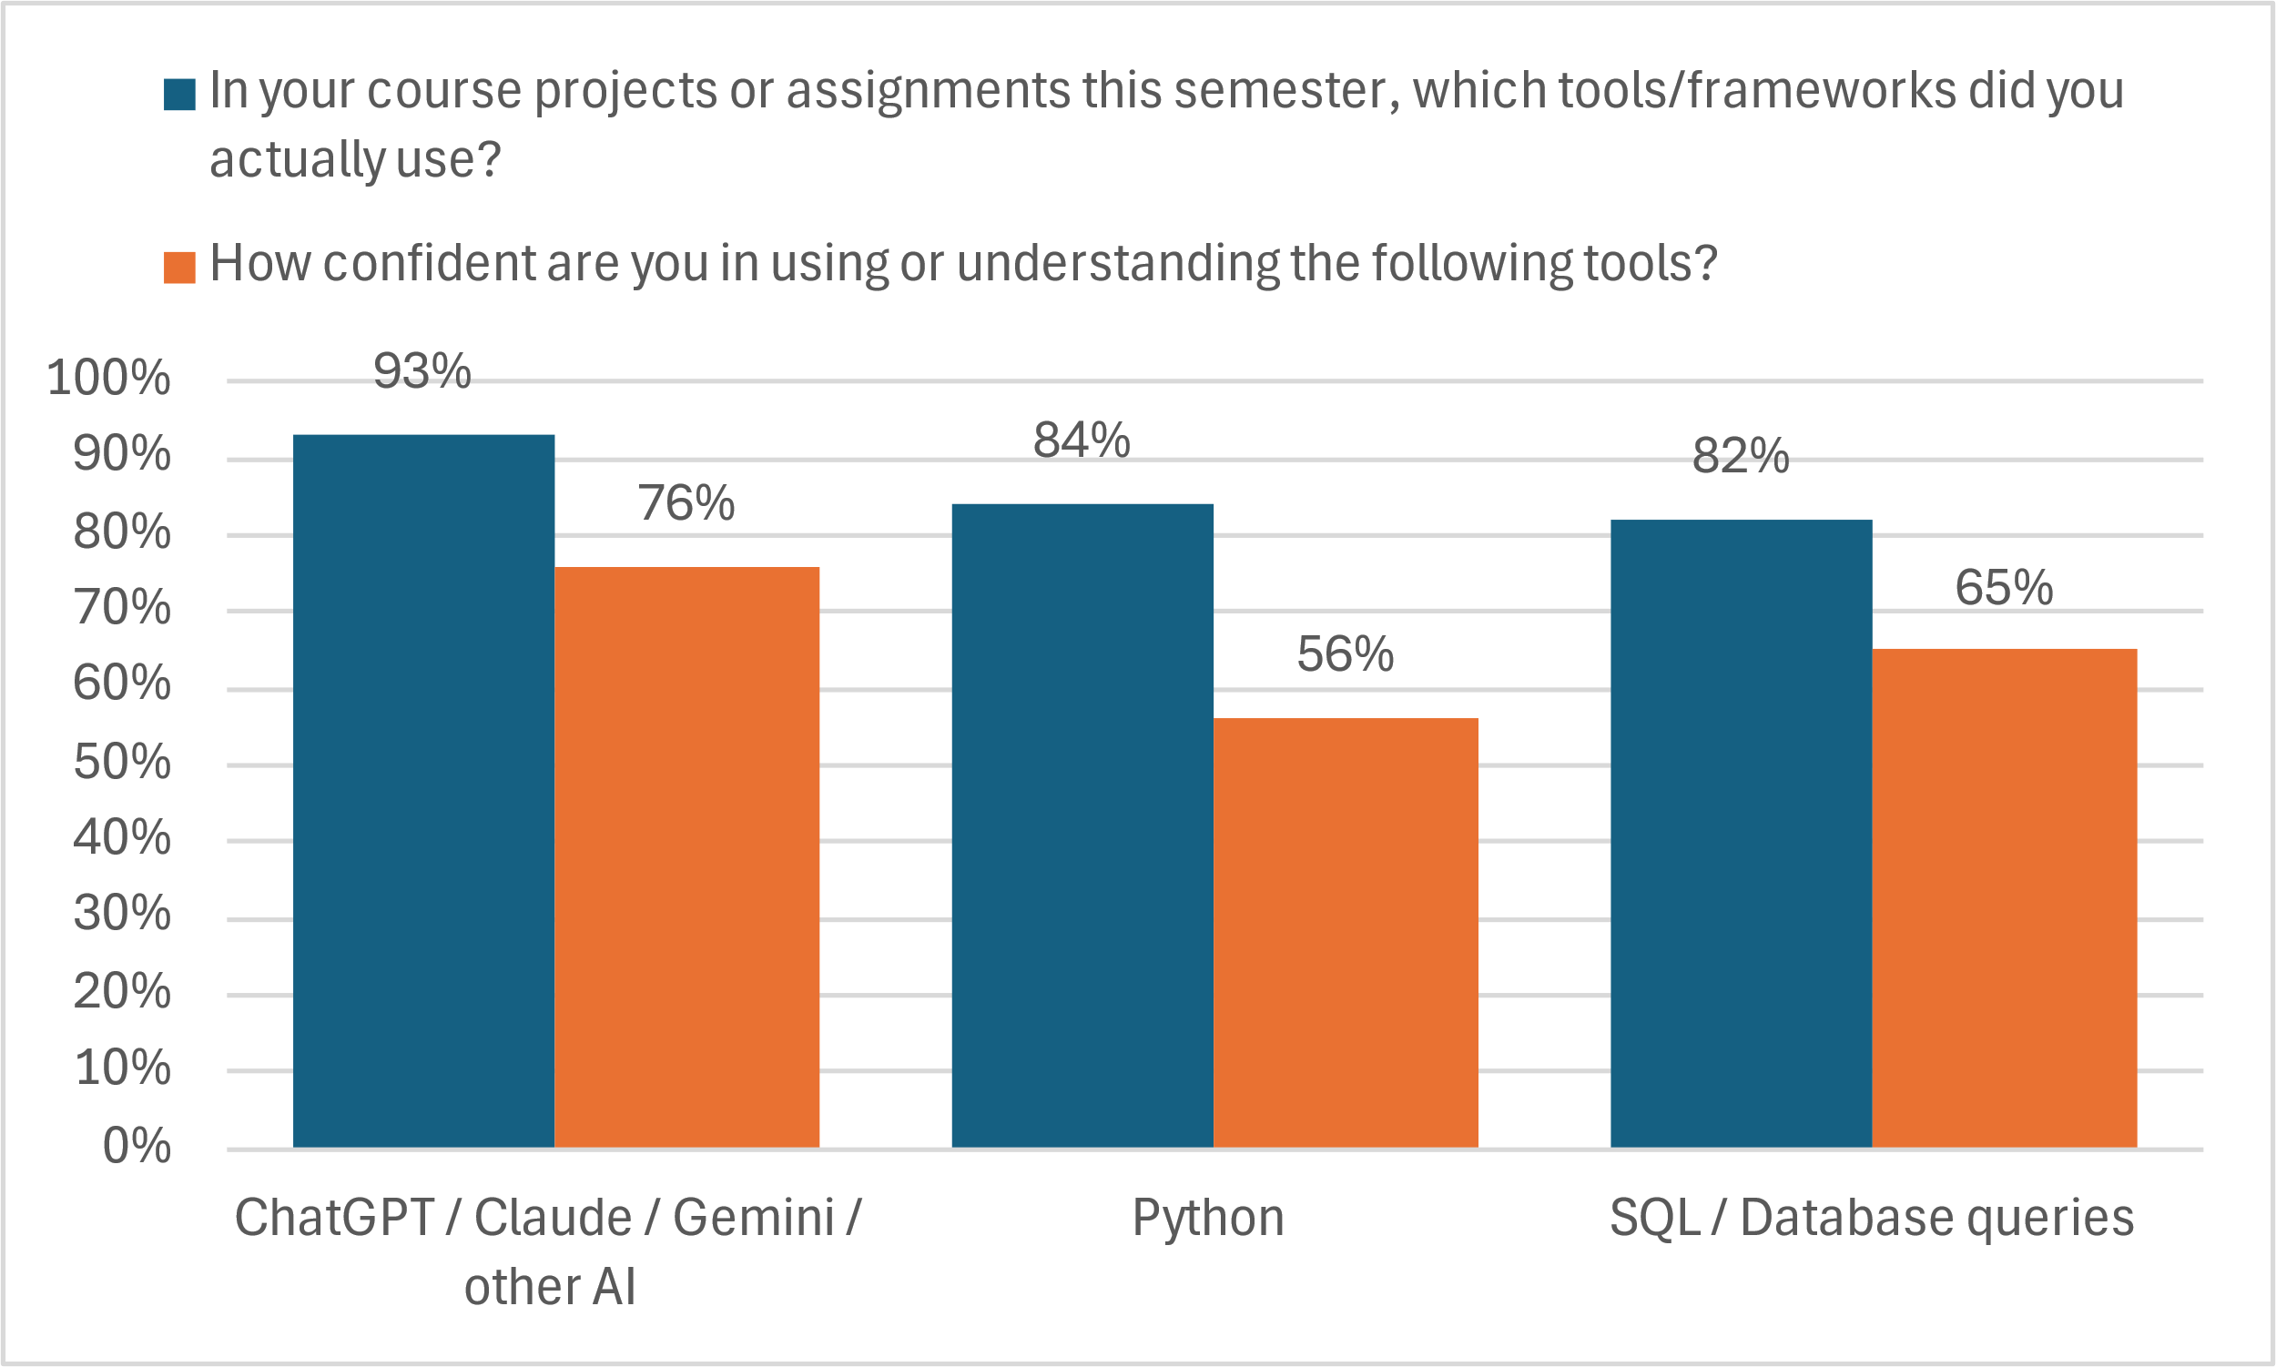
Figure 2.3.1. IT students revealed usage behavior exceeds stated confidence

Figure 2.3.2. Automation program students revealed usage behavior exceeds stated confidence

2.4. Industry 4.0. Readiness
IT students appear better prepared for Industry 4.0 than their counterparts in Automation programs, reporting higher confidence in highly automated environments. This advantage is largely attributed to their coursework in general programming and AI. However, both groups lack a deep understanding of industrial automation concepts, indicating that Industry 4.0 exposure remains limited and uneven even in specialized curricula. Despite these gaps, students from both disciplines share a strong interest in specialized laboratory courses focused on Digital Twins

Figure 2.4. Industry 4.0. Readiness

2.5. Tool usage Frequency
The frequency of tool usage among IT students aligns with the stated confidence level.

Figure 2.3.3. IT students’ usage frequency

Automation program students stated confidence exceeds revealed usage behavior

Figure 2.3.3. Automation program students’ usage frequency

3. Lecturer Perspectives

3.1. Lecturer Profile
The IT program sample is characterized by a higher proportion of senior faculty (16+ years of experience), whereas the Automation program is primarily represented by mid-career lecturers with 8 to 20 years of experience.

Figure 3.1. Lecturer Profile: teaching experience

Half of the lecturers (50%) identify as 'mainstream adopters' who integrate new tools only after their value is proven, while the other 50% classify themselves as 'early adopters' who are eager to experiment with emerging technologies.
The even split between early and mainstream adopters suggests a balanced approach to digital transformation, ensuring that new tools are thoroughly tested by enthusiasts before broad implementation
This distribution provides a strong foundation for peer-to-peer professional development, where early adopters can validate emerging technologies for their mainstream colleagues.
Overall, the predominantly positive attitude toward educational technology indicates a low level of institutional resistance to future digital integration.

Figure 3.1. Lecturer Profile: technology adoption

3.2. Observed Students Struggle Frequency
The most significant challenges identified for IT students are in teamwork and time management (3.43). These are followed by programming logic (3.00), while independent problem-solving, basic data handling and communication skills also shows notable levels of difficulty (2.86). Considering the findings in Chapter 4 regarding employer preferences for logic and architecture, it is essential to restructure IT educational programs accordingly.
The most significant challenges identified for Automation program students is independent problem-solving.

5- almost always; 4 -often; 3-sometimes; 2-rarely; 1-never
Figure 3.2.1. Lecturer observed students struggle frequency
Feedback from program lecturers indicates that both the academic structure and the existing infrastructure are fully capable of supporting digital and AI integration. Specifically, there are no reported constraints regarding program frameworks or essential technical resources like software, high-speed connectivity, or external service access.
Faculty members have identified significant gaps in student preparedness at the point of entry. IT lecturers report that students often lack essential foundational competencies, including mathematics, data literacy, and core programming concepts, as well as a grasp of computer architecture. Furthermore, there is a noted deficiency in higher-order skills such as logical thinking, problem-solving, and professional oral communication. This is compounded by the diverse preparedness of students, requiring significant pedagogical adaptation. Similarly, Automation lecturers emphasize that incoming students frequently arrive without a solid command of basic mathematical and computing skills.
However, IT program lecturers encounter several critical barriers to providing technologically advanced education, most notably a deficit in modern infrastructure (equipment and laboratories), the rapid evolution of the field, which often outpaces curriculum development and the vast volume of emerging information. Meanwhile, Automation lecturers highlight a distinct set of challenges: a lack of foundational competencies in mathematics and programming among students, as well as a general resistance to innovation.
IT faculty frequently identify several key skill gaps during practical assignments, most notably a deficit in soft skills, particularly the inability to communicate technical concepts clearly. Other concerns include insufficient background knowledge, a lack of attentiveness, and a tendency to rely on AI-generated outputs without critical verification. Furthermore, students often struggle to apply theoretical principles in practice and demonstrate low engagement. In contrast, Automation lecturers primarily emphasize a weak grasp of fundamental disciplines.
According to faculty assessments, students in the IT program require the most significant development in Soft Skills (1), followed closely by Cloud Computing & DevOps (1,43). Areas such as Responsible AI & Ethics (2), Cybersecurity Fundamentals (2), AI Tools for Business (2) and Industrial Automation (IoT/PLC-SCADA) were also identified as needing improvement, though with a slightly lower urgency.
Conversely, for the Automation program, lecturers highlighted an immediate need for advancement in technical domains, specifically Cloud Computing & DevOps, Responsible AI & Ethics, AI Business Tools, and Industrial Automation/SCADA. Soft Skills were also noted as a secondary but important area for growth.

1=most improvement needed, 4 =least improvement needed
Figure 3.2.2. Lecturer rank students’ improvement needed

Faculty members in both programs are actively enhancing their digital and AI competencies, primarily through independent study. In the IT program, lecturers also prioritize applying these technologies within their personal projects and participating in formal professional development. Similarly, Automation faculty combine self-directed learning with organized training.
To further strengthen the technological component of their teaching, lecturers identified specialized upskilling programs, research seminars, and modernized laboratory infrastructure as the most critical support factors.
Lecturer personally need upskilling in the next areas to better integrate digital/AI components into their teaching: ML & Neural Engineering, Data Science & Analytics And Applied AI & Implementation

Figure 3.2.3. Lecturer Upskilling Gaps

3.3. Curriculum Design Confidence
Faculty members across both programs demonstrate high proficiency in the technical aspects of course design. IT lecturers excel in objective setting and credit allocation (ECTS), showing a strong trend in horizontal course integration (4.25). In contrast, Automation lecturers report maximum confidence (5.0) in assessment design and defining final competencies, with a particular strength in vertical curriculum progression (4.5).
Despite these strengths, both departments face similar pedagogical challenges. A shared 'confidence gap' is evident in the application of Bloom’s Taxonomy, which is significantly more pronounced in the Automation program (1.5) compared to the IT program (2.75). Additionally, while IT faculty struggle more with elective management (3.5), Automation faculty find horizontal synchronization and workload-to-credit conversion more challenging (3.5).
Figure 3.3. Lecturer confidence in curriculum design
Within curriculum design faculty members have identified several key areas where additional training would be highly beneficial. These include the systematic development of competencies and the application of Bloom’s Taxonomy for drafting learning outcomes. Furthermore, lecturers expressed a need for professional development regarding curriculum and syllabus constraints, as well as the methodology for the calculation and distribution of student workload.

Industry Employer Assessment

Representing a cross-section of the industry, eight companies participated in the focus group sessions. Recruitment trends vary by scale: IT companies reported hiring 2–3 young professionals in the last year, while larger organizations saw a higher intake of 7–8 graduates distributed across multiple departments.

4.1. Day-1 Skill Readiness Requirements
According to the focus group, soft skills are the top priority for employers. Their 'Must-Have' list for new hires includes:
- A genuine passion for the work ('sparkle in the eyes');
- Meticulous code reading and attention to detail;
- Bridging the communication gap between technical and non-technical teams;
- Collaborative mindset and teamwork;
- Impactful self-presentation;
- Reliability in meeting deadlines without constant supervision.
Regarding technical competencies for IT specialists, employers expect graduates to be 'Day 1 ready' in areas such as development environments and version control systems (Git, GitHub, GitLab). Essential entry-level skills also include systems thinking, the ability to request detailed specifications, and proficiency in code documentation and testing.
While mastery of proprietary company tools is not a prerequisite—as firms typically provide this training during internships—the baseline for entry-level roles is shifting. Several respondents noted that AI systems are now handling tasks traditionally assigned to juniors, which is fundamentally reshaping hiring patterns and raising the expectations for new hires.
Employers report that entry-level IT graduates encounter significant difficulties in several core areas at the start of their careers. Most notably, there is a gap in architectural and infrastructure knowledge, as well as a limited understanding of the software development lifecycle (SDLC). Technically, graduates struggle with the practical application of programming languages such as Python, Java, and Flutter, and show a lack of proficiency in modern domains like DevOps, Data Science, and Machine Learning. Furthermore, their ability to manage version control systems and utilize Cloud platforms or Generative AI tools for professional tasks remains underdeveloped.
Employers of Automation program graduates expect 'Day 1' proficiency in handling digital equipment. However, evidence suggests a significant gap in student readiness, particularly regarding industrial and process technologies, such as Industrial Automation, IoT, and PLC-SCADA. This deficiency is directly linked to the lack of laboratory equipment and infrastructure within universities. This institutional challenge was further corroborated by faculty feedback, where lecturers identified inadequate infrastructure as the primary obstacle to providing a technologically up-to-date education.

4.2. Technologies Active in Production
Generative AI, including ChatGPT, Gemini, and Claude, is the most widely used infrastructure among the surveyed companies. Six out of seven organizations report active production use of these tools. Data analytics/BI tools and process automation are also each used by six companies. Four companies use cloud platforms like Google Cloud Platform, Microsoft Azure, Amazon Web Services, and Databricks. Machine learning/predictive models and industrial automation/IoT/PLC-SCADA are each used by three firms. Digital Twins/Industrial simulation is in use by only one company. However, machine learning/predictive models and Digital Twins/Industrial simulation are planned for deployment next year by four and three companies, respectively. Overall, the technology profile indicates that data analytics/BI tools, process automation, and cloud platforms form the core technical environment for new employees.
This suggests:
- Generative AI has become a standard more quickly than traditional ML.
- Knowledge of BI tools and process automation is now a basic requirement.
- Skills in Digital Twins and ML will become critical in the near term (next year).

Figure 4.2. Technologies used in production today

4.3. Hiring Signal Priorities
As Industry 4.0 technologies mature, employers have identified a shift toward higher-level technical orchestration and strategic soft skills. The next generation of young employees is expected to master the following core areas : Advanced AI & System Integration (AI Orchestration & Integration, IoT & System Automation, Data Analysis & Cybersecurity), Architectural & Systems Engineering(Systems Thinking, Systems Architecture & Design, Knowledge of Technological Processes), Strategic Professional Skills(Technical Documentation Literacy, Budget & Time Management, Continuous Professional Development) and Soft Skills (Critical Thinking, Strategic Communication & Teamwork).

Figure 4.3. Technologies used in future

4.4. What Employers Wish Universities Taught Better
To meet industry demands, higher education must prioritize focusing on Python and practical software development, adopting AI as a fundamental tool in the professional toolkit, understanding the lifecycle of deployment and tech environments, proficiency in Business Intelligence, SQL, and ML models, cultivating the ability to design complex technical frameworks and developing digital literacy (professional command of office and productivity software).

Figure 4.4.1. University Technical Training Priorities

Employers are looking for 'mature professionals' with high cognitive and social intelligence. They prefer candidates who possess a solid foundational mindset and only require onboarding into specific business processes

Figure 4.4.2. University Soft skills Training Priorities

Workshop Scenario Performance

5.1. Lecturer Prediction Accuracy
To validate self-reported confidence through direct skill observation, workshops were conducted for students across two academic programs. This approach serves as a 'hype-proof' assessment method, providing a structured setting to verify data gathered from questionnaires and focus groups. By utilizing scenario-based activities tailored to each discipline, the project team was able to evaluate firsthand how students tackle digital and AI-related challenges relevant to their fields.
Overall, IT students demonstrated solid proficiency in Data & Analysis, mastering most of the assessed skills. Only three competencies saw performance around the 50% threshold: SQL JOIN operations (52.09% and 50.00%) and identifying AI/ML use cases (50.00%). The most challenging area was BI platform usage, with only 42.31% of students succeeding.
In contrast, most Automation program students were able to demonstrate only two out of thirteen D&A skills: data type identification in CSV/Excel files (64.55%) and selecting appropriate chart types (58.3%).

Figure 5.1.1. Data & Analysis Skills

IT students showed moderate technical proficiency, with an average mastery rate of 50% across assessed skills. Key competencies such as unit testing (TC.A3) and version control management (TC.A4) hovered right at the 50% mark. However, SQL operations, API consumption, and basic Git workflows proved more difficult, with success rates dropping to 46%. Conversely, Automation students struggled with the broader curriculum, demonstrating proficiency in only two of the nine skills: writing functions (79.17%) and error identification (75%).
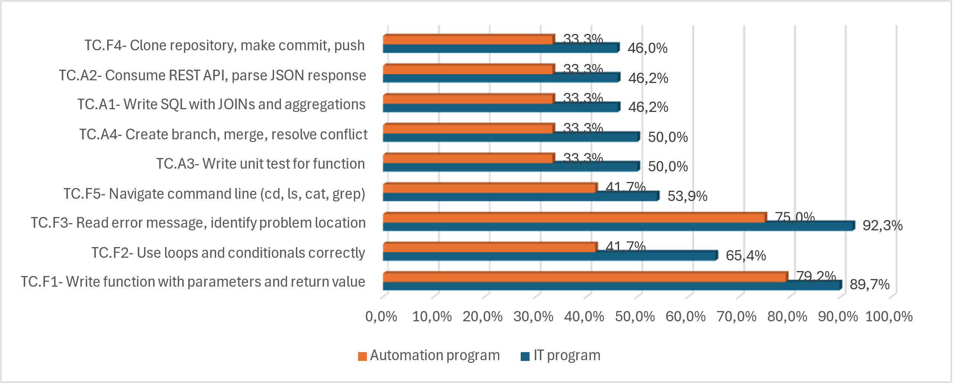
Figure 5.1.2. Technical Skills

IT students exhibited a moderate foundation in AI Readiness, achieving an average mastery rate of 75%. However, performance was notably lower in critical areas such as identifying ethical concerns (53.85%) and spotting factual errors in AI outputs (50%). In contrast, Automation students faced significant challenges with the curriculum, meeting the proficiency threshold in only one area: identifying factual inaccuracies in AI-generated text (58%)

Figure 5.1.3. AI Readiness Skills

Lecturers have pinpointed specific areas for improvement in both the IT and Automation programs. While students grasp the theoretical foundations, they struggle with professional-grade technical tools and high-level analytical tasks that require critical thinking.

Strategic Priority Analysis

6.1. Strategic Implications for Curriculum Development
To define the core content of the Curriculum, we identified areas where student self-assessments align with the perspectives of both lecturers and employers. The findings are categorized as follows for IT program.
Monitor (lower-left quadrant). Generative AI chatbots: while confidence is high, the curriculum must prioritize Responsible AI & Ethics to ensure professional integrity, Cloud platforms: General proficiency in cloud environments.
Strength (upper-left quadrant). SQL / Database queries, AI image or data generation tools fall within the Strength quadrant. Student responses, lecturer and employer observations indicate comparatively lower levels of difficulty in these areas. According to Generative AI chatbots, Cloud platforms employer observation said that it is necessary to pay attention to quality of this competence.
Student GAP (upper-right quadrant). These skills show low student confidence though lecturers and employer observe only moderate difficulty: Working with APIs (consuming, building), Process Automation & Control Systems
Both student self-assessment and lecturers observe coincide in the next skills: Version control (Git, GitHub, GitLab), Data visualization tools, Data analysis tools, Big Data Analytics platforms, Programming tools (Python, R).
Critical Gaps (lower-right quadrant). These areas show high student gap, high employer demand, and significant struggles observed by lecturers. Integration into the curriculum is essential: Cloud Computing & DevOps tools; Industrial Automation (IoT, PLC-SCADA technologies).
Areas for Quality Improvement. These topics require deeper integration: Programming: Enhancing core logic, proficiency in code documentation, testing, and the Software Development Lifecycle (SDLC); Data & Automation Stack: Data visualization, Big Data analytics platforms, Process Automation & Control Systems; AI/ML: Mastery of Machine Learning and Deep Learning tools and frameworks. Students feel confident in these areas, and while they meet employer needs, the focus should shift toward professional standards and ethics: Development Workflows: Version control (Git, GitHub, GitLab)
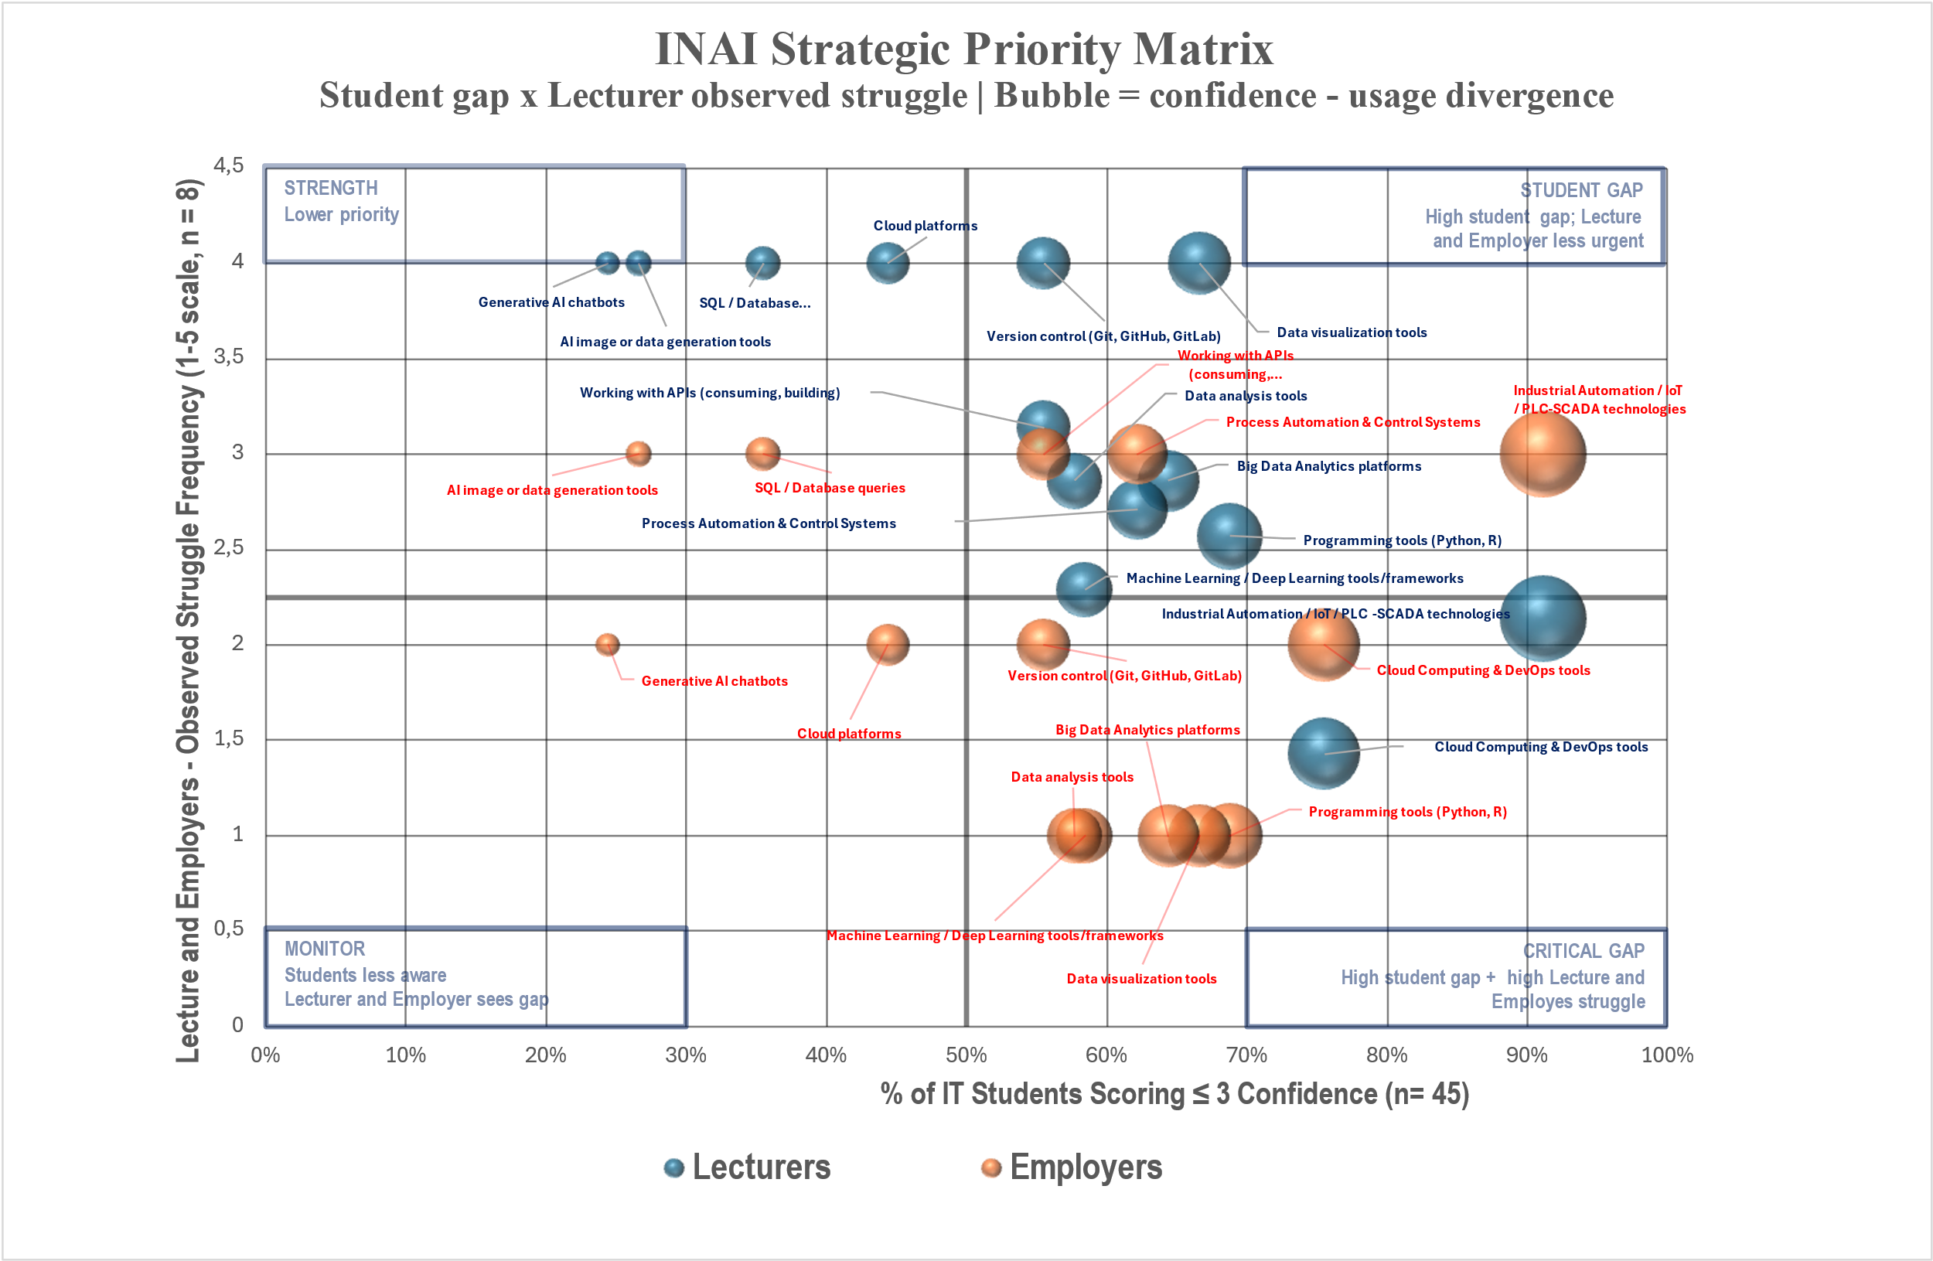
Figure 6.1.1. IT program Strategic Priority Matrix

The findings are categorized as follows for Automation program.
Monitor (lower-left quadrant). None of the skills belong in this quadrant.

Strength (upper-left quadrant).
Generative AI chatbots, AI image or data generation tools fall within the Strength quadrant.

Student GAP (upper-right quadrant). These skills show low student confidence though lecturers and employer observe only moderate difficulty: SQL / Database queries Cloud platforms Working with APIs (consuming, building), Version control (Git, GitHub, GitLab), Data analysis tools Machine Learning / Deep Learning tools/frameworks, Process Automation & Control Systems, Big Data Analytics platforms, Data visualization tools, Programming tools (Python, R), Cloud Computing & DevOps tools.
Critical Gaps (lower-right quadrant). These areas show high student gap, high employer demand, and significant struggles observed by lecturers. Integration into the curriculum is essential: Industrial Automation (IoT, PLC-SCADA technologies).
Areas for Quality Improvement. Automation program students are significantly lagging the requirements of the modern digital economy. Addressing this issue requires the development of a new curriculum.
Figure 6.1.1. Automation program Strategic Priority Matrix

Conclusion

The results of the Needs Analysis indicate that Automation program students are significantly lagging the requirements of the modern digital economy. To address this, the following strategic actions are proposed:
1. Develop curriculum. Current courses in Big Data, Machine Learning, SQL, and Programming within the IT curriculum are largely outdated and lack practical orientation. They no longer align with local labor market demands. It is imperative to overhaul this content before scaling it to new program. [Linked findings: F3 (Git/SQL), F4 (programming self-report gap), F9 (theory–practice gap). Evidence layers: student survey + lecturer survey + employer focus group + workshop. Status: addresses a Confirmed deficit at INAI.]
2. Faculty Development and Pilot Testing. To ensure high-quality delivery, lecturers must undergo specialized training and participate in pilot teaching programs organized under the DIGITECH project. This will ensure that teaching staff are prepared to handle updated technologies and methodologies.[Linked findings: F8 (no formal AI training received), F9 (theory–practice gap; Partial at INAI). Evidence layers: lecturer survey + workshop. Status: addresses a Confirmed deficit at INAI; sequence pedagogical retraining ahead of AI tool tutorials (see What Not To Do guardrail).]
3. Shift to Applied Learning. The new curriculum must pivot toward a Project-Based Learning (PBL) approach, covering the full software development lifecycle. [Linked findings: F4 (programming self-report gap), F7 (self-learning dominates), F9 (theory–practice gap), F11 (employer convergence on applied skills). Evidence layers: student survey + lecturer survey + employer focus group + workshop. Status: addresses a Confirmed deficit at INAI.]
4. Enhancing soft skills. All stakeholders - including students, employers, and faculty—identify soft skills as one of the primary areas for improvement. Beyond technical mastery, the program will emphasize strategic soft skills, specifically critical thinking and professional work-readiness.[Linked findings: F5 (AI eval confidence vs. practice), F11 (employer priority convergence on professional execution). Evidence layers: student survey + lecturer survey + employer focus group. Status: addresses a Confirmed deficit at INAI.]
5. Infrastructure and Industrial Integration. To bridge the significant gap in Industrial Automation, IoT, and PLC-SCADA, the acquisition of modern laboratory equipment is essential. Up-to-date facilities are a prerequisite for providing students with relevant, hands-on experience in industrial and process technologies.[Linked findings: F10 (infrastructure/capacity deficit; Partial evidence at INAI per Convergence Summary), DT (Digital Twins implication). Evidence layers: lecturer survey + employer focus group. Status: medium-term investment — infrastructure readiness assessment must precede module launch (see What Not To Do guardrail).]
6. Proposed Curriculum Structure. Under the DIGITECH project, the new curriculum for Automation program will be built around five core pillars: Engineering Disciplines; Advanced Programming; Industrial Automation; Machine Learning & AI; Foreign Languages and Soft Skills.[Linked findings: F3 (Git/SQL), F4 (programming), F9 (theory–practice gap), F10 (infrastructure deficit), F11 (employer convergence). Evidence layers: student survey + lecturer survey + employer focus group + workshop. Status: structural redesign — combines Confirmed deficit response (Git/SQL/programming) with medium-term investment (Industrial Automation).]

7. Industry Collaboration. Following focus group discussions, key employers have agreed to join an Advisory Board. This partnership will facilitate industry-led internships and establish a mentorship program where students are guided by industry experts.[Linked findings: F7 (self-learning dominates — formal channels needed), F11 (employer priority convergence). Evidence layers: employer focus group. Status: addresses a Confirmed deficit at INAI through ongoing employer engagement; supports verification of demand signal over time.]

Standardized Reporting Annex
A. Sample sizes and response rates
Group | Target population | Responses (n) | Response rate | 15% met?
Students (INAI, primary) | 60 | 45 | 75.0% | Yes
Lecturers (INAI) | 10 | 8 | 80.0% | Yes
Employers (focus group) | Target 5–8 firms | 8 | Within target | n/a
Workshop (students) | 2 scenarios | 26 (INAI) + 12 (KSTU) | n/a | n/a
B. Top-5 gap table (confidence vs. usage vs. demonstrated)
Competency | Student confidence (low %) | Usage signal | Workshop performance
Data Science (IT) | 43.3% (Section 2.1) | Below confidence (Section 2.3) | BI: 42.31%; SQL JOIN: ~50%
Cloud Platforms (IT) | 33.33% (Section 2.1) | Below confidence | Not directly assessed
Machine Learning (IT) | 31.13% (Section 2.1) | Below confidence | AI use-case ID: 50%
Industrial Automation / IoT / PLC-SCADA (Automation) | High (Section 2.1, 6.1 Critical Gap) | Limited (lab access constraint) | Only 2 of 13 D&A skills mastered
AI critical evaluation / ethics | High self-confidence (Section 2.2) | Frequent (consortium F1) | IT ethics ID: 53.85%; Auto: 58%
C. Employer day-1 requirements summary
Summary of the day-1 requirements identified by the 8 employer representatives in the INAI focus group. For IT graduates, employers expect day-1 readiness in development environments, version control (Git/GitHub/GitLab), systems thinking, request-for-specification skills, and code documentation and testing. For Automation graduates, day-1 expectations centre on handling digital equipment and on familiarity with industrial automation, IoT and PLC-SCADA. Across both profiles, the soft-skill day-1 expectations include genuine engagement (“sparkle in the eyes”), attention to detail in code reading, bridging technical–non-technical communication, collaborative mindset, impactful self-presentation, and meeting deadlines without constant supervision. Mastery of proprietary company tools is explicitly not a day-1 requirement and is provided through internal onboarding.
D. Prioritization matrix
Quadrant (BTU scale) | INAI competencies
Critical Gap (high gap + high struggle) | Cloud Computing & DevOps; Industrial Automation (IoT, PLC-SCADA).
Monitor (high struggle + relative confidence) | Generative AI chatbots, Cloud platforms (general use). Curriculum should prioritise Responsible AI & Ethics for these.
Curriculum Gap (high gap + moderate struggle) | APIs (consuming, building), Process Automation & Control; for Automation program: SQL/DB, Cloud, Git, Data analysis, ML, Programming, Big Data, Data viz.
Relative Strength | SQL / Database queries, AI image/data generation tools (IT program).

Yerevan State University — Ijevan Branch (YSU) – Ijevan, Armenia

141  YSU Students  Survey respondents |  | 33  YSU Lecturers  Survey respondents | 68  Industry Partners  Employer questionnaires | 2  Workshop Groups  2 scenarios

1. Executive Summary / Institutional Context and Data Coverage
The needs analysis conducted within the framework of the DIGITECH project aimed to assess the level of digital skills among students and academic staff of the Ijevan Branch of Yerevan State University and to identify the key areas where further capacity development is required, taking into account the demands of the modern labor market.
The results of the analysis indicate that students who participated in the surveys and focus group discussions generally possess a basic level of digital literacy and are familiar with the use of fundamental digital tools within their respective professional fields. At the same time, certain gaps in skills were identified in several advanced technological areas, particularly in data analysis, automation technologies, programming, and the application of Industry 4.0 systems.
The study also demonstrates a growing interest among both students and academic staff in the use of artificial intelligence tools; however, there is a need to further develop competencies related to their effective and responsible use. The findings also highlight the importance of expanding practical learning approaches and the integration of technological tools within the educational process.
The analysis of the perspectives of external stakeholders and employers indicates that the modern labor market values not only professional knowledge but also competencies related to working with data, the application of digital technologies, and problem-solving skills.
Overall, the needs analysis suggests that the further development of educational programs should particularly focus on strengthening digital and technological competencies, enhancing practical learning components, and more actively integrating innovative technologies into the educational process.

2. Institutional Context and Data Coverage Overview
Yerevan State University (YSU) is the largest and one of the leading higher education institutions in the Republic of Armenia, offering a wide range of modern and continuously updated academic programs. The university operates a three-cycle education system consisting of bachelor’s, master’s, and doctoral (PhD) programs.
Within the structure of YSU, there is one regional branch — the Ijevan Branch of Yerevan State University (YSU Ijevan Branch), which plays an important role in ensuring access to higher education and fostering professional capacity development in the northeastern region of Armenia.
One of the priority objectives of the YSU Ijevan Branch is the development of natural sciences, economics, humanities, and cultural fields in the region. To achieve this goal, the branch includes four faculties — Natural Sciences, Humanities, Economics, and Applied Arts — as well as 10 professional chairs.
Currently, approximately 1,200 students study at the YSU Ijevan Branch. During its years of operation, the branch has produced around 8,000 graduates, most of whom are successfully employed in various sectors of public life, including state and public institutions, educational organizations, the banking sector, and other organizations.
Within the framework of the DIGITECH project needs analysis, surveys were conducted among students and academic staff of the YSU Ijevan Branch. The respondents represented the Faculties of Natural Sciences and Economics. It should be noted that in the questionnaires the institutional affiliation is indicated as Yerevan State University; however, the collected data refer specifically to the educational programs implemented at the YSU Ijevan Branch.
Data collection was conducted through online surveys using separate questionnaires for students and academic staff. The questionnaires included sections related to students’ digital skills, the use of artificial intelligence, knowledge of Industry 4.0 technologies, and the integration of digital technologies into the teaching and learning process.
37, 82, and 22 students from three educational programs of the Ijevan branch of Yerevan State University: the Bachelor's degree in Informatics and Applied Mathematics of the Faculty of Natural Sciences, the Bachelor's degree in Finance of the Faculty of Economics (registered as "Economics" in the survey results), and the Master's degree in Business Administration of the Faculty of Economics, participated in the survey respectively. In total, responses were collected from 141 students and 33 academic staff members. The surveys were conducted online using the Google Forms tool.
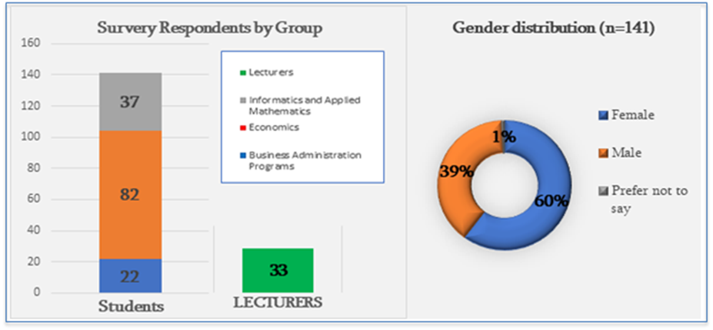
The diagram below presents the demographics of the students who participated in the survey: the number of participants by age, educational level, and type of program.
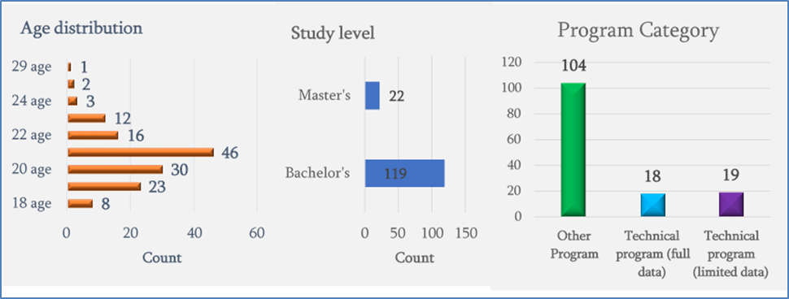

3. Students’ Skill Gap Analysis
The surveys conducted within the framework of the DIGITECH project aimed to assess the level of students’ digital skills and to identify the key areas where skill gaps exist. The analysis is based on responses from Sections B, C, and F of the student questionnaire, as well as Section C of the academic staff questionnaire.
The survey results indicate that students generally possess a certain level of basic digital tool competencies; however, significant gaps exist in several advanced technological areas. These gaps are particularly evident in skills related to data analysis, automation technologies, programming, and Industry 4.0 systems.
The analysis shows that the majority of students demonstrate an adequate level of general digital literacy, but they often experience difficulties when applying these skills to more complex and professionally oriented tasks. At the same time, responses from academic staff also confirm that students encounter certain challenges, particularly in the practical application of technological tools and in the field of data analysis.
The findings indicate the need to strengthen students’ digital competencies, especially in the areas of programming, data processing, automation, and the application of modern digital technologies. The development of educational programs in these areas can contribute to improving students’ competitiveness in the labor market and better preparing them to work in an increasingly digitalized economy.

3․1 Student Digital Skill Gaps in IT Programs
(based on the Student Questionnaire – Sections B, C, and F; Lecturer Questionnaire – Section C; and Workshop data)

Students’ digital skill levels were assessed using a 1–5 scale, where 1 indicates a very low level and 5 indicates a high level of competence.
The results of the analysis indicate that students are relatively confident in the use of general digital tools; however, significant skill gaps exist in several advanced technological areas. The lowest average scores were recorded particularly in the areas of industrial automation and IoT technologies (PLC/SCADA), as well as in the use of cloud computing and DevOps tools. Relatively low scores were also observed in process automation systems, Big Data analytics platforms, and system integration through APIs.
These results indicate that the most pronounced skill gaps among students are related to technologies that represent key components of the modern Industry 4.0 environment. Such technologies are widely used in automated production systems, smart manufacturing solutions, and data-driven management systems. Therefore, the limited level of these competencies may somewhat restrict graduates’ competitiveness in the labor market.
The analysis of students’ responses also shows that their overall digital competencies are generally at a moderate level. A significant proportion of students rated their digital skills as average or above average, which indicates the presence of a basic level of digital literacy. However, the lower scores recorded in advanced technological competencies demonstrate a gap between general digital literacy and professional digital skills.
The analysis also shows that the range of digital tools used by students during their studies is relatively limited. Students most frequently use spreadsheet software (such as Excel), programming languages (Python, C++, C#), as well as AI-based chatbots and text-generation tools. At the same time, tools and technologies widely used in modern digital production environments—such as cloud platforms, DevOps environments, or industrial automation systems—are used comparatively less frequently. This suggests that students still have limited experience in working with more complex and specialized digital systems.
Students’ responses also demonstrate a growing interest in the use of artificial intelligence tools. At the same time, the survey results indicate the need to further develop students’ AI literacy, particularly in the areas of critically evaluating AI-generated information, ensuring the ethical use of AI systems, and formulating effective prompts. These competencies are especially important in a context where AI tools are rapidly being integrated into both educational processes and the labor market.
The results of the lecturer survey also confirm certain limitations in students’ digital competencies. According to lecturers’ assessments, students often experience difficulties in applying theoretical knowledge to practical problem-solving. In particular, challenges are noted in understanding programming logic, data analysis, and the integration of different technological systems. This suggests the existence of a gap between theoretical knowledge and its practical application.
Observations obtained during the two workshops further highlight that students need to develop not only specific technical skills but also analytical thinking, problem-solving abilities, and the capacity to design technological solutions. Effective performance in the IT field requires not only programming knowledge but also systems thinking and an understanding of the interconnections between different digital technologies.
Overall, the analysis indicates that educational programs in information technologies should particularly strengthen the teaching of advanced digital technologies, expand the practical and project-based learning components, and ensure more active student engagement in the use of modern digital platforms and technological tools. Such an approach can contribute to the development of students’ digital competencies and better prepare them to work in a rapidly digitalizing economy.

3․2 Student Digital Skill Gaps in Business Administration Programs
(based on the Student Questionnaire – Sections B, C, and F; Lecturer Questionnaire – Section C; and Workshop data)

The digital skill levels of students enrolled in Business Administration and Economics programs were assessed using a 1–5 scale, where 1 indicates a very low level and 5 indicates a high level of competence. The analysis results indicate that most students possess a moderate level of digital competencies; however, certain skill gaps are observed in the application of several advanced digital technologies.
The three diagrams below present the results of the confidence in the use of digital tools of students of the Master's degree programs in "Business Administration (BA), "Finance" (Economics-Ec) and "Informatics and Applied Mathematics (IAM)", where the scores 1-5 are grouped into 3 groups: low (1-2), Neutral (3), High (4-5) and the Mean scale of average scores. The results are presented in ascending order of average score.
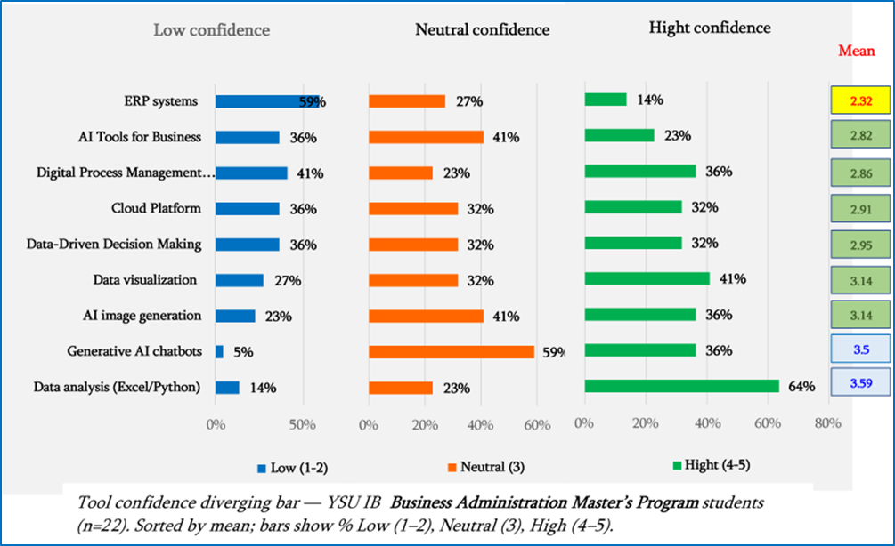
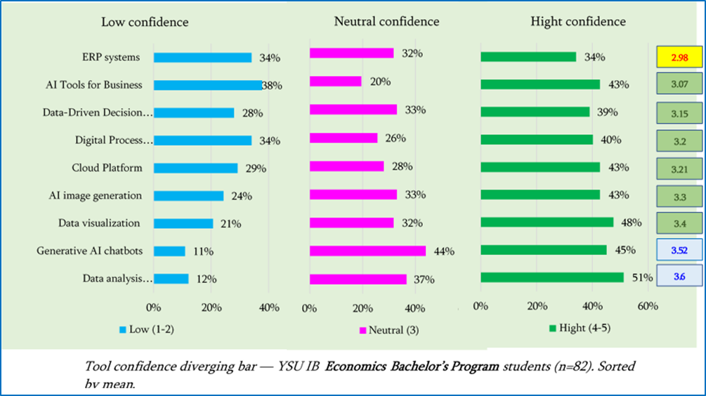
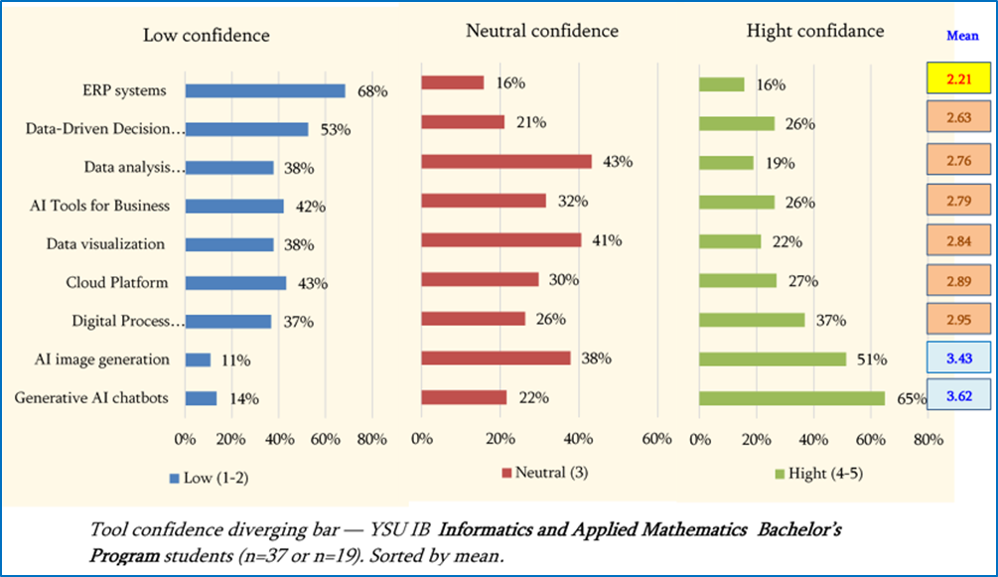

The analysis of these results shows that the students of the branch have skill limitations, in particular:
- in the area of ​​knowledge and application of the ERP system for resource planning, which has the lowest score for students of the three programs considered. For BA, the average score was 2.32, with only 14% of the 22 participants having a high level of confidence, and 34% having a very low level; for Ec students, the average score was 2.98 and 34% of the 82 participants having the lowest level; for IAM students, the average score is 2.21, which is a very low score for informatics; 68% of the 19 students who answered the question have a low level of knowledge of this system,
- in the field of digital business management systems (Digital Process Management systems): for BA the average score was 2.86, with 41% of the 22 participants having a low level of confidence, for Ec: 3.2 (34%), for IAM: 2.95 and 37% of the 19 students who answered the question having a low level of understanding of these tools),
- in the fields of application of digital platforms used for data-driven decision making (Data-Driven Decision Making tools): for BA the average score was 2.95 and 36% of the participants having a low level of confidence, for Ec: 3.15 and 28% having low confidence, for IAM: 2.63 average score and more than half of the 19 students having low knowledge).
In addition, some students have limited experience in using technologies that are widely used in today's digitalized business environment, such as cloud services (BA: 2.91, Ec: 3.21, IAM: 2.89 average scores), the use of AI tools in business (2.82, 3.07, and 2.79 average scores, respectively), and a low level of confidence and understanding is observed among approximately one third of students.
The analysis of student responses also shows that economics students have relatively high confidence and understanding of data analysis tools (Excel/Python), with an average score of 3.6. This means that general-purpose digital tools are most often used in the learning process, such as spreadsheets (Excel), the Python programming language, presentation tools, and in some cases, digital tools based on artificial intelligence. It is obvious that knowledge of these tools stems from their profession and the presence of practical courses in data processing in the curricula. At the same time, more specialized business analytics tools and data management systems, which are widely used in modern organizations, are relatively underused.
Let us present comparative diagrams of the results of students from three educational programs on confidence and knowledge of digital tools by individual tools:

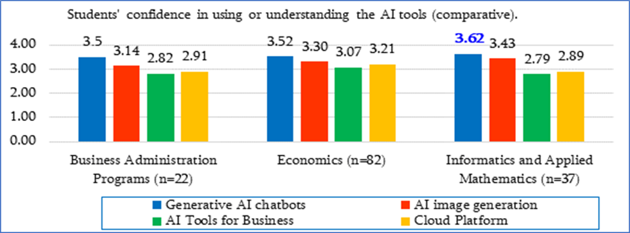
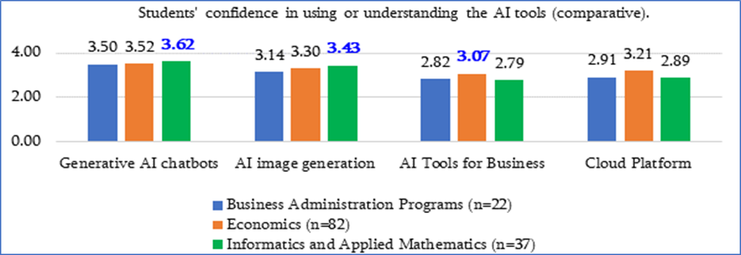
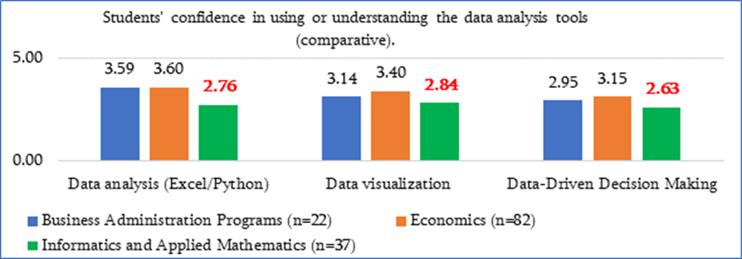
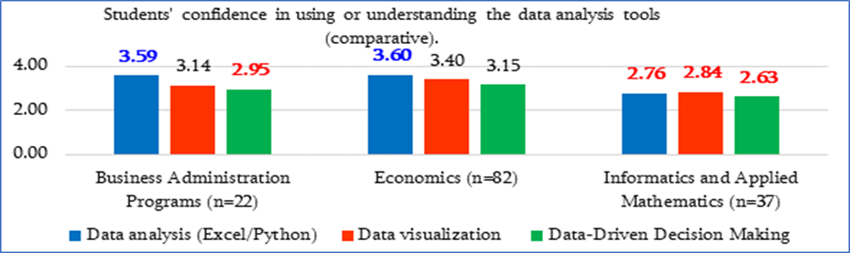
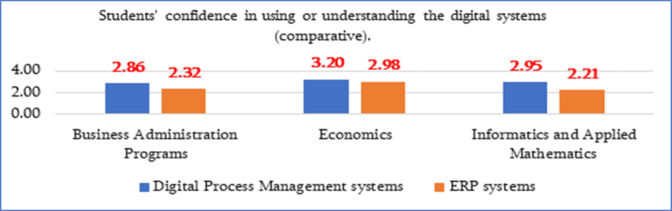
Only 18 students from the "Informatics and Applied Mathematics" educational program answered the question about knowledge and confidence in digital tools, process automation, machine learning, big data analysis, and IoT technologies. The results are presented in the diagram in ascending order of average scores.
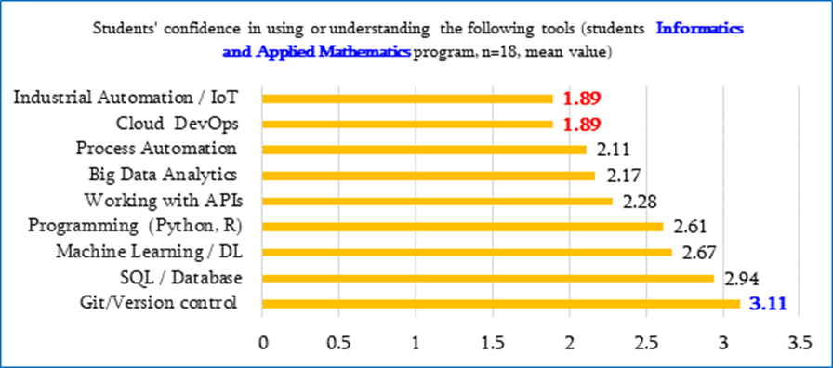
The analysis of these results shows that IAM program students have presented relatively high results in terms of knowledge and confidence in the Python programming language, machine learning, databases and the Git environment, the average scores are in the range of 2.61 to 3.11. These are, of course, not high results, but the confidence in them is due to the fact that according to the curriculum of the educational program, students study and use all the mentioned tools.
Here, the knowledge of artificial intelligence, cloud platform, industrial toolkit, big data processing tools is open to students of this program. In this direction, significant processes of educational and technical improvement are being carried out at the Faculty of Natural Sciences of the branch: the educational program is being revised and the curriculum already includes theoretical and practical courses, internships aimed at developing students' knowledge and abilities in this direction, and graduation theses covering these topics have been added. The creation of laboratories of the necessary capacity and technically equipped will create an opportunity to develop the level of students' knowledge of digital knowledge and the use of digital tools.
Conclusion:
AI tools are relatively confidently used by students of the Informatics and Applied Mathematics program (the highest score is 3.62 average points), and business-related tools are used by students of the Economics program (the highest score is 3.62 average points).
Data processing tools are relatively well mastered and used confidently by students of the Economics program, but this is a problem for students of the Informatics and Applied Mathematics program.
So far, students of all programs have problems with managing digital processes and working with systems.
The results of the lecturer survey also indicate the need to further develop students’ analytical thinking, data-related competencies, and the practical application of digital tools. According to lecturers’ assessments, students often possess sufficient theoretical knowledge; however, they experience difficulties in applying this knowledge when analyzing real business situations and solving practical problems.
Overall, the analysis indicates that Business Administration educational programs should particularly strengthen the teaching of data analysis tools, the use of digital business systems, and the integration of AI and data-driven technologies into the educational process. Such an approach can contribute to the development of students’ digital competencies and better prepare them to work effectively in a modern digitalized business environment.

3.3 Student Soft Skills Gaps
(based on the Student Questionnaire – Section B; Lecturer Questionnaire – Section C; Workshop and Focus Group Data)

The assessment of the level of soft skills development among students of the Faculties of Natural Sciences and Economics at the Ijevan Branch of Yerevan State University is based on the analysis of responses from Section B of the student questionnaire as well as Section C of the lecturer questionnaire. The analysis was also supplemented by observations obtained during focus group discussions organized within the framework of the DIGITECH project.
The results of the analysis indicate that although students possess certain professional knowledge and basic digital skills, there are still developmental needs in the area of soft skills. These skills are particularly important in the context of the modern labor market, which requires not only technical knowledge but also effective communication, collaboration, and the ability to solve problems collectively.
The survey results show that for some students there is a need to further develop critical thinking, problem-solving abilities, as well as effective communication and teamwork skills. These competencies play an important role both in the educational process and in future professional activities.
The diagram below presents the analyzed results of the responses of students of the Master's degree program "Business Administration" on tasks and soft skills. The diagram shows the percentage results for low and high levels of these skills and the corresponding average scores. The results are presented in ascending order of average score.
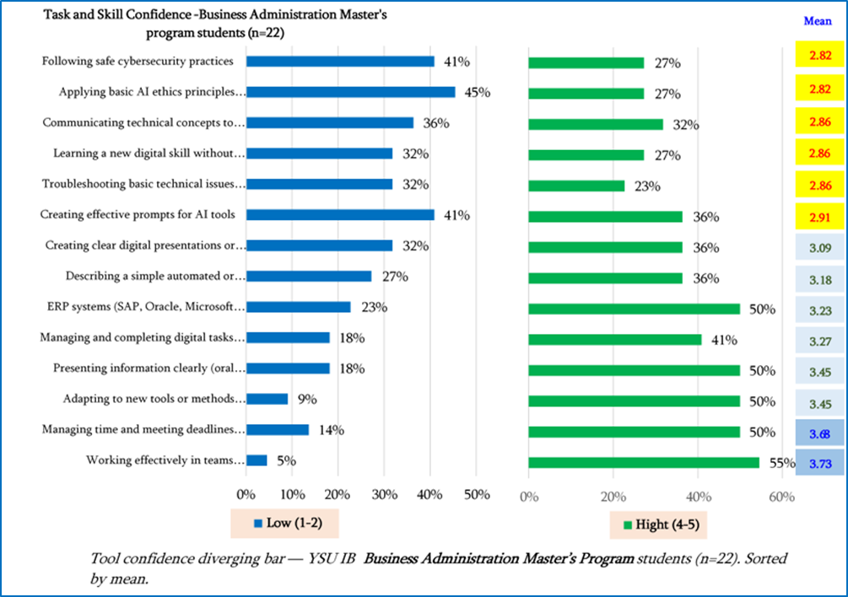
The presented results show that the following skills are quite low among BA students:
- Applying basic AI ethics principles and Following safe cybersecurity practices – 2.82,
- Learning a new digital skill without guidance, Troubleshooting basic technical issues independently and Communicating technical concepts to non-technical audiences - 2.86,
- Creating effective prompts for AI tools - 2.91,
and in general these skills are low among 32-45% of the 22 students who participated in the survey.
The results for several skills are also not high, on average from 3.09 to 3.27.
It should be noted here that students of this program believe that they have confidence in the following skills they have acquired during their studies:
- Presenting information clearly (oral and written) and Adapting to new tools or methods quickly – 3.45,
- Managing time and meeting deadlines independently – 3.68,
- Working effectively in teams – 3.73.
The following diagram presents the opinions of students of the “Finances” (Economics) educational program of the Faculty of Economics on tasks and soft skills, expressed in percentages and averaged results.
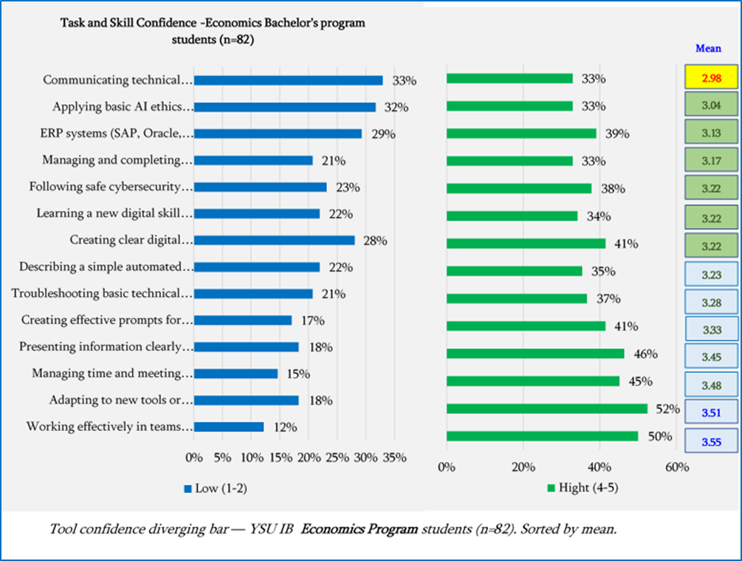
The presented results show that the level of the following skills is quite low among the students of the Ec program: Applying basic AI ethics principles and Communicating technical concepts to non-technical audiences – 2.98, 3.04. For the remaining skills, the students showed an average of 3.04-3.33 results.
It should be noted here that the students of the Ec program are confident in their acquired team working skills – 3.55 and in their ability to quickly adapt to new tools and methods – 3.51.
The following diagram presents the level of tasks and soft skills based on the results of the students of the “Informatics and Applied Mathematics” educational programs. The results are presented in ascending order of average score.
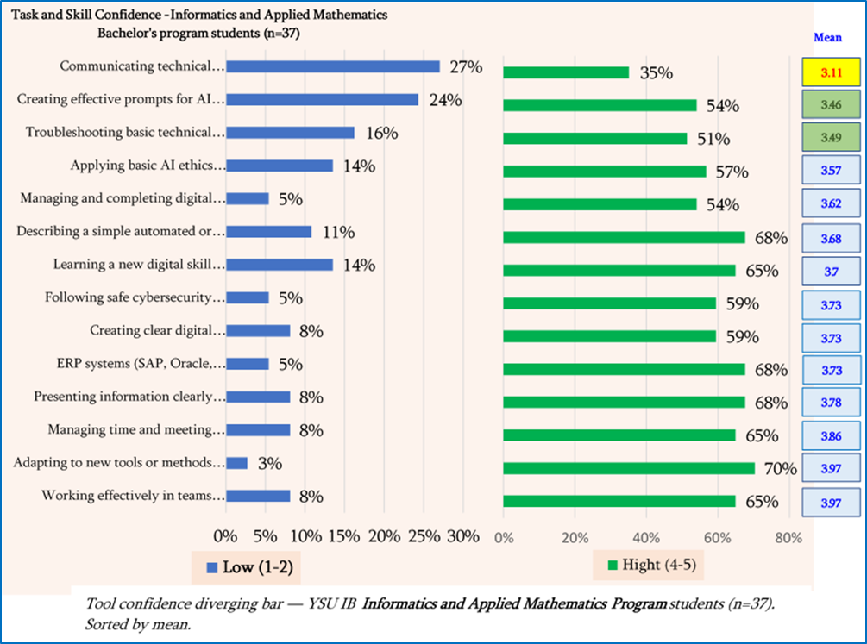
These results show that IAM Program students are quite confident in the soft skills they have acquired and have an average score of 3.97 for working in a team, 3.97 for quickly mastering new tools and methods, 3.86 for time management, etc. Here, the level of skills for communicating professionally with a non-professional audience is low, 3.11. To develop such skills, meetings and discussions with professional and non-professional audiences, practical work with an audience with a different contingent, etc. are more needed.
The following diagrams present the comparative results obtained for tasks and soft skills of students of the 3 educational programs. Students Task and Skill Confidence are arranged in descending order of average scores of students of the Informatics and Applied Mathematics program.

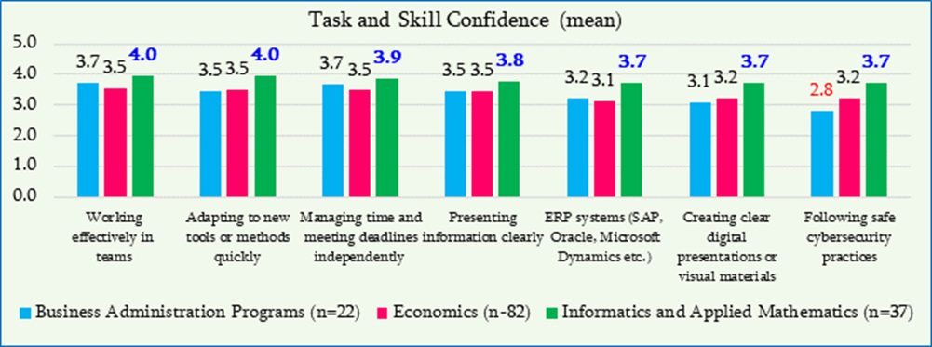
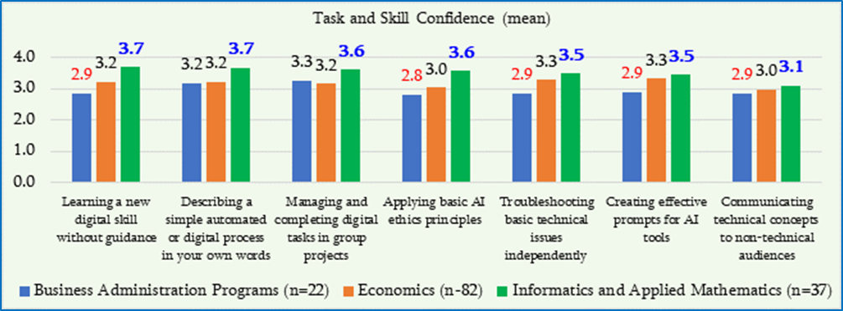
The analysis of lecturers’ responses also indicates that students sometimes experience difficulties when applying their knowledge to solve complex or multi-component problems. According to lecturers’ observations, greater attention should be given to the development of students’ analytical thinking, independent work skills, and collaborative teamwork abilities.
Observations obtained during the two workshops organized for students and lecturers of the YSU Ijevan Branch further emphasize that working effectively in a modern digitalized and technological environment requires not only the development of technical skills but also the strengthening of interpersonal and communication competencies. In particular, the ability to work effectively in teams, clearly present technical ideas, and engage in interdisciplinary collaboration is considered especially important.

4. Student AI Competence and Usage Readiness
(based on the Student Questionnaire – Section B and additional sources)

The assessment of students’ competencies and readiness to use Artificial Intelligence (AI) tools among students of the Faculties of Natural Sciences and Economics at the Ijevan Branch of Yerevan State University was conducted based on the analysis of responses from Section B of the student questionnaire. The analysis was further complemented by observations obtained during two workshops organized within the framework of the DIGITECH project.
The survey results indicate that a significant proportion of students are already familiar with artificial intelligence tools and use them in the learning process. In particular, the average confidence level in using AI-based chatbots is approximately 3.55 out of 5, indicating that students actively use such tools, mainly for information search, preparation of academic assignments, and idea generation.
At the same time, the analysis shows that students’ competencies need to be further developed in several areas. Lower scores were recorded in the critical evaluation of AI-generated information (average score of approximately 3.08) and in the understanding of the ethical use of AI technologies (average score of approximately 3.02). This indicates that although students use AI tools, the skills required for their effective and responsible application are not yet fully developed.
In addition, the survey results indicate that the use of AI tools by students is primarily limited to information search and the preparation of textual materials. Comparatively fewer students make use of AI capabilities related to data analysis, business process automation, or support in solving technological problems. This suggests the need to further develop students’ AI literacy and encourage a more diverse application of AI technologies in the educational process.
The diagrams below show the scope and level of use of the tools they use in their courses, projects, or assignments.
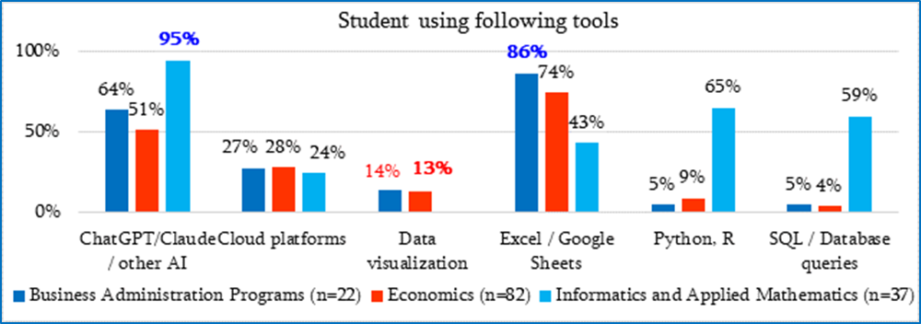
These results show that 95% of the 37 students who participated in the IAM program survey use artificial intelligence tools, that is, these tools have become integral tools for students of the informatics specialty, this activity is due to the large-scale independent work carried out by students in almost all courses, the implementation of research work and the requirements of graduation theses covering modern topics in the field. They also quite actively use databases and the SQL language - 59%, the Python language, which is due to the presence of relevant courses in the curriculum: Databases, Machine Learning, Mathematical Modeling.
Ec program students successfully and actively use Excel spreadsheets - 74% and artificial intelligence tools - 64%.
Here, the gaps and low results in specific educational programs are mainly due to the requirements of the specialty and, to some extent, also to the low interest of students.
Let us present the opinions of students on the frequency of their use of spreadsheets, programming languages, AI chatbots, databases, Git and Cloud platforms.
The diagram presents the numerical average opinions of students from 3 educational programs on the level of use of the mentioned tools. The calculation of the frequency of use was carried out according to the following principle: 1 point for the answer “Never”, 2 for “Monthly”, 3.5 for “Weekly”, 5 points for “Daily”.
The following results were obtained:
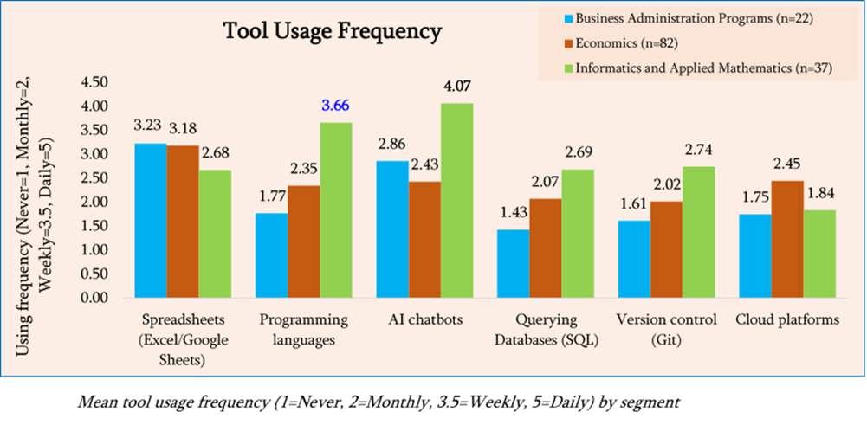These results show that programming languages, AI chatbots, and tools are clearly successfully used by IAM program students as professional tools and directions, and spreadsheets are successfully used by economists, etc.
Overall, the analysis indicates that students demonstrate a growing interest in artificial intelligence technologies and are willing to use them both in their studies and in their future professional activities. At the same time, there is a need to strengthen the systematic teaching of AI tools and to further develop students’ critical thinking, digital responsibility, and data-driven thinking, which will contribute to the more effective and responsible use of artificial intelligence technologies in both educational and professional environments.

5. Industry 4.0 Readiness in Students
(based on the Student Questionnaire – Section D)

Only students of the Informatics and Applied Mathematics program (n=18) mentioned practical applications of "Industry 4.0" technologies (e.g., integration of artificial intelligence with physical systems, connection of software with equipment/sensors, automation), readiness to work in a highly automated environment with artificial intelligence, and interest in professional laboratory courses.
This factor is important when assessing Industry 4.0 readiness, as students enrolled in technical programs typically have greater exposure to digital technologies, automation systems, and the digitalization of production processes.
The results of the analysis indicate that some students have a general understanding of Industry 4.0 technologies; however, their practical experience in applying these technologies remains limited. In particular, students demonstrate comparatively lower competencies in the practical use of industrial automation systems, smart manufacturing systems, and digital production technologies. This suggests that there is a need to further develop not only theoretical knowledge but also practical competencies related to the application of these technologies.
At the same time, the survey results indicate that students demonstrate interest in Industry 4.0 technologies. There is noticeable interest in digital production systems, smart technologies, and the potential applications of Digital Twins.
Now, let's present quantitative data on the activity and quality of students' knowledge and application of individual areas of Industry 4.0 technologies through diagrams.
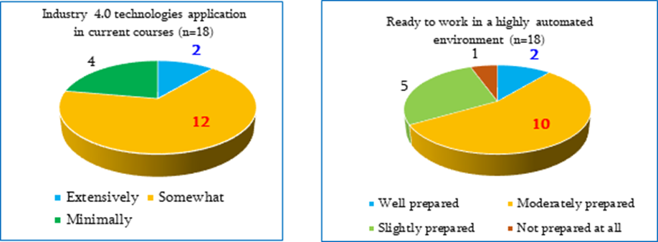
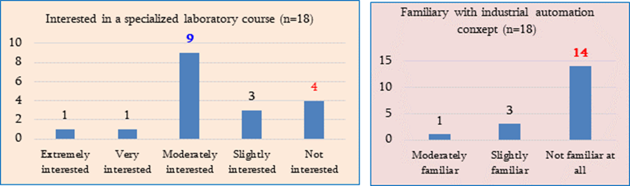
These results show that:
- students are not familiar with the integration of artificial intelligence with physical systems, software with hardware/sensors, and automation processes in their courses (12 out of 18 students stated this),
- 10 out of 18 students (55.6%) are moderately prepared to work in a highly automated environment,
- half of the students have moderate interest in specialized laboratory courses on digital twins,
- 77.8% (14) of them are completely unfamiliar with the concepts of industrial automation.
It is also interesting to observe the results that reveal the students' opportunities and directions for self-education, overcoming problems, and self-development. All 141 students of 3 educational programs answered these questions and the following facts and existing problems for ensuring the future and progress were recorded.
When asked who they would turn to or how they would behave when encountering technical problems, students equally chose almost all of the proposed options. The following diagram presents the students' attitude towards this issue.
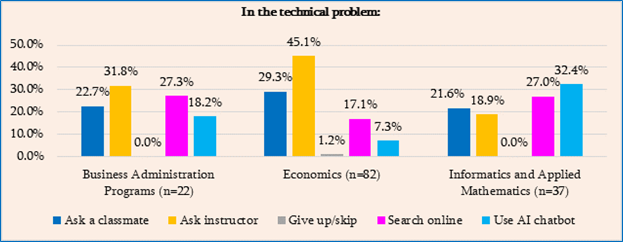
These results show that, for example,
- BA program students will turn to a classmate in case of problems - 22.7%, 31.8% of them (7 students) will turn to a lecturer, 27.3% will search online and a smaller number will turn to artificial intelligence for help. In other words, students certainly expect support from their lecturers and options to overcome on their own.
- 45% of 82 students (37 students) of the Ec program also trust, value their lecturers and expect their support, and 24% will turn to classmates, a fairly small number of students will use AI services.
This means that modern technologies are not yet widely used by economics students, or they simply prefer to communicate with their fellow students and teaching professors, or they do not yet have the necessary skills and abilities to work with artificial intelligence; This is clearly a significant gap for economics students and it is necessary to support students in acquiring these skills with appropriate additional or mandatory special courses.
But here is a different picture among IAM students. Out of 37 students, 10 will look for information on solving technical problems they have online, and 12 will turn to artificial intelligence. Despite these results, not all students are able to freely operate on online platforms and with artificial intelligence.
Answering the relevant question within the framework of the survey, students made a choice from the list offered as the main sources of development of their digital skills: friends, social media, online courses, self-education, university courses and trainings organized by the university, as a result of which we have the following picture:
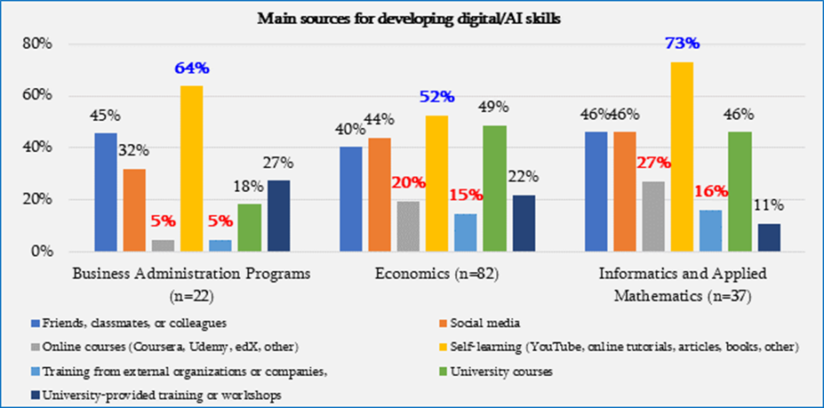
These results show that the majority of students in the 3 educational programs develop their digital skills through self-education, through online materials and books, in particular, this indicator was 64% for BA, 52% for Ec, and 73% for IAM. These are quite high indicators and prove the confidence and opportunities of the students of the branch in their knowledge and abilities. The next highest indicator is the friends, respectively 45%, 40%, 46%.
Self-development, of course, is a laudable argument and here it should be noted that the main tools among these self-development opportunities are online systems.
Overall, the analysis indicates that students’ knowledge and skills related to Industry 4.0 technologies are still in a formative stage and require further development. In this regard, it would be beneficial for educational programs to expand instruction related to Industry 4.0 technologies and to ensure more active student involvement in practical projects, laboratory work, and technological experimental environments.

6. Employer-Identified Skill Gaps
(based on focus group data and additional sources)

To assess the alignment of educational programs at the Ijevan Branch of Yerevan State University with labor market requirements, studies of the opinions of external stakeholders and employers are conducted regularly. This process is carried out within the framework of the branch’s internal quality assurance system and aims to identify the level of professional preparedness of graduates, as well as the skills most demanded by the labor market.
For this purpose, several surveys are conducted at the branch, particularly surveys of external stakeholders regarding graduates and surveys carried out within the framework of internship organizations. These surveys assess students’ practical competencies and the effectiveness of their performance in real working environments.
The survey results indicate that employers generally provide a positive assessment of the professional preparedness and practical skills of the branch’s graduates. According to employers, graduates possess sufficient professional knowledge, diligence, and work discipline; they are able to collaborate in teams and communicate effectively within the workplace. In addition, employers emphasize graduates’ ability to work with information technologies, which is considered an important competitive advantage in the modern labor market.
Special attention is also given to digital skills. The survey results indicate that graduates generally possess basic knowledge of information technologies and are able to apply them in their professional activities. However, according to employers’ observations, the potential for applying these skills has not yet been fully utilized. This particularly concerns the more advanced use of digital tools, data processing, and the integration of technological solutions into work processes.
In addition to issues related to professional and practical competencies, the comparative analysis of the conducted studies also highlights certain institutional and educational environment challenges. In the context of the rapid development of modern technologies, it is important to ensure an appropriate educational and technological environment within universities that enables students to more actively use digital tools and innovative technologies in the learning process.
From this perspective, continuous support for the professional development of academic staff is also important, particularly in the areas of digital technologies, artificial intelligence, and Industry 4.0 solutions. In the modern educational environment, lecturer training and the introduction of new teaching methods are essential prerequisites for the effective development of students’ digital and technological competencies.
In addition, it is important to develop a learning environment that encourages student participation in practical projects, interdisciplinary collaboration, and the application of technological solutions to real-world problems. Such an approach can contribute both to the development of students’ professional competencies and to their more effective integration into the labor market.

7. Challenges in Technology-Enhanced Teaching
(based on the Lecturer Questionnaire – Section B)

The analysis of responses from 33 lecturers from the Faculties of Natural Sciences and Economics at the Ijevan Branch of Yerevan State University indicates that the application of technology-enhanced teaching is generally viewed positively; however, a number of challenges arise in its effective implementation.
According to lecturers, the integration of digital technologies into the educational process can significantly contribute to improving teaching effectiveness, increasing student engagement, and enhancing students’ digital competencies. At the same time, certain limitations exist that hinder the broader use of technologies. These limitations are related both to organizational and infrastructural factors and to the need for further professional development of lecturers.
The survey results indicate that for the effective development of technology-enhanced teaching, it is necessary to address both technical and organizational issues while also ensuring the continuous professional development of lecturers in the field of digital technologies.
These challenges are presented in more detail in the following subsections.

7.1 Structural and Infrastructure Barriers
(based on the Lecturer Questionnaire – Sections B and D)

The analysis of lecturers’ responses indicates that the implementation of technology-enhanced teaching is in some cases limited by structural and infrastructural factors.
In particular, lecturers report certain limitations related to the availability of specialized software, the effective use of digital learning platforms, and in some cases the availability of appropriate technical equipment. These factors may partially limit the broader application of modern digital technologies in the educational process.
In addition, the effective implementation of technology-enhanced teaching requires appropriate technical support and an organizational environment that assists lecturers in the use of digital tools.
The results of the analysis indicate that the continuous development of the university’s digital infrastructure is an important prerequisite for the effective integration of technologies into the teaching and learning process.

7.2. Lecturer Upskilling Gaps
(based on the Lecturer Questionnaire – Sections C and E)

The analysis of lecturers’ responses indicates that the effective implementation of technology enhanced teaching also requires the continuous development of lecturers’ digital and technological competencies.
According to the survey results, some lecturers note the need to expand training opportunities related to the use of digital technologies in order to enable them to more effectively utilize new digital tools in the teaching process.
In particular, lecturers express interest in developing their competencies in the following areas:
the effective use of digital learning platforms, the application of data analysis and digital tools, the integration of artificial intelligence tools into the teaching process, and the use of innovative and technology-based teaching methods.
Overall, the analysis indicates that expanding professional development opportunities for lecturers can significantly contribute to the effective implementation of technology-enhanced teaching and to the development of students’ digital competencies.

8. Strategic Prioritization Matrix for Skills Development
(based on the two-dimensional analysis of skill gaps and employer demand)

The strategic prioritization matrix for skills development was developed based on the results of the needs analysis, incorporating the analysis of student and lecturer questionnaires as well as the perspectives of external stakeholders and employers. The matrix is based on the combination of two key criteria: the level of labor market demand and the existing skill gaps among students. This approach makes it possible to identify those areas where educational interventions may have the greatest impact.
The results of the Needs Analysis indicate that the modern labor market requires professionals who possess not only domain-specific knowledge but also well-developed digital and analytical skills, as well as the ability to apply technological solutions in professional practice. At the same time, the analysis of the surveys indicates that students generally possess basic competencies in the use of digital tools; however, the depth of their application and the broader use of technological solutions still require further development.
Based on the combination of these two criteria, several priority areas for skills development have been identified.
Skill Area | Labor Market Demand | Skill Gap | Priority Level
Application of digital tools and technologies | High | Medium | High
Data analysis and digital data processing | High | High | Very High
Application of artificial intelligence tools | High | High | Very High
Practical application of IT skills | High | Medium | High
Teamwork and communication skills | High | Medium | High
Problem-solving and analytical thinking | High | Medium | High
Leadership and initiative | Medium | Low | Medium
Interdisciplinary collaboration | High | Medium | Medium

The analysis of the matrix indicates that the highest priority is assigned to those skills that simultaneously demonstrate high demand in the labor market and significant development needs among students. In particular, this category includes data analysis competencies, the application of artificial intelligence tools, and the more advanced use of digital technologies in professional practice.
At the same time, certain skills—such as communication and teamwork—are already positively assessed by employers; however, their continuous development remains important for maintaining graduates’ competitiveness.
Overall, the strategic assessment indicates that the further development of educational programs should particularly focus on strengthening digital and technological competencies, expanding students’ practical experience, and integrating innovative technologies into the learning process.

9. Recommendations for Actions

The results of the conducted needs analysis indicate that the further improvement of educational programs should particularly focus on strengthening students’ digital and technological competencies, as well as developing practical skills and competencies aligned with labor market requirements. To achieve this goal, several actions are proposed that can contribute to the modernization of the educational process and enhance the competitiveness of graduates.

First, it is important to ensure the more active integration of digital and technological components into educational programs. This includes incorporating not only dedicated courses but also specific topics related to data analysis, the use of digital tools, and artificial intelligence technologies within existing course curricula. Such an approach can contribute to deepening students’ digital competencies and preparing them to work in modern technological environments. [Linked findings: F1 (AI chatbot overreliance), F5 (AI eval confidence vs. practice; Confirmed at YSU), F8 (no formal AI training received). Evidence layers: student survey + lecturer survey. Status: addresses a Confirmed deficit at YSU on AI evaluation/ethics; integration approach (embedding into existing curricula) aligns with Part I implication that response should be cross-course rather than a standalone module.]
The second important direction concerns the expansion of students’ practical experience. For this purpose, it is necessary to strengthen cooperation with employer organizations, expand internship opportunities, and encourage students’ participation in real projects and applied problem-solving activities. Such experience will enable students to apply their theoretical knowledge more effectively in practical environments. [Linked findings: F7 (self-learning dominates; Confirmed at YSU), F9 (theory–practice gap; Partial at YSU), F11 (employer priority convergence; Partial at YSU). Evidence layers: student survey + lecturer survey + employer focus group. Status: addresses a Confirmed deficit at YSU on practical/applied experience; treat employer-cooperation expansion as ongoing implementation rather than one-off action.]

The third important direction is related to the professional development of academic staff. In the modern educational environment, it is important to ensure continuous training opportunities for lecturers in the areas of digital technologies, artificial intelligence, and Industry 4.0 solutions. This can contribute to the application of innovative teaching methods and the more effective integration of technologies into the teaching and learning process. [Linked findings: F8 (no formal AI training received), F9 (theory–practice gap; Partial at YSU). Evidence layers: lecturer survey. Status: addresses a Confirmed deficit at YSU; should prioritise process-focused pedagogy over tool tutorials (see What Not To Do guardrail on substituting tool training for pedagogical retraining).]

In addition, it is important to further develop the university’s educational infrastructure and technological environment by ensuring access to appropriate digital platforms, software, and technical resources that will enable both students and lecturers to make more active use of modern technologies in the learning process. [Linked findings: F10 (infrastructure/capacity deficit; Partial at YSU per Convergence Summary). Evidence layers: lecturer survey. Status: medium-term investment — infrastructure readiness assessment must precede any applied module launch (see What Not To Do guardrail).]

Standardized Reporting Annex
A. Sample sizes and response rates
Evidence layer | Engaged audience | Responses analysed | Response rate (primary target group)
Students (survey) | 129 (IAM — primary target group) | 141 total (37 IAM + 82 Economics + 22 BA) | 28.7% (37/129) — Met
Lecturers (survey) | 33 (IAM faculty) | 33 | 42.4% (14/33) — Met
Employers (questionnaire) | Partner-ecosystem employers (no fixed denominator) | 68 questionnaires | n/a
Workshop groups | YSU Ijevan students & lecturers | 2 groups | n/a
B. Top-5 gap table (confidence vs. usage vs. demonstrated)
Competency | Stated confidence (1–5) | Usage / curriculum exposure | Demonstrated (workshop)
Industrial Automation / IoT / PLC-SCADA | Lowest in survey; 77.8% (14/18) IAM students completely unfamiliar with industrial automation | 12/18 IAM students report no curriculum integration of AI with physical systems / sensors | Not assessed in YSU workshops
Cloud Computing / DevOps | Low (BA 2.91, Ec 3.21, IAM 2.89 mean) | Used "comparatively less frequently" than spreadsheets/Python (s.3.1) | Not assessed in YSU workshops
ERP / Digital business management systems | Lowest ERP scores: BA 2.32, IAM 2.21; 68% IAM low confidence | Limited experience; not part of standard curriculum exposure | Not assessed
Critical AI evaluation & ethics | Critical evaluation 3.08; AI ethics 3.02 mean (lower than overall AI confidence 3.55) | 95% IAM students use AI tools; 64% Ec students use AI tools (high usage despite low evaluation skill) | Workshop observations confirm AI skills not yet structured
Communicating technical concepts (soft skill) | BA 2.86, Ec 3.04, IAM 3.11 mean | Lecturers note difficulty in interdisciplinary collaboration / clear presentation | Workshop emphasised interpersonal/communication competencies as a gap
C. Employer day-1 requirements summary
- Applied digital skills — using digital tools to solve real business or technical problems, not in isolation (basic IT competence acknowledged; potential under-utilised).
- Data processing and integration of technological solutions into work processes — identified as an area not yet fully developed by graduates.
- Critical evaluation and responsible use of AI — convergent with cross-consortium F11 employer signal.
- Professional execution — teamwork, communication, work discipline; acknowledged as a graduate strength but a continued employer expectation.
D. Standardised prioritization matrix
Quadrant | YSU competencies (mapped from Section 8 matrix)
Critical Gap (high gap + high demand) | Data analysis and digital data processing; Application of AI tools (both rated “Very High” in the matrix).
Curriculum Gap (high gap + moderate demand) | Industrial Automation / IoT / PLC-SCADA; ERP / Digital business management systems — high student gap with employer demand unclear in YSU data; treat as medium-term investments pending readiness assessment (F10).
Monitor (moderate gap + high demand) | Application of digital tools and technologies; Practical application of IT skills; Teamwork and communication skills; Problem-solving and analytical thinking; Interdisciplinary collaboration.
Relative Strength | Leadership and initiative (medium gap, medium demand); spreadsheet use among Ec students (74% active use); AI chatbot use among IAM students (95%).

Armenian State University of Economics (ASUE) – Yerevan, Armenia

Needs Analysis Report
Armenian State University of Economics - (P6)
Project: DIGITECH – “Introduction of Innovative Technologies in Digitalization of Technological Processes and Production” - 101237882 - ERASMUS-EDU-2025-CBHE
Location: Armenian State University of Economics (ASUE), Yerevan, Armenia
Period: February- March 2026 (Workshop was held on March 25, 2026).

92  ASUE Students  Survey respondents |  | 15  ASUE Lecturers  Survey respondents | 6  Industry Partners  Employer questionnaires | 3  Workshop Groups  3 scenarios

Executive Summary
This report outlines the findings of the DIGITECH Erasmus+ Needs Analysis conducted for Armenian State University of Economics (ASUE), Armenia. It is based on self-reported student and academic stuff confidence surveys (n=57).

1. Introduction and methodology
The present report reflects the results of the working meetings and discussions conducted within WP2 of the “DIGITECH” project, which was selected for funding under the Erasmus+ CBHE 2025 call. The study aims to assess the technical competencies of students and academic staff of ASUE and to triangulate these findings with the requirements of the labor market. According to this, the workshop objective was to support participants in identifying gaps and priority needs for integrating digital technologies into ASUE curricula, ensuring alignment with labor market demands and DIGITECH project objectives.
The workshop were held with the following focus groups:
Faculty, staff and students from:
Chairs of the Faculty of Information Technologies and Data Science of the ASUE:
- Chair of Statistics and Data Science
- Chair of Actuarial and Financial Mathematics
- Chair of Business Information Systems and Information Technologies
Representatives of the business sector.
Workshop comprised the following activities:
Key digital trends were introduced, including:
- Artificial Intelligence applications in education and business
- Data-driven decision-making
- Growing demand for digital and green skills
Participants discussed how these trends affect curriculum development and graduate employability. Industry representatives provided practical insights.

2. Students skill gap analysis
2.1 Key Findings: Students
The following trends were identified based on students’ self-assessments and practical work:
Technological Directions: Students self-assessment of overall digital/technical skills shows “Intermediate” as the higher indicator, then “Basic” and “Advanced”. Important, that the “Very Advanced” category is only 1.1% of respondents (Chart 1).
Chart 1. Students self-assessment of overall digital/technical skills

The big gap between the “Intermediate” and “Very advanced” (more than 45%) means uncertainty of measurement and understanding of skill levels.
In terms of confidence in using digital/technical tools, students’ self-assessment indicates interesting transformation in last few years: Machine-learning and Deep-learning that was leading priority in last decade, have retreated now to last place, giving up his position to Generative AI Chatbots (Chapter 2.). The difference that is more than 40% of respondents means significant change of behavior and attitude towards new technologies. However, comparative analyses with the self-assessment of digital skills shows the intermediate level of using AI tools.
Chart 2. Students self-assessment of overall digital/technical confidense

3. Student Usage Industry Readiness, 4.0 Readiness in Students
Based on the results obtained, we can conclude that the current level of practical application in courses in relation to Industry 4.0 is widely used: about 35%. But “very widely” category is only 1.3%. The big difference shows the lack of understanding of the meaning of these categories.
Chart 3. Inclusion of practical industry 4.0 application in courses

The next direction of survey was exploration of tools actually used in the courses. In this context “Excel/Google sheets”, “AI Chatbots” and “Python” are priority directions ranging between 55%-65%. R programming, data visualization and Power BI are in last places with average 11% usage (chart 4.).
Chart 4. Tools actually used in courses/assignment work

In general, the survey among students of ASUE shows the following circumstances.
- Motivation to use new technologies and AI tools are significant, however the applicable practice and capacities are below average.
- New technologies are entering into practical application fast, but the curriculum modernization doesn’t respond quickly.

4. Key Findings: Academic Staff
ASUE lecturers’ survey identified some important features within DIGITECH goal and objectives. In particular, they emphasized limitations and barriers in accepting technological advancements and innovations. However, the limitations in curriculum are not higher (chart 5.), but in infrastructures are higher (chart 6).
Chart 5. Curricular structure limitations on integrating AI/technology
Obviously, “no significant limitation” dominates for curricula adaptation on AI/technologies, however “limitations are present” and “partly limitations” together are 53% that is concerning.
What are about infrastructural limitations and barriers that are about 80%, are significantly hinder to integrate AI/technology in educational processes.
Chart 5. Infrastructural limitations on integrating AI/technology

The next important result of lecturers’ survey is related to the digital/AI competences need to improve. The main results are illustrated in the Chart 6, according to which there are scattered distribution among opinions, however some peculiarities are exist.
Chart 6. Digital/AI competences needing improvement

According to Chart 6, “AI tools for business” competence is most demanded to improve (3.5 among 4). Next important competences based on ranking are “Digital process management”, “Industrial automation” and “Programming fundamentals”. These are the framework of needed changes.

5. Position of the Business Representatives
In the workshop/focus group meeting in ASUE, business representatives emphasized the following key issues:
- Lack of compliance between practice and theory in digital competences: Students come from institutions need significant skill qualification courses, practice and new knowledge to be engaged in the industry.
- Low level of technology-based decision-making: Although the students possess necessary knowledge on technology after graduation, however the technology-driven decision-making methodology is not developed.
- Low level of industrial value-chain development with university support: The universities are participating in industrial value-chain creation with small percentage. The reason is deficit of connectivity mechanism rather than capacity of universities.

6. Key Findings and Recommendations
The results of the questionnaires filled in by the representatives of ASUE in the framework of DIGITECH survey are related to the following aspects.
- AI technologies are widening very fast in the framework of toolkits used by students during their individual works.
- YouTube is one of the best solutions in self-learning.
- The need for standardized and coordinated AI learning in ASUE is demanded for educational proposes.
- University-provided short-term trainings or workshops have a good impact on learning outcomes.
- Online tutorials becoming more and more popular among teaching materials that aren’t correlated technically with Moodle.
- Visualization and analyzing tools through AI technologies are widely used across disciplines and topics.
- Social media is an important source of educational communication.
- Students use AI without necessary level of information and knowledge on the technologies.
- The university don’t support financially the subscription of AI tools, but provides trainings.
- Students and university stuff have limited access to licensed software, specialized digital tools, or industry-grade platforms.
- Low level of skill and experience but high level of AI using brings issues rather than solutions.
- Faster technology change compared with university updates of learning materials and methodologies.
- Limited opportunities to work with AI empowered businesses because of limited number of enterprises.
- Need for laboratories to bridge knowledge and education on AI and machine learning with business.
- Uncertainty in regulations in AI and the practical implementation of AI in research and development.
More than 60% of lecturers are “Early adopter” who mentioned the main challenges they face in providing students with technologically up-to-date education the followings:
- Harmonization of technology, theory and practice,
- Lack of systemic approach,
- Constrained institutional resources, limited access to advanced digital infrastructure,
- Ensuring equal access to modern technologies and tools,
- Students lack basic skills.
The lecturers mentioned that there aren’t limitations in general in study programs to use AI or digital content in study programs, however the administrative process to change curriculums require long time.
In the framework of administrative barriers lecturers mentioned the limited capacities of AI and digital content empowered labs.
On the question about the students’ skill on using AI or digital tools the general answer was “not structured and methodically not approved skill” that means students can’t use the tools within institutional context.
The lack of solid and strong background of students was the generalized answer by lecturers related to the prerequisites of students using AI and digital tools.
The main analyses of the students’ questionaries reflecting again perfunctory understanding on AI and digital content, as well as tools in their educational and research activities, that shows the big gap between the framework they use and standardized approaches. In particular, the survey shows following specifications.
- Answers to the question on the preparation in a highly automated environment where AI agents or Digital Twins are part of the workflow, more than 55% replied “moderately prepared” and “slightly prepared”. In general, the average understanding in this case is dominated.
- The question about the interest in a specialized laboratory course focused on Digital Twins (virtual replicas of physical systems), 75% and higher responses were in favor “interested”.
- The unfamiliarity of industrial automation was about 90% of respondents.
- About 50/50 distribution of self-learning and university courses on digital/AI skills is an important indicator for improvement of curricula.

7. Key Outcomes
- Identification of priority digital skills and curriculum gaps
- Improved understanding of labor market requirements
- Initial curriculum development ideas aligned with digital transformation
- Draft action plans for institutional implementation
- Strengthened collaboration between academia and industry

8. Recommendations / Next Steps
- Integrate identified digital skills into curricula
- Strengthen partnerships with industry stakeholders
- Develop pilot courses or modules (including micro-credentials)

Conclusion/Recommendation

- Improvement digital and AI components in curricula: Emphasizing the digital tools and AI components in curricula will enable ASUE to be actively integrated with the labor market new requirements. Resilient and technology-based curricula is a priority for ASUE, according to the surveys and workshops. [Linked findings: F1 (AI chatbot overreliance; Confirmed at ASUE), F5 (AI eval confidence vs. practice; Partial at ASUE), Evidence layers: student survey + lecturer survey + employer focus group. Status: addresses a Confirmed deficit at ASUE on AI integration into learning — pair with verification-protocol focus rather than additional AI tool exposure.]
- Upskill of Academic Staff on methodical and practical context: Academic stuff need to satisfy new requirement through professional trainings in order to enhancing competencies in digital tools and AI within advanced technologies. [Linked findings: F8 (no formal AI training received), F9 (theory–practice gap; Confirmed at ASUE). Evidence layers: lecturer survey + employer focus group. Status: addresses a Confirmed deficit at ASUE. Caveat: ASUE lecturer feedback specifically AI applications as needed direction for upskilling and harmonized improvement.]
- Strengthening University-Employee Connectivity through Practical Infrastructure: The infrastructure modernization based on improved methodology and enhanced laboratory facilities identified as important strength in the framework of university-employee cooperation. [Linked findings: F10 (infrastructure/capacity deficit). Evidence layers: lecturer survey + employer focus group. Status: hard prerequisite for any applied module. Confirmed deficit response, not medium-term investment.]
- Combination of Theoretical and Practical Skills of Students: Improvement of hard and soft skills are important part of curricula improvement and research capacity upskilling. [Linked findings: F9 (theory–practice gap; Confirmed at ASUE), F11 (employer priority convergence on professional execution; Partial at ASUE). Evidence layers: lecturer survey + employer focus group. Status: addresses a Confirmed deficit at ASUE; cross-consortium elevation of soft skills.]

Standardized Reporting Annex
A. Sample sizes and response rates
Group | Target population | Responses (n) | Response rate | 15% met?
Students (ASUE, Faculty of Inform. Technologies and Data Science) | 500 | 92 | 18.4% | Yes
Lecturers (ASUE, Faculty of Inform. Technologies and Data Science) | 45 | 15 | 33% | Yes
Employers (focus group) | Target 5–8 firms | 6 | Within target | n/a
Workshop (students) | 3 scenarios | 28 (ASUE students at the Faculty of Inform. Tech. and Data Science) | n/a | n/a
B. Top-5 gap table (confidence vs. usage vs. demonstrated)
Competency | Student confidence | Usage signal | Workshop performance
Responsible AI and Ethics | 1.25 out of 4 (31.25%) | Below confidence | Strongly needed to upscale and regulate the field
Digital Twins and Simulation | 1.75 out of 4 (43.75%) | Below confidence | Prioritized within university-business connectivity
Process Automation and Control Systems | 2 out of 4 (50%) | Average | Indicated AI as automation and control tool within digital tween laboratory
Machine Learning/Deep Learning | 1.50 out of 4 (37.5) | Below confidence | Prioritized within curriculum
Soft Skills | 1.75 out of 4 (43.75) | Below confidence | Prioritized within curriculum and laboratory
C. Employer day-1 requirements summary
Establishment of Digital Tweens Laboratory and amendment of curriculum were indicated as major fields of improvement.
“AI tools for business” (ranked 3.5 out of 4) – described as a highly demanded subject by university was prioritized by employers as well.
“Data processing and integration of technological solutions into work processes” — emphasized as a field for university-business cooperation and partnership.
“Industrial Automation, /IoT/ PLC-SCADA” (ranked 3 out of 4) – Considered important direction for transformation from university to business.
AI chatbots identified as the main direction of upskill and improvement through digital tween laboratory.
D. Prioritization matrix
Quadrant (BTU scale) | ASUE competencies
Critical Gap (high gap + high struggle) | Digital twins and simulations, machine learning, soft skills
Monitor (high struggle + relative confidence) | Generative AI chatbots, data-driven decision-making
Curriculum Gap (high gap + moderate struggle) | R, Data visualization, Power BI (10-12% usage)
Relative Strength | Programming fundamentals, digital process management, AI tools for business (3-3.5, out of 4)

Georgian Technical University (GTU) – Tbilisi, Georgia

Needs Analysis Report
Georgian Technical University - (P7)
Project: DIGITECH – “Introduction of Innovative Technologies in Digitalization of Technological Processes and Production” - 101237882 - ERASMUS-EDU-2025-CBHE
Location: Georgian Technical University (GTU); Tbilisi; Georgia
Period: February- March 2026 (Workshop was held on March 4–5, 2026).

50  GTU Students  Survey respondents |  | 17  GTU Lecturers  Survey respondents | 7  Industry Partners  Employer questionnaires | 3  Workshop Groups  3 scenarios

Executive Summary
This report outlines the findings of the DIGITECH Erasmus+ Needs Analysis conducted for Georgian Technical University (GTU), Tbilisi. It is based on self-reported student and academic stuff confidence surveys (n=57).

1. Introduction and methodology
The present report reflects the results of the working meetings and discussions conducted within WP2 of the “DIGITECH” project, which was selected for funding under the Erasmus+ CBHE 2025 call. The study aims to assess the technical competencies of students and academic staff of GTU and to triangulate these findings with the requirements of the labor market.
The working meetings were held with the following focus groups:
- Students;
- Academic staff;
- Representatives of the business sector.
Working meetings comprised the following activities:
- Review of the skills map: identification of digital and AI-related competencies.
- Practical scenario exercises: addressing realistic tasks through data interpretation and the use of AI tools.
- Determination of priorities: ranking of retraining and capacity-building needs.

2. Students skill gap analysis
2.1 Key Findings: Students
The following trends were identified based on students’ self-assessments and practical work:
Technological Directions: Students identify a strong need to enhance their knowledge and skills in modern digital technologies (programming, big data processing, and analytics) as well as in industrial technologies (automation of various processes, robotics, and IoT)
- AI Capabilities: While the use of artificial intelligence (AI) tools is widespread among students, their skills in analytical and critical evaluation, as well as in the purposeful and effective integration of AI into professional and business tasks, continue to pose a challenge.
- Priorities: According to students, the priority areas are deepening their understanding of programming fundamentals and studying industrial automation technologies (PLC–SCADA; Factory), which contribute to their professional development and ensure alignment with modern industrial requirements.
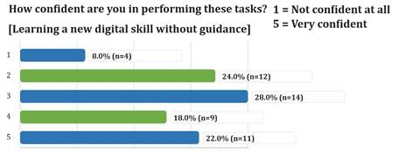
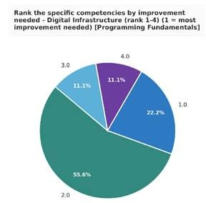
Figure 1. Technical IT skill confidence in students.
3. Student AI Competence and Usage Industry Readiness, 4.0 Readiness in Students
Based on the results obtained, we can conclude that the current level of knowledge and skills is not sufficiently high, particularly in relation to Industry 4.0 and the advanced application of Artificial Intelligence.
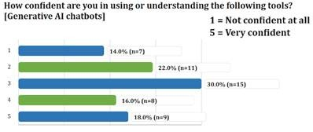
Figure 2. AI skill confidence in students.

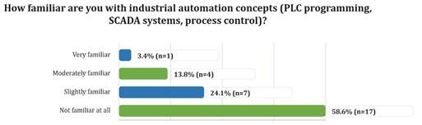
Figure 3. PLC and SCADA systems skill confidence in students.
4. Challenges in Technology - Enhanced Teaching

3. Key Findings: Academic Staff
Lecturers have identified several significant deficiencies that hinder the comprehensive delivery of modern, high-quality education.
- Teaching Challenges: One of the primary obstacles identified is the insufficient knowledge of artificial intelligence (AI) applications, which significantly hinders the effective formulation of tasks and the attainment of desired outcomes.
- Infrastructure Barriers: A major challenge is the outdated computer equipment (including computers, 3D printers, robotics, and other devices), coupled with the limited availability of modern cameras and remote communication tools. In addition, access to licensed software (e.g., Inventor and various simulation programs) is insufficient.
- Competency Challenges: Lecturers have observed that some students face challenges in basic mathematical knowledge, advanced information technology (IT) skills, English language proficiency, and academic writing. Difficulties are also evident in effective time management, which significantly affects full engagement in the learning process.

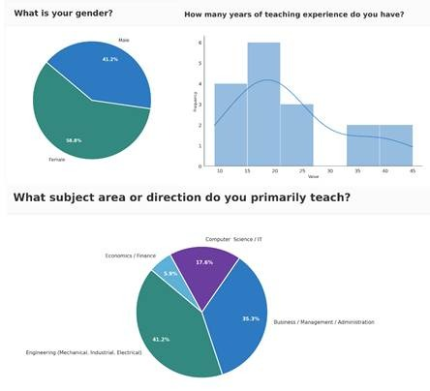
Figure 4. GTU Academic stuff analytics (gender, experience and field)

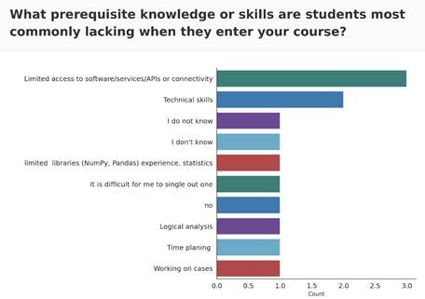
Figure 5. Technical barriers faced by students.

4. Employer-Identified Skill Gaps
4. Position of the Business Sector and Employers
In the focus group meetings held on March 5, business representatives emphasized the following key issues:
- Market Alignment: The need to ensure a stronger alignment between the university’s educational outcomes and the actual requirements of the labor market was emphasized.
- Demand for Innovation and Competencies: Employers consider it particularly important for students to possess advanced competencies in modern technologies. Additionally, they emphasized the significance of developing so-called soft skills and the need for their more systematic integration into curricula, especially within engineering programs.
- Critical Analysis and Risk Assessment Skills: Representatives of the business sector emphasize the need to prepare professionals who can make decisions based on incomplete or imperfect digital data, critically evaluate results generated by artificial intelligence (AI), and identify the potential risks associated with them.

4. Challenges in Technology-Enhanced Teaching
Teaching Challenges: A key challenge identified is the limited understanding of artificial intelligence (AI) applications, which greatly affects the effective design of tasks and the achievement of expected results. Infrastructure Barriers: Another significant issue is outdated computer equipment, including computers, 3D printers, robotics, and other devices, along with the lack of modern cameras and remote communication tools. Additionally, access to licensed software such as Inventor and various simulation programs remains insufficient. Competency Challenges: Lecturers have noted that some students struggle with fundamental mathematical knowledge, advanced information technology (IT) skills, English language proficiency, and academic writing. Challenges in effective time management are also common, significantly reducing full participation in the learning process.
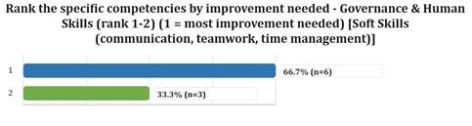
Figure 5. Improvement priority for academic staff.
4. Recommendations for Actions

5. Key Findings and Recommendations
The results of this study revealed that, within the framework of the “DIGITECH” project, the development of the following areas is of particular significance:
- Curriculum Update: Systematic integration of digital technologies and artificial intelligence (AI) capabilities into academic programs, aimed at reducing the mismatch between educational outcomes and labor market requirements.[Linked findings: F1 (AI chatbot overreliance; Confirmed at GTU), F5 (AI eval confidence vs. practice; Partial at GTU), F6 (AI as default problem solver; Confirmed at GTU), F11 (employer priority convergence; Partial at GTU). Evidence layers: student survey + lecturer survey + employer focus group. Status: addresses a Confirmed deficit at GTU on AI integration into learning — pair with verification-protocol focus rather than additional AI tool exposure.]
- Professional Development of Academic Staff: Provision of targeted training and upskilling programs for academic staff, aimed at enhancing competencies in artificial intelligence (AI) tools and advanced engineering graphics software.[Linked findings: F8 (no formal AI training received), F9 (theory–practice gap; Confirmed at GTU). Evidence layers: lecturer survey + employer focus group. Status: addresses a Confirmed deficit at GTU. Caveat: GTU lecturer feedback specifically flags AI applications as “largely problematic” in classroom use — sequence pedagogical retraining ahead of AI tool tutorials (see What Not To Do guardrail).]
- Enhancement of Educational and Research Infrastructure: It is essential to upgrade the university’s teaching and laboratory spaces with modern computer equipment and appropriate simulation software. Equally critical is ensuring the systematic renewal of the existing technological base.[Linked findings: F10 (infrastructure/capacity deficit; Confirmed at GTU — one of only two institutions with Confirmed status on F10). Evidence layers: lecturer survey + employer focus group. Status: hard prerequisite for any applied module rollout — readiness assessment must precede curriculum redesign (see What Not To Do guardrail). Confirmed deficit response, not medium-term investment.]
- Synergistic Development of Professional and General Skills: It is essential to promote the comprehensive and systematic development of both technical (hard) skills and general (soft) skills, such as communication, teamwork, and critical thinking, to better prepare students in line with the requirements of the modern professional environment.[Linked findings: F9 (theory–practice gap; Confirmed at GTU), F11 (employer priority convergence on professional execution; Partial at GTU). Evidence layers: lecturer survey + employer focus group. Status: addresses a Confirmed deficit at GTU; aligns with cross-consortium F11 elevation of soft skills by employers.]
The results of this analysis will be applied in the modernization and further development of the curricula at the Georgian Technical University (GTU).
Key Comments from the Two-Day Working Meetings:
Students:
- I aim not merely to use artificial intelligence (AI) tools (such as ChatGPT, Gemini, etc.) superficially,
- but to integrate them effectively into the learning and research process in order to achieve more accurate and valid results;
- My priority is to acquire high-tech skills in areas such as MLOps and big data;
- I aim to further deepen my knowledge of programming languages (Python, C++);
- I consider it important to master basic digital tools (Advanced Excel, PowerPoint) and graphic software (Adobe Photoshop, Illustrator) at a professional level.
- I am interested in applying artificial intelligence in the creation of visual content.
- I am ready to actively participate in any training or course that will help me transform theoretical knowledge into practical digital skills.
- …
Lecturers
- AI Usage Knowledge: This remains largely problematic; although students use AI tools, they often fail to arrive at correct answers, and the errors are evident;
- At the same time, it is necessary to ensure the continuous updating of laboratory and educational facilities, particularly licensed software (e.g., AutoCAD, Inventor, Catia), computer equipment, robotics, simulators, and other resources;
- I have completed a course on the use of various artificial intelligence (AI) tools and their practical implementation. I am particularly interested in learning from European experiences regarding how our colleagues in Europe are applying these new capabilities;
- I find it both interesting and valuable to receive additional training on integrating digital and artificial intelligence content into existing courses;
- I am interested in the curricula of European universities, including their focus areas and course syllabi.
- …
Business:
- It is critically important for a student to have solid knowledge in their core specialty; however, in today’s reality, this alone is no longer sufficient. Proficiency in modern technologies is already a basic requirement rather than an additional advantage;
- We often observe that new professionals possess technical potential, but face significant challenges in terms of so-called “soft skills.” They struggle with effective communication, teamwork, and the distribution of assigned responsibilities within a group setting;
- One of the main challenges in the workplace is time management. Young specialists often struggle to prioritize tasks and meet deadlines, which directly impacts business productivity;
- We expect professionals capable of using digital tools and artificial intelligence not only to retrieve information, but also to optimize real business tasks.
- It is important for students to develop critical thinking skills; they should be able to verify data provided by AI and make informed decisions;
- We would like the learning process to place greater emphasis on presentation skills and professional ethics, in order to facilitate a faster and smoother integration of new employees into the business environment.
- The business sector is prepared to collaborate closely with the university so that students can develop practical and social competencies during their studies, which they will encounter in real workplace settings.
- …
Note:
In line with the objectives and scope of the project, the target and focus groups were primarily composed of academic staff and students from the Faculty of Transportation Systems and Mechanical Engineering at the Georgian Technical University.

Standardized Reporting Annex
A. Sample sizes and response rates
Evidence layer | Engaged audience | Responses analysed | Response rate (primary target group)
Students (survey) | 250 (Faculty of Transportation Systems & Mechanical Engineering) | 50 | 18.0% (45/250) — Met
Lecturers (survey) | 30 (Faculty academic staff) | 17 | 33.3% (10/30) — Met
Employers (focus group) | Partner-ecosystem employers (no fixed denominator) | 7 | n/a
Workshop groups | GTU students (Mar 4–5, 2026) | 3 groups / 3 scenarios | n/a
B. Top-5 gap table (confidence vs. usage vs. demonstrated)
Competency | Stated confidence | Usage / curriculum exposure | Demonstrated (workshop / lecturer)
Industrial Automation / PLC-SCADA | Low; identified by students as a priority area to deepen | Constrained by outdated equipment, robotics and simulation software (s.3 Infrastructure Barriers) | Lecturers cite as competency gap; not directly assessed in workshops
Critical AI evaluation | AI tools widely used; critical-evaluation skills limited (s.2 Key Findings) | High usage of ChatGPT/Gemini | Lecturers report students use AI tools but often fail to arrive at correct answers
Programming & Big Data analytics | Identified by students as a priority area for further development | Limited; rapid field evolution outpaces curriculum (lecturer-reported) | Not formally assessed; lecturers note theory-practice gap
Foundational skills (math, English, academic writing, IT) | Not directly surveyed | n/a | Lecturers flag as competency challenge affecting full engagement
Soft skills & time management | Not directly surveyed | n/a | Employers & lecturers identify communication, teamwork, deadline management as gaps
C. Employer day-1 requirements summary
- Advanced competencies in modern technologies (Industry 4.0, digital tools) — baseline expectation rather than additional advantage.
- Critical analysis & risk assessment of AI-generated results — ability to make decisions on incomplete/imperfect data.
- Soft skills — communication, teamwork, distribution of responsibilities; time management and meeting deadlines.
- Using AI to optimise real business tasks (not just retrieve information); verifying AI-generated data and making informed decisions.
- Presentation skills and professional ethics — to support smoother integration into the business environment.
D. Standardised prioritization matrix
Quadrant | GTU competencies
Critical Gap (high gap + high demand) | Critical AI evaluation & verification; programming/Big Data analytics for engineering applications — both convergent across student, lecturer and employer layers.
Curriculum Gap (high gap + moderate demand) | Industrial Automation / PLC-SCADA / robotics — identified student priority and lecturer-flagged but constrained by infrastructure (treat as medium-term investment behind F10 readiness assessment).
Monitor (moderate gap + high demand) | Soft skills (communication, teamwork, deadline management); academic English & writing.
Relative Strength | Wide consumer-AI tool familiarity (ChatGPT, Gemini), interest in MLOps/Big Data; students self-report readiness to participate in applied training.

Business and Technology University (BTU) - Tbilisi, Georgia

Needs Analysis Report
March 9th 2026

203  BTU Students  Survey respondents |  | 46  BTU Lecturers  Survey respondents | 7  Industry Partners  Employer questionnaires | 3  Workshop Groups  3 scenarios

Executive Summary
This report presents the findings of the DIGITECH Erasmus+ Needs Analysis for Business and Technology University (BTU), Tbilisi. It is based on a four-layer triangulation methodology: self-reported student confidence surveys (n=203), lecturer-observed student struggle assessments (n=46), industry employer day-1 readiness questionnaires (n=7), and live workshop scenario performance data (3 groups across 3 scenarios).

Key Findings at a Glance
- 64% of Technical students rate themselves low (1–2/5) in Machine Learning / Deep Learning confidence
- 43–44% of Technical students score low in core engineering workflow tools (SQL, Git) — cited as day-1 requirements by 71% of employers
- 6 of 7 employers report changed skill expectations due to AI; 3/7 now hire fewer junior staff
- Problem-solving and communication top employer hiring priorities, outranking university credentials and AI-native capability
- All 3 workshop groups correctly identified AI hallucination (Scenario A), but no group demonstrated a coherent verification process — a consistent workflow gap across all groups
- Lecturers systematically underestimated student cybersecurity awareness in the security-focused scenarios (C and E)

The report identifies three structural misalignments: (1) students claim stronger AI confidence than their critical AI task performance justifies; (2) employer day-1 requirements diverge sharply from demonstrated student capability, particularly in SQL and Git; and (3) lecturer predictions of student capability showed a consistent pattern of underestimation, most pronounced in security-related tasks.

1. Methodology and Sample

1.1 Four-Layer Triangulation Framework
The DIGITECH needs analysis at BTU employs a four-layer evidence model designed to detect discrepancies between self-reported competence and actual performance. Each layer provides a distinct evidence type; convergence across layers strengthens findings, while divergence signals overconfidence, curriculum gaps, or measurement artefacts.

Layer | Description and Evidence Type
Layer 1 — Student Survey | Self-reported tool confidence and usage frequency. n=203 BTU students. Captures perceived capability and revealed usage behaviour.
Layer 2 — Lecturer Assessment | Lecturers rate how frequently their BTU students struggle with specific skills. n=46. Captures observed classroom performance.
Layer 3 — Industry Questionnaire | 7 Georgian employers assess day-1 skill requirements, hiring signal priorities, and AI impact on hiring. Captures labour market demand.
Layer 4 — Workshop Scenarios | 3 student groups complete 3 live diagnostic scenarios (AI hallucination, deepfake BEC, regex security). Captures demonstrated performance.

A key analytical principle running through all four layers is the distinction between confirmed skill gaps and potential hype-driven signals. A finding is treated as a confirmed gap only when corroborated by two or more independent evidence layers. Findings supported by a single layer — particularly high student interest in emerging technologies — are flagged as requiring further validation rather than immediate curriculum action.

1.2 BTU Sample Composition
BTU students were filtered by university name from the consortium-wide survey (total n=809). The BTU cohort breaks into two analytically relevant segments: Technical Program students (n=75, full data) and Business Program students (n=122). Six Technical students with limited data are excluded from skill-specific analyses.
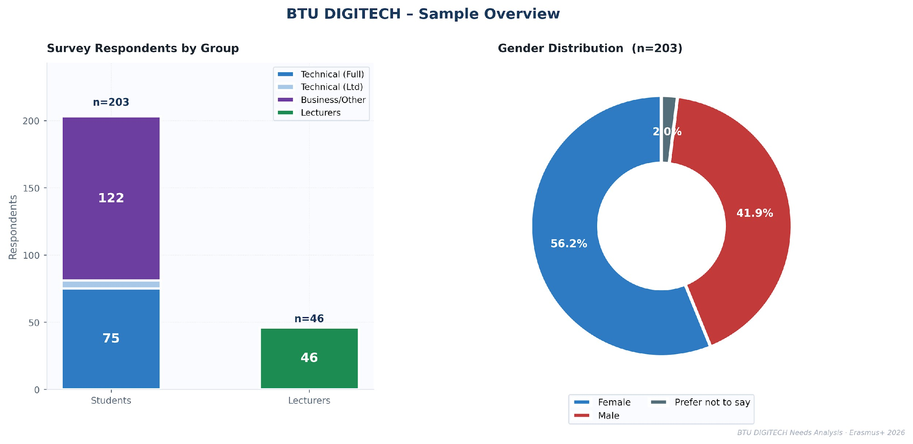
▸ Figure 1.1 BTU survey respondents by segment and gender distribution.

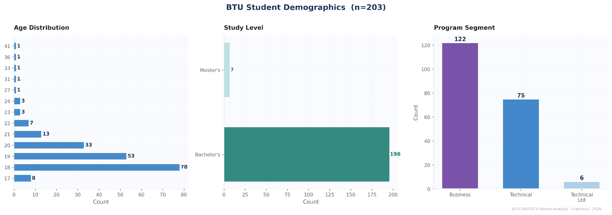

▸ Figure 1.2 BTU student demographics: age, study level and program segment.

2. Digital Tool Competency — Technical Program Students

2.1 Tool Confidence Profile
Technical students (n=75) show a bifurcated confidence profile. Generative AI chatbots and data analysis tools attract the highest mean scores, reflecting consumer-facing AI familiarity. By contrast, foundational engineering tools — Machine Learning frameworks (mean 2.17), Big Data platforms, Cloud DevOps, and Industrial Automation — sit below 3.0, with over 40% of students rating themselves 1 or 2 out of 5.
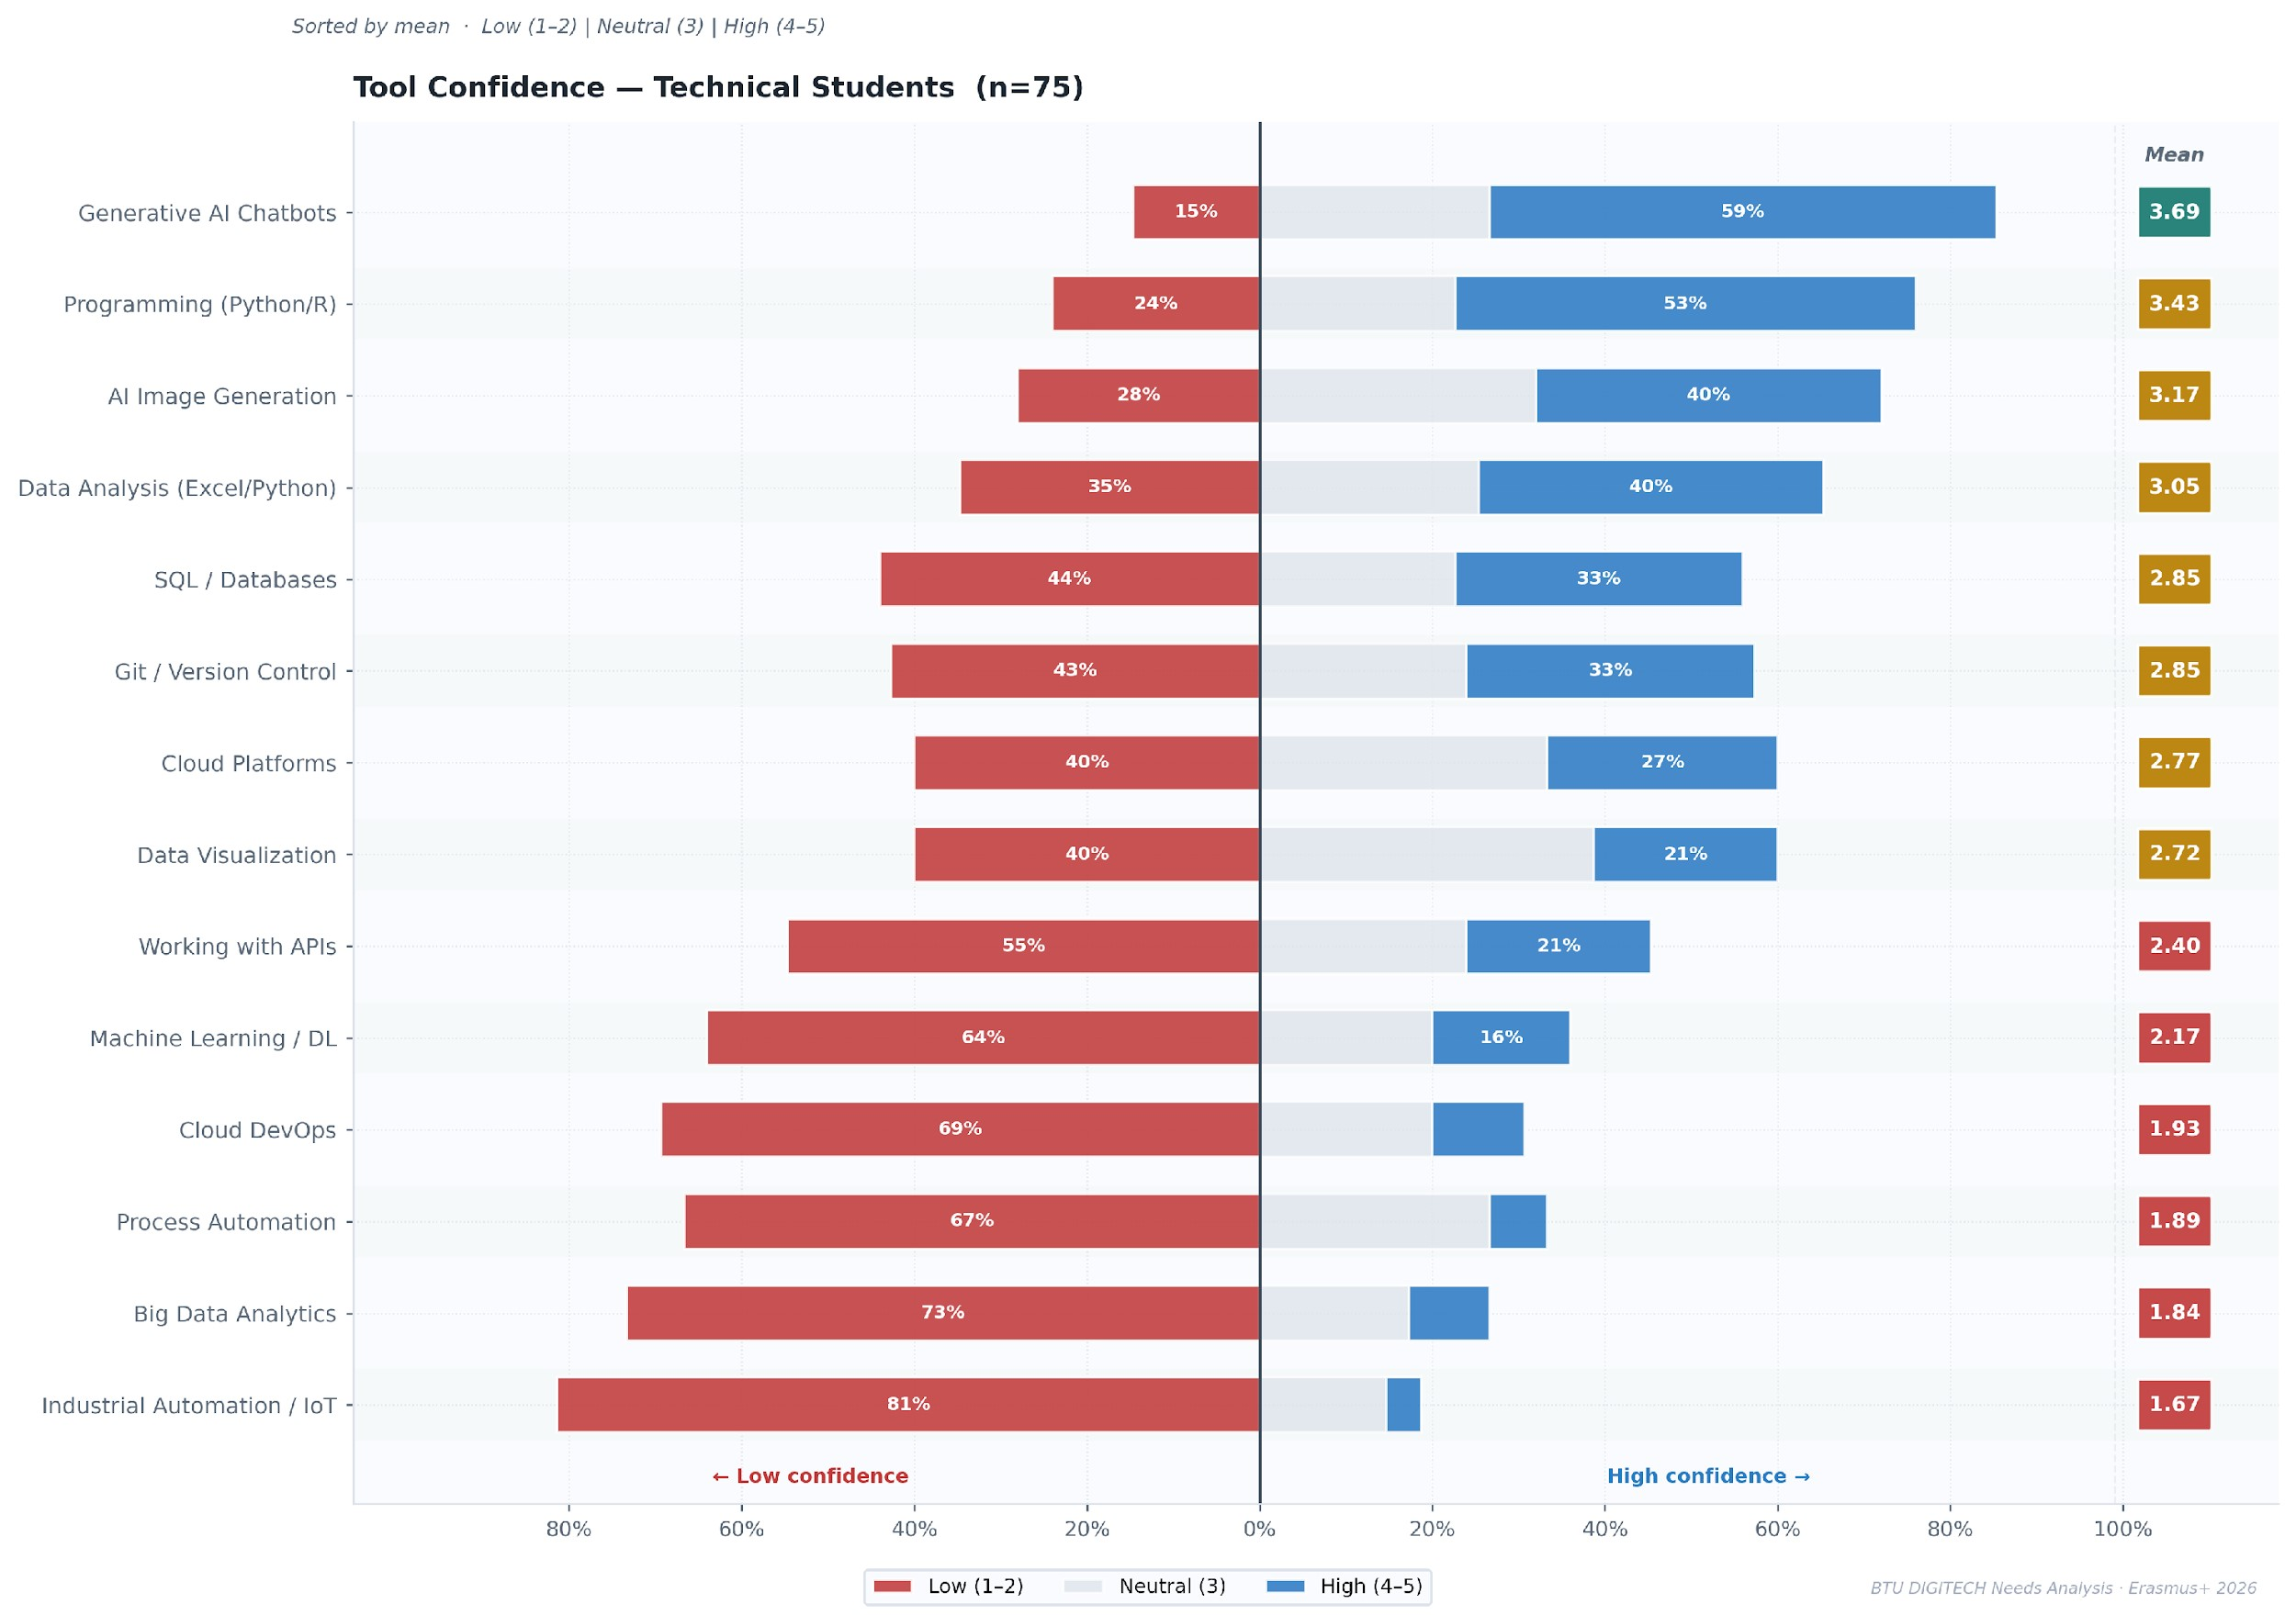
▸ Figure 2.1 Tool confidence diverging bar — BTU Technical students (n=75). Sorted by mean; bars show % Low (1–2), Neutral (3), High (4–5).

Critical Tool Gaps — Technical Students (n=75)
- Machine Learning / Deep Learning: mean 2.17 — 64% score low (1–2)
- SQL / Database queries: mean 2.85 — 44% score low (Fundamental-level skill, Day 1 employer requirement — 5/7 employers)
- Git / Version control: mean 2.85 — 43% score low (Fundamental-level skill — 5/7 employers rate Git as a Must Have day-1 requirement)
- Cloud platforms: mean 2.77 — 40% score low, despite cloud being majority-employer infrastructure (6/7 firms)

2.2 Task and Soft Skill Confidence
Task-level confidence is generally stronger than tool confidence. AI-critical tasks — evaluating AI output accuracy (mean 3.75) and applying AI ethics (mean 3.44) — rank highest. However, these self-assessed scores will be contrasted against workshop performance data in Chapter 7, where actual exercise outcomes reveal important process gaps.
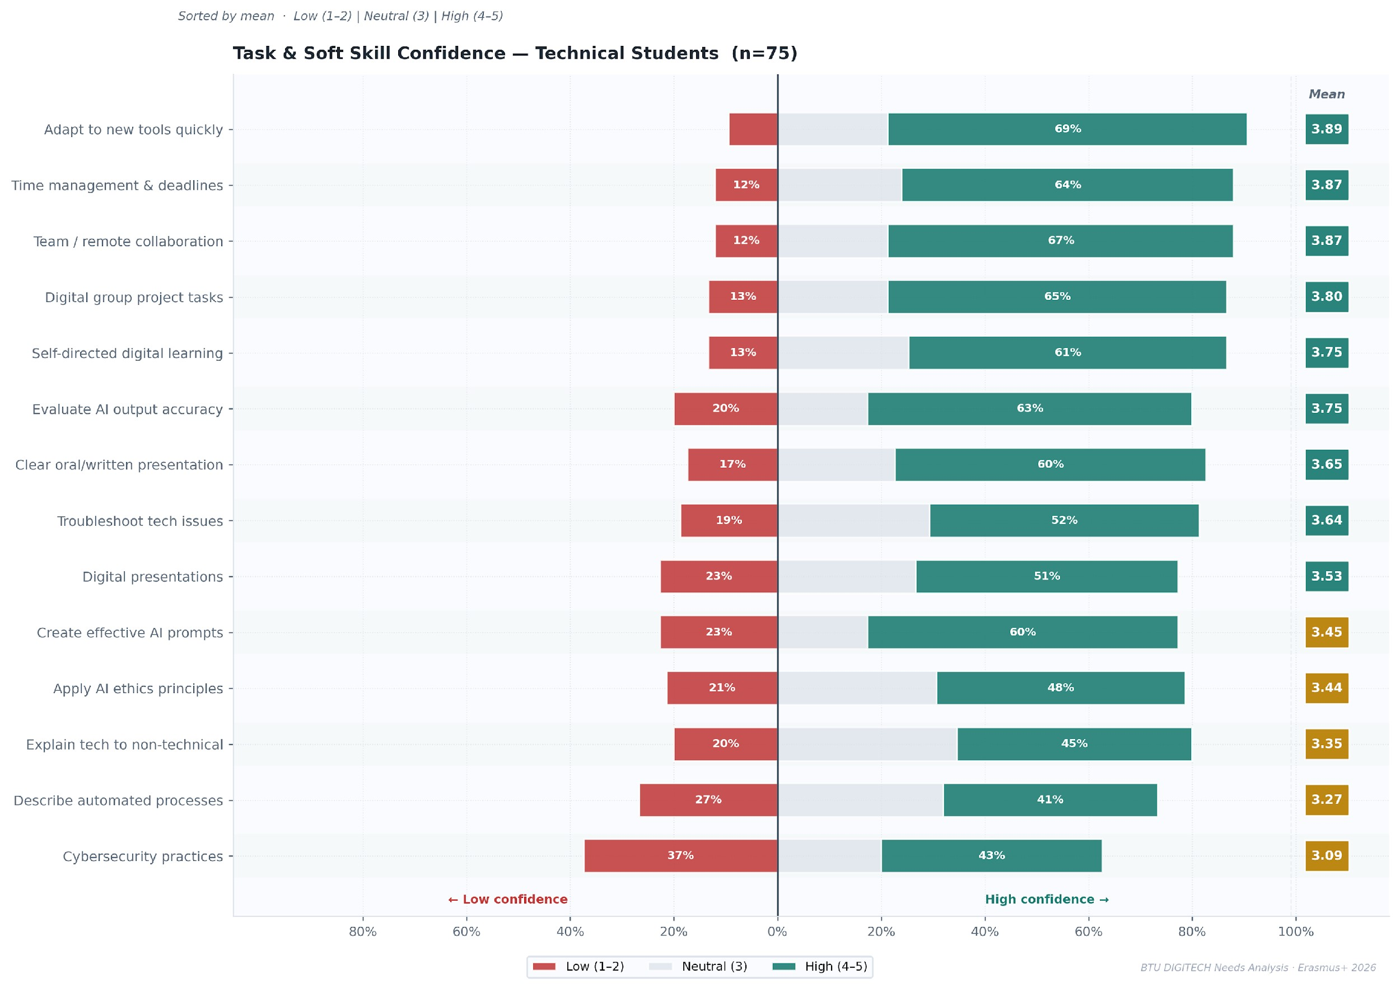
▸ Figure 2.2 Task and soft skill confidence diverging bar — BTU Technical students (n=75).

2.3 Confidence-Usage Gap
A positive gap (confidence exceeding actual usage) is a diagnostic signal of potential overstatement. For Git and SQL, the gap is particularly pronounced among Technical students: they claim reasonable confidence but rarely use these tools in practice. The cloud platform gap is smaller, suggesting students both lack confidence and avoid using it, which is a more consistent signal.
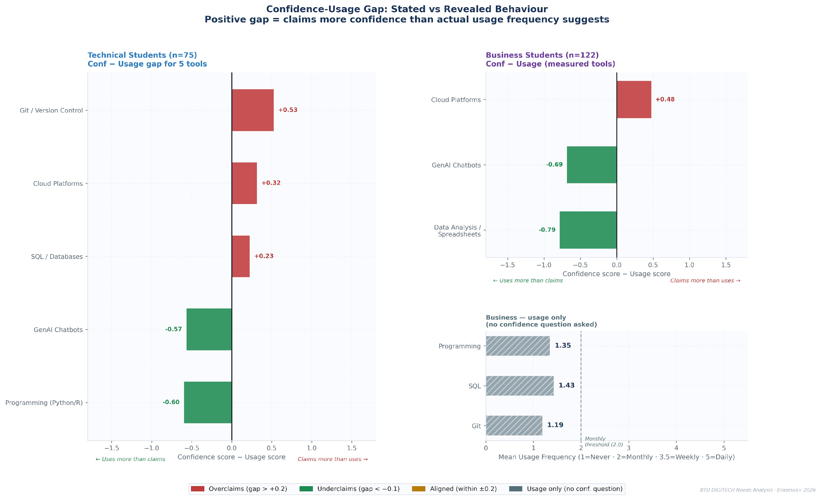
▸ Figure 2.3 Confidence minus usage gap by segment. Positive = stated confidence exceeds revealed usage behaviour.

2.4 Industry 4.0 Readiness
Technical students report limited readiness for Industry 4.0 environments. Most describe course coverage of Industry 4.0 topics as minimal or only somewhat sufficient, and preparedness for automated workplaces is concentrated at the lower-to-middle levels of the scale. Familiarity with IoT and SCADA systems is particularly limited, indicating that exposure to industrial automation technologies remains low.

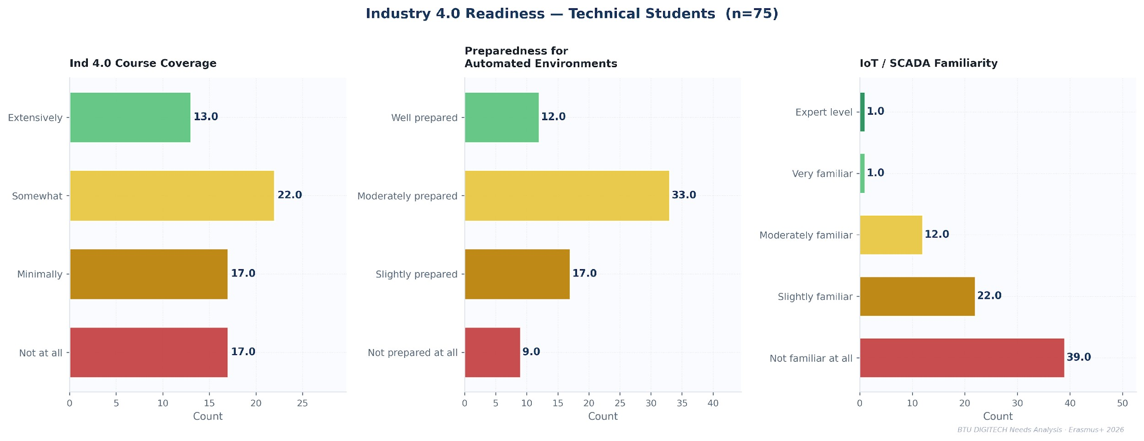
▸ Figure 2.4 Industry 4.0 readiness: course coverage, preparedness for automation, and IoT/SCADA familiarity (Technical students only).

The picture across all three indicators is consistent: Industry 4.0 exposure within the technical curriculum is currently limited and uneven. While a portion of students report moderate preparation for automated environments, this preparedness appears to rely more on general computing and programming skills than on specific familiarity with industrial technologies. The extremely low levels of IoT and SCADA familiarity are particularly notable, suggesting that students have little exposure to the operational systems that underpin real-world cyber-physical environments. This gap reinforces the need for applied learning environments—such as Digital Twin or Industry 4.0 laboratory components—that connect data, automation, and physical systems within a unified practical framework.
On the other hand, correlation analysis shows no meaningful relationship between students’ familiarity with industrial automation concepts and their interest in a Digital Twins laboratory course. Therefore, strong interest exists even among students with limited prior exposure to automation technologies, specifically among students who reported being not familiar with industrial automation concepts (n = 39), 71.8% still expressed high interest (very interested or extremely interested) in the proposed Digital Twins laboratory course.

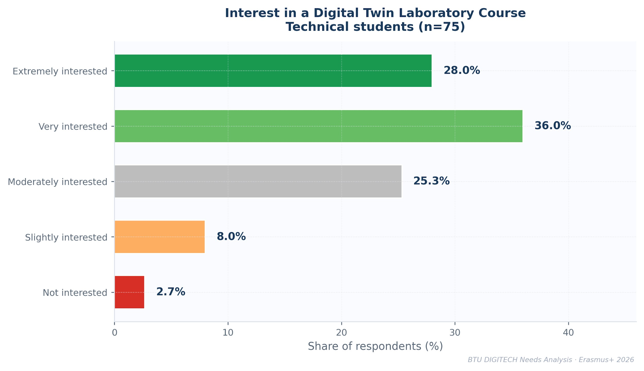
▸ Figure 2.5 Student interest in a Digital Twin laboratory course (Technical students, n=75).

2.5 Tool Usage Frequency
Spreadsheets remain the most-used tool across both segments. AI chatbot usage is high for both cohorts. Programming tool and Git usage is significantly lower than confidence claims for Technical students, corroborating the confidence-usage gap analysis.

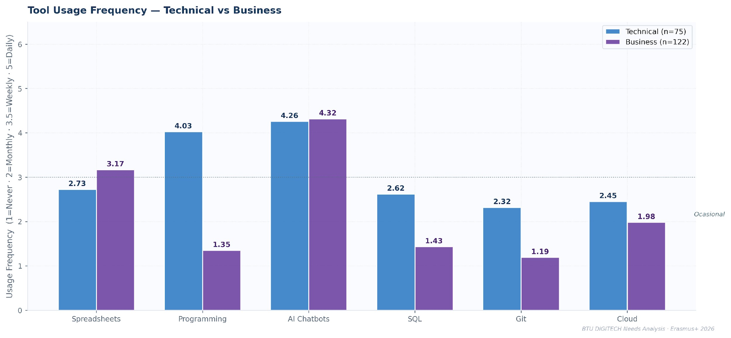

▸ Figure 2.6 Mean tool usage frequency (1=Never, 2=Monthly, 3.5=Weekly, 5=Daily) by segment.

3. Digital Tool Competency — Business Program Students

3.1 Business Student Tool Confidence Profile
Business program students (n=122) show confidence skewed toward digital communication and AI tools, with weaker confidence in SQL, programming, and cloud platforms. The majority rate data analysis and AI chatbot confidence above 3.0, but ERP systems, DevOps, and Big Data remain largely unfamiliar.
▸ 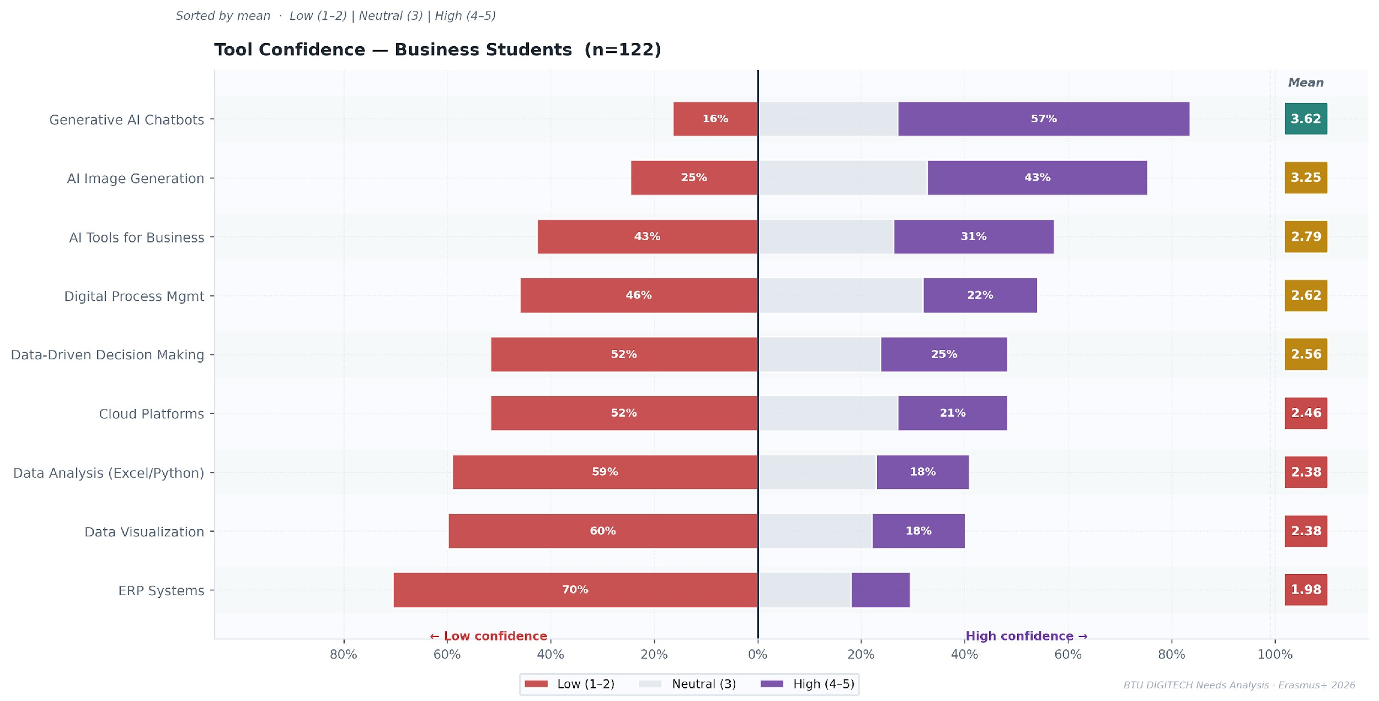
Figure 3.1 Tool confidence diverging bar — BTU Business students (n=122). Sorted by mean score.

3.2 Technical vs Business Cohort Comparison
Technical students hold a clear advantage in programming, SQL, Git, and cloud platforms. However, for general digital tools (AI chatbots, data visualisation, AI for business, ERP systems), the cohort gap narrows considerably. Business students match or exceed Technical students on time management and teamwork, suggesting that professional skill development is stronger in the business curriculum.
▸ 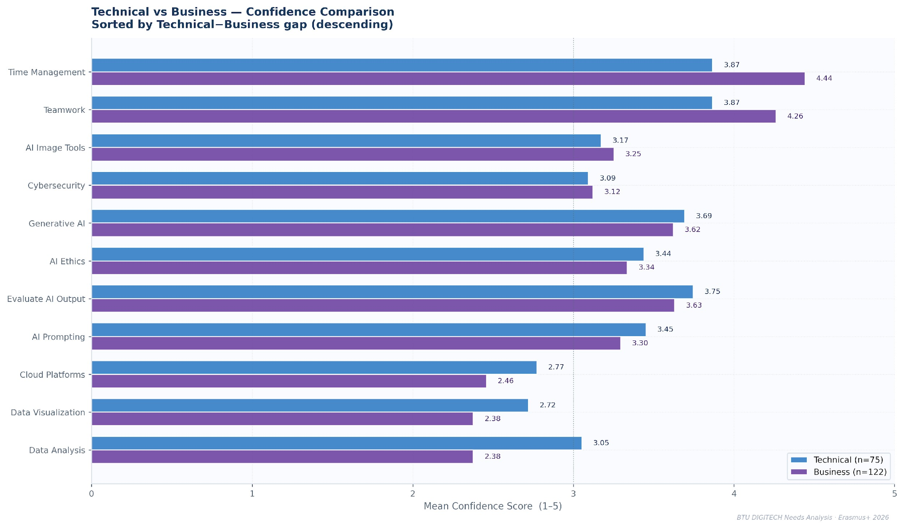
Figure 3.2 Side-by-side comparison of Technical vs Business mean confidence scores, sorted by gap size.

3.3 Self-Assessed Overall Skill Level
Both cohorts concentrate self-assessments in the intermediate range. The Technical cohort shows a wider spread, with more students at both extremes. The Business cohort clusters more tightly in the middle, suggesting more homogeneous self-perception.

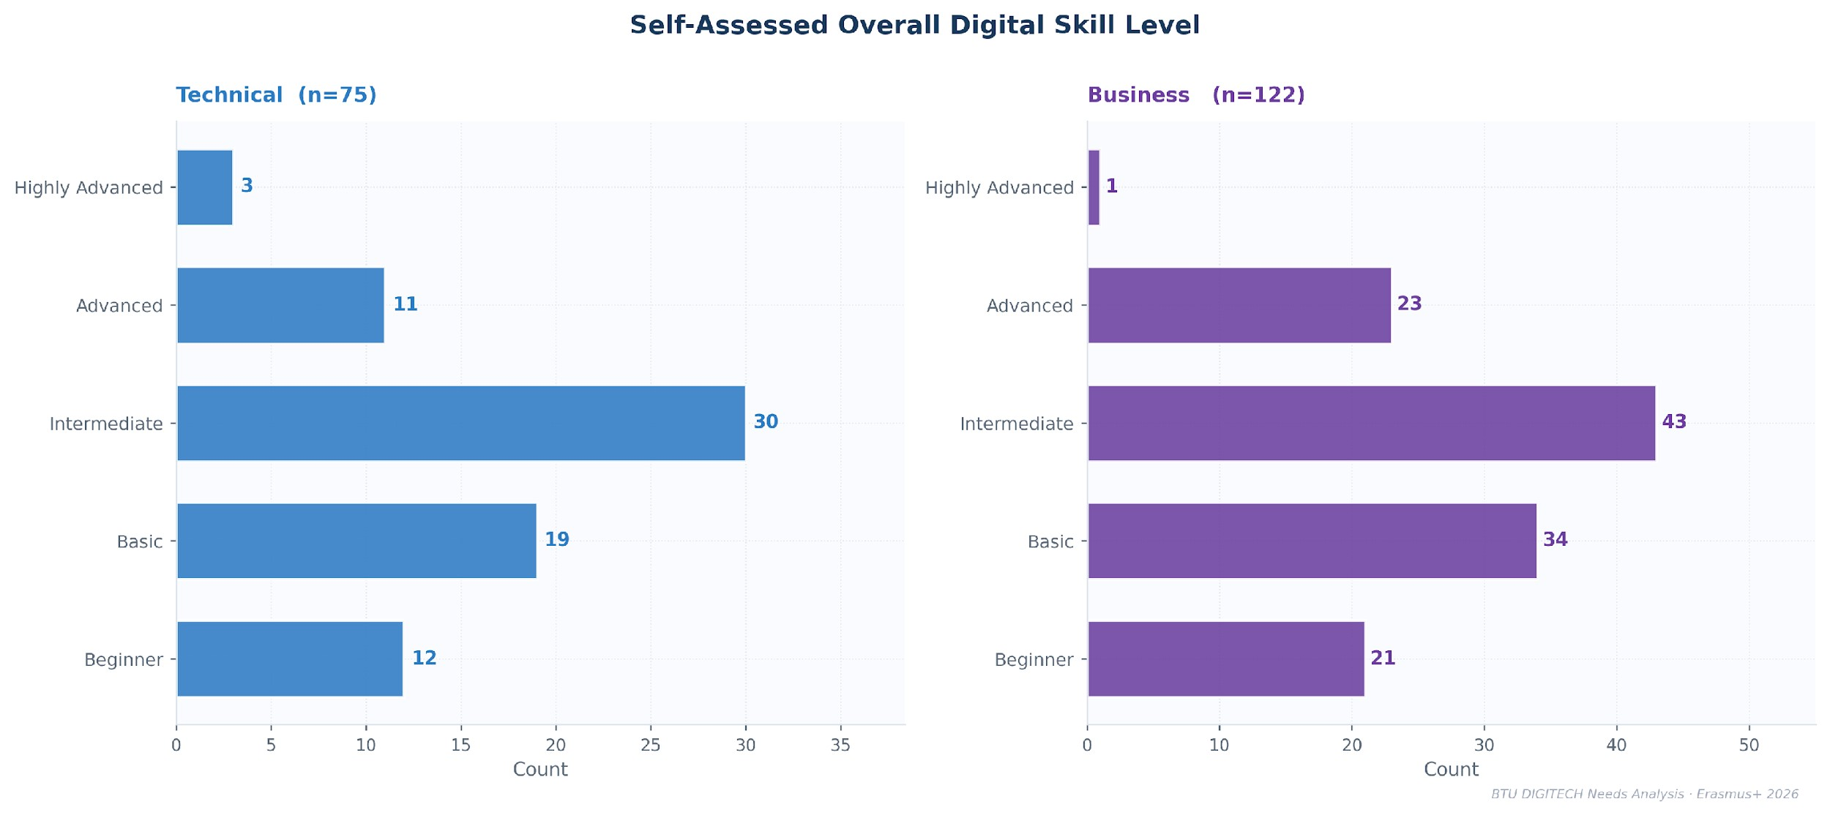

▸ Figure 3.3 Self-assessed overall digital skill level by segment.
Taken together, the Business student profile reveals a cohort that is comfortable with consumer-facing digital tools and soft professional skills, but under-exposed to the technical stack — SQL, programming, cloud infrastructure — that defines modern data-driven workplaces. This gap is narrower but structurally similar to the Technical cohort’s weaknesses, suggesting that both segments will benefit from the curriculum interventions identified in Chapters 6 and 9. Chapter 4 addresses an additional cross-cohort challenge: the gap between AI tool familiarity and genuine critical AI literacy.

4. AI Literacy and the Hype-Readiness Gap

4.1 The Triangulation Challenge with AI Confidence
AI tools present a specific diagnostic challenge: high self-reported confidence in AI chatbot usage does not necessarily translate to critical AI literacy. This chapter cross-plots three dimensions — AI tool confidence, critical AI task confidence, and actual usage frequency — to identify where students are genuinely capable versus where they may be overstating readiness.

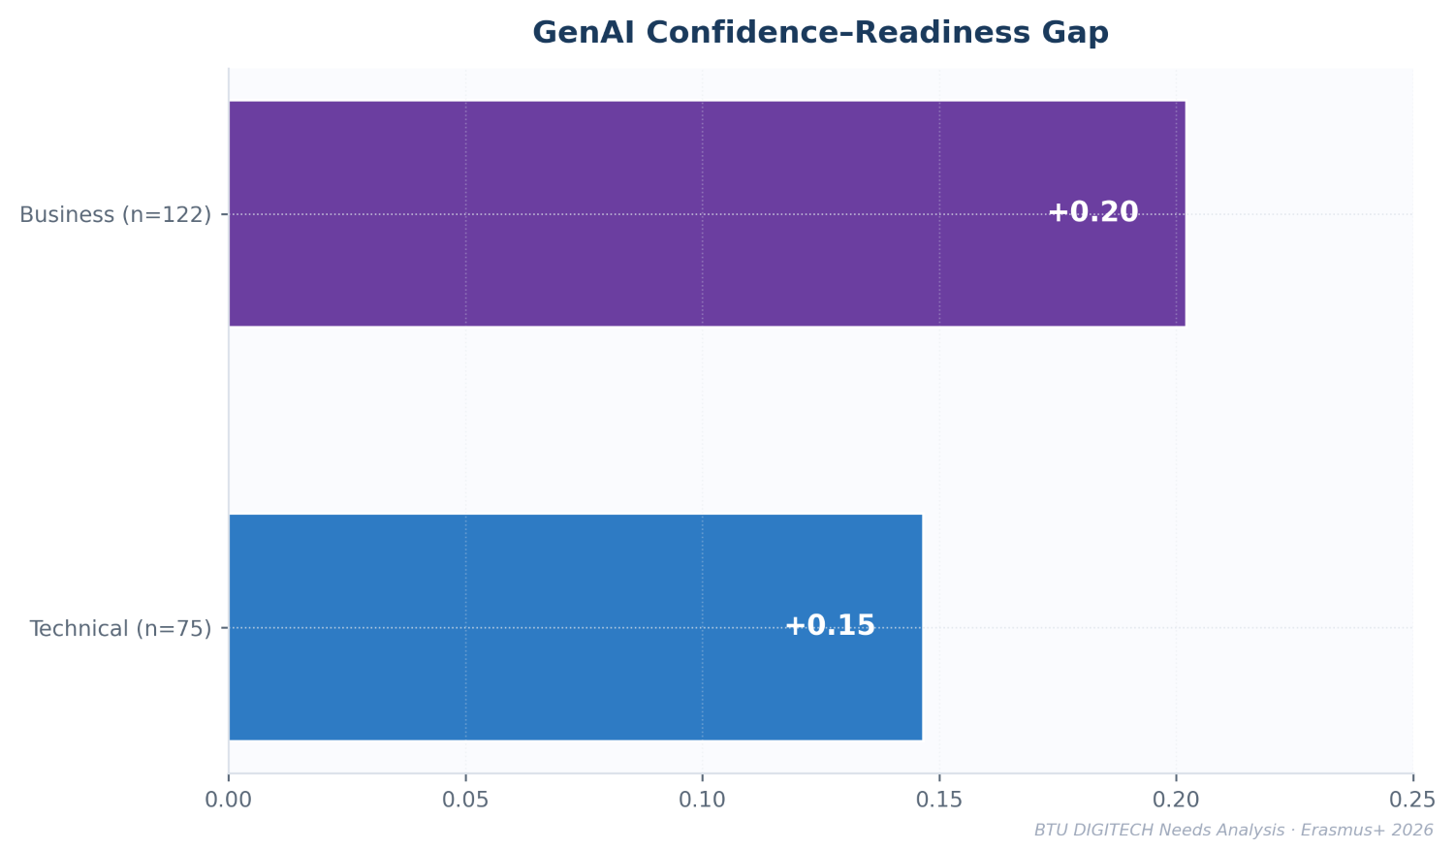
▸ Figure 4.1 AI Literacy Gap: Self-Reported Tool Confidence vs Critical Task Readiness
BTU students report relatively high confidence in using AI tools, but this confidence exceeds their demonstrated readiness in critical AI tasks such as evaluating outputs, understanding ethical implications, and constructing effective prompts and contexts. The resulting confidence–readiness gap indicates that AI familiarity does not yet translate into consistently reliable verification practices.
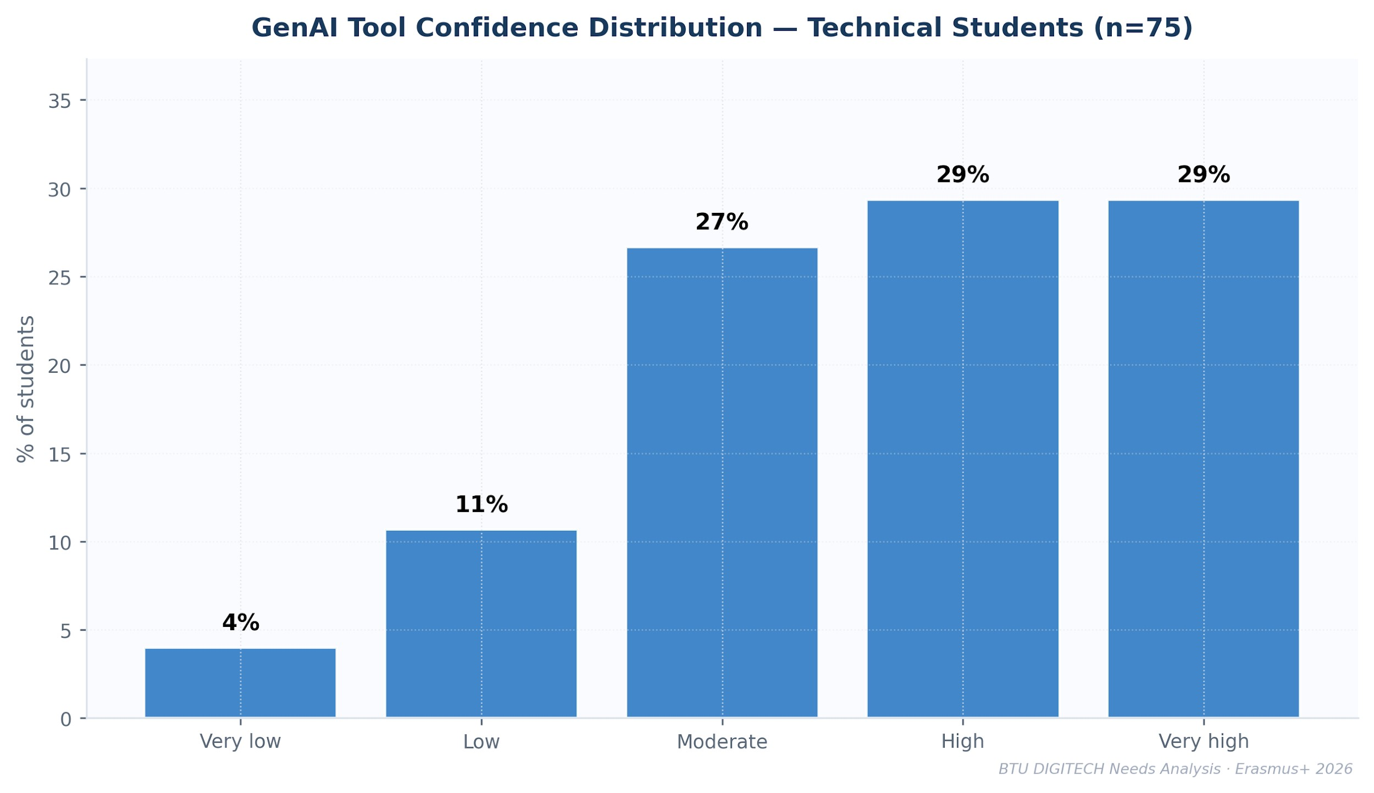
▸ Figure 4.2 AI Confidence Distribution
The distribution shows that most Technical students cluster in the moderate-to-high confidence range for AI tool use (3–5), with comparatively few reporting low familiarity. This self-reported familiarity, however, does not indicate uniform critical literacy — as the task readiness distribution below makes clear.

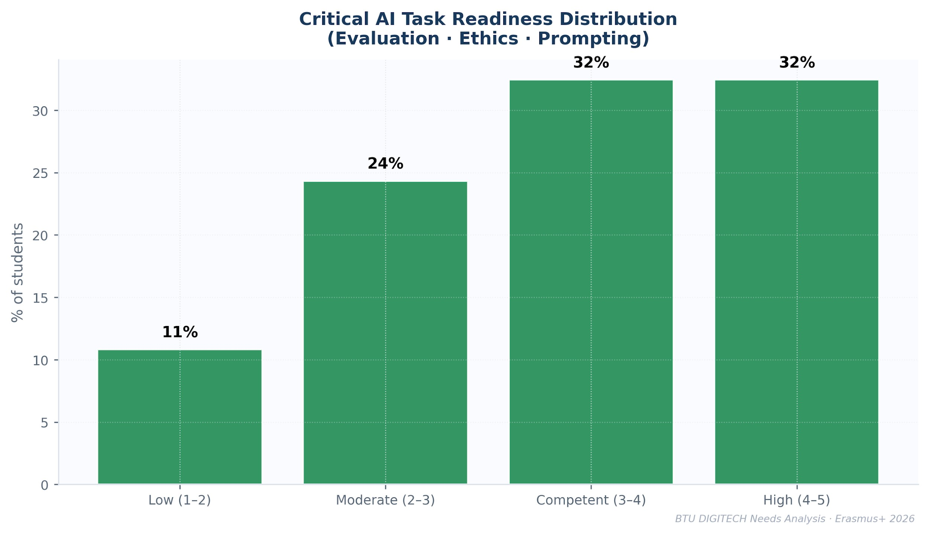
▸ Figure 4.3 Critical Task Readiness Distribution

While the mean across critical AI task readiness scores sits at 3.46, roughly one third of students score below 3 on tasks such as evaluating AI output accuracy and recognising ethical implications — a meaningful tail of underpreparedness that the aggregate mean conceals.
Similar patterns have been identified in previous research on student interaction with generative AI (Digital Ecosystem Digest, 2025, Integrating Generative AI into Learning and Teaching – A University-Level Spotlight from Georgia). Most students report verifying AI-generated results at least occasionally; however, those who rarely verify outputs tend to exhibit higher confidence in the accuracy of AI responses. This overconfidence increases the risk of accepting incorrect or misleading information without critical evaluation. In contrast, students who verify AI outputs using multiple sources or validation methods tend to maintain more cautious levels of trust and avoid over-reliance on the tool. Empirical evidence from mentioned previous research of 167 students indicates a weak but statistically significant negative correlation between verification behaviour and confidence (ρ = –0.16, p = 0.037), suggesting that stronger verification practices are associated with more calibrated trust in AI-generated information. This pattern resembles the well-known Dunning–Kruger effect, where individuals with lower levels of competence tend to overestimate their abilities, while those who engage more deeply with a task become more aware of its limitations and uncertainties.
The observed "confidence-readiness gap" directly validates the concerns outlined in the European Digital Competence Framework for Citizens (DigComp 2.2). Specifically, under Competence Area 1 (Information and Data Literacy) and Competence Area 5 (Problem Solving), DigComp 2.2 emphasizes the critical need for citizens to critically evaluate AI-generated content and understand the provenance of data. The BTU findings demonstrate that, while students easily achieve the operational levels of AI tool usage (Levels 1–3 in DigComp), they struggle with the highly specialized evaluation and verification requirements (Levels 4–6) necessary for professional IT environments.

4.2 AI Literacy Triangle — Three-Way Evidence
- Confidence signal (survey data)
85% of Technical students report GenAI confidence of 3 or higher, indicating widespread familiarity with AI tools
- Capability signal (task readiness scores)
Average readiness across AI evaluation, ethics, and prompting tasks is 3.46, but 35% of students score below the competence threshold (<3), indicating uneven development of critical AI literacy.
- Behaviour signal (workshop observation)
Students correctly identified hallucination risks but no group demonstrated a coherent verification process, indicating a workflow gap rather than a knowledge deficit.
- Gap implication
Across self-assessment, measured task readiness, and observed behaviour, AI familiarity currently exceeds systematic verification practices, producing the confidence–readiness gap shown in Figure 4.1

5. Lecturer Perspectives

5.1 Lecturer Profile
The lecturer cohort is predominantly early-career, with two-thirds of respondents reporting seven or fewer years of teaching experience. Mid-career lecturers (8–15 years) form a secondary group, while highly experienced lecturers (16+ years) represent a smaller share of the sample. This distribution indicates a relatively young teaching cohort, with a substantial proportion of instructors still consolidating their pedagogical practices.
At the same time, attitudes toward technology in teaching are strongly positive. Half of lecturers identify as mainstream adopters who integrate technology once its value is established (50%), while 46% describe themselves as early adopters willing to experiment with new tools. Only 4% position themselves as cautious users. Rather than indicating resistance to technology, this distribution suggests that digital tools are already broadly accepted within the teaching community, although lecturers differ in the speed and manner of adoption.
The profile points to a generally favorable institutional context for advancing technology-enhanced teaching practices. The primary challenge is therefore unlikely to be reluctance toward technology, but rather ensuring consistent and pedagogically grounded integration of digital tools across courses, particularly as early-career instructors continue to develop their instructional approaches.
▸ 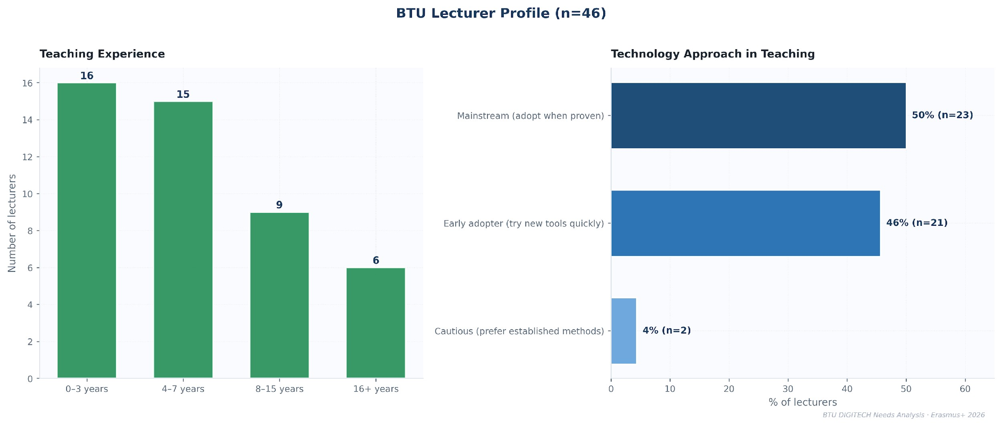
Figure 5.1 BTU lecturer profile: teaching experience distribution and technology adoption stance.

5.2 Observed Student Struggle Frequency
BTU lecturers (maximum n=46) rated how frequently their students struggle with nine competency areas. Figure 5.2 presents mean struggle scores per domain on a five-point scale (1 = Never, 5 = Almost Always). The number of valid responses per skill is shown in each cell; lecturers who marked a competency as Not Relevant for their course are excluded from the mean calculations.

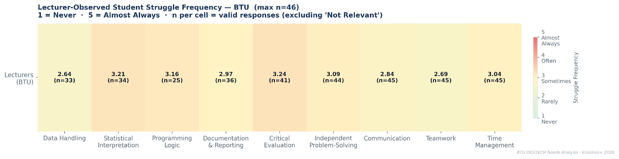
▸ Figure 5.2 Lecturer-observed student struggle frequency
(1=Never, 5=Almost Always). n per skill reflects only lecturers for whom the skill is course-relevant.

Critical evaluation and statistical interpretation are the domains with the highest observed struggle (means 3.24 and 3.21), followed by programming logic (3.16) and independent problem-solving (3.09). In contrast, data handling receives the lowest struggle rating (2.64), suggesting that lecturers perceive foundational data manipulation tasks as comparatively less problematic than higher-order analytical competencies.
The contrast between high struggle in critical evaluation and low struggle in data handling directly reinforces the AI literacy findings in Chapter 4: students manage operational tasks but falter at the analytical layer above them.

5.3 Curriculum Design Confidence
Lecturers report very high confidence in core course-level design tasks, including specifying course objectives (mean 4.61), structuring study programs (4.52), selecting teaching methods (4.50), and defining exit competencies (4.50). These results suggest that BTU faculty feel comfortable designing individual course components and instructional approaches.
However, confidence declines for curriculum-level alignment and competency-structuring tasks. Vertical course integration (4.04), horizontal course integration (4.00), and integrating electives (3.98) receive lower ratings, indicating that coordinating learning pathways across the program is perceived as more challenging. The lowest confidence appears in applying Bloom’s taxonomy (3.78), a framework commonly used to structure measurable learning outcomes and cognitive progression.
The gap between course-level confidence and program-level coordination is the key finding here: BTU lecturers are well-equipped to design individual courses but less confident navigating the connective tissue between them. Strengthening capacity in outcome structuring, Bloom-based cognitive mapping, and program-level coordination will therefore be important for the curriculum development objectives of the DIGITECH project.
Since curriculum design was not the primary objective of the survey, the data obtained from this section should be interpreted with caution. Compared with other parts of the questionnaire, the items in this section offered fewer differentiated response options, which may have reduced the depth of responses. As a result, it is possible that some respondents did not evaluate these questions with the same level of detail as other sections of the survey. In addition, a number of participating lecturers, particularly invited lecturers mostly are not directly involved in curriculum planning and therefore are not expected to possess detailed knowledge of program-level curriculum design processes.
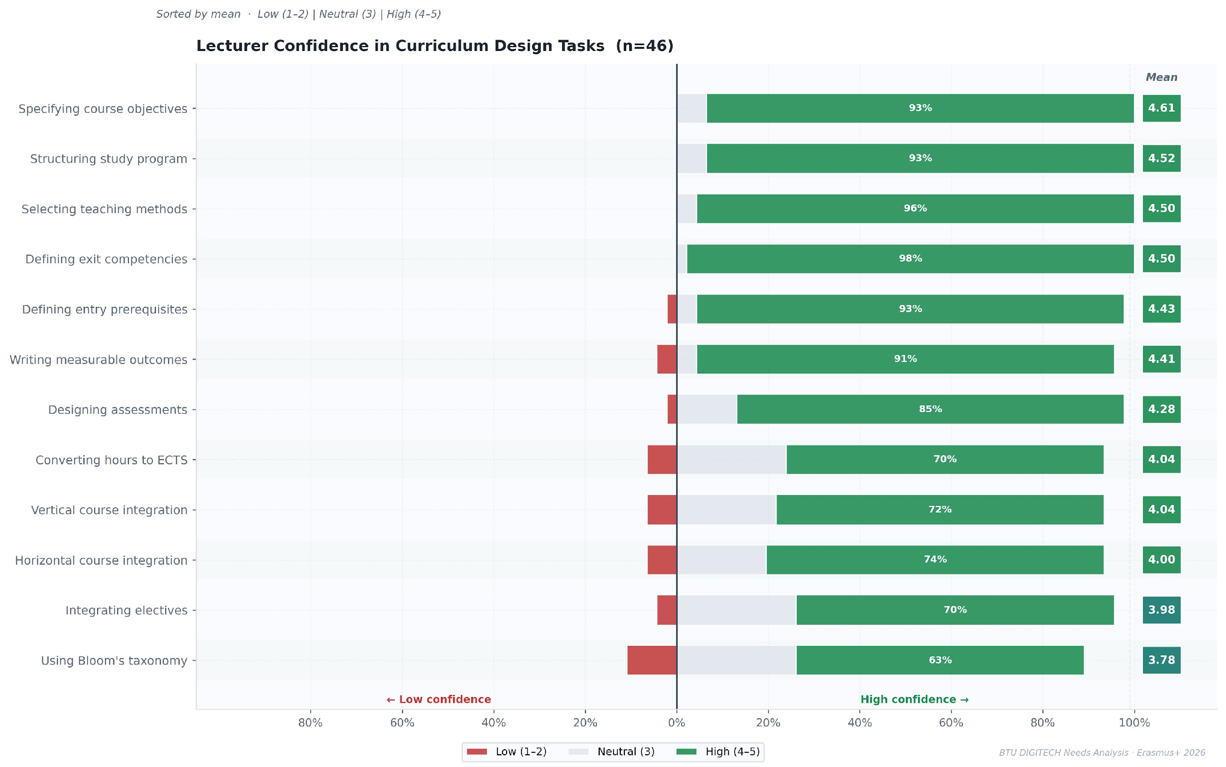
▸ Figure 5.3 BTU lecturer confidence in curriculum design tasks (n=46). Diverging bar sorted by mean.

6. Industry Employer Assessment
Representatives of seven Georgian employers completed the DIGITECH industry questionnaire. Respondents represented companies actively deploying cloud platforms, AI/ML workflows, and API-driven systems in production environments.
The questionnaire covered five areas: day-1 skill requirements, technology stack expectations, AI’s impact on hiring, candidate evaluation priorities, and qualitative assessments of graduate preparedness.

6.1 Day-1 Skill Readiness Requirements
Employers evaluated 21 technical and transversal skills using a three-point readiness scale:
- A — Must Have on Day 1
- B — Should Have within one month
- C — Nice to Have
Skills are sorted by mean importance score (A=3, B=2, C=1).

▸ 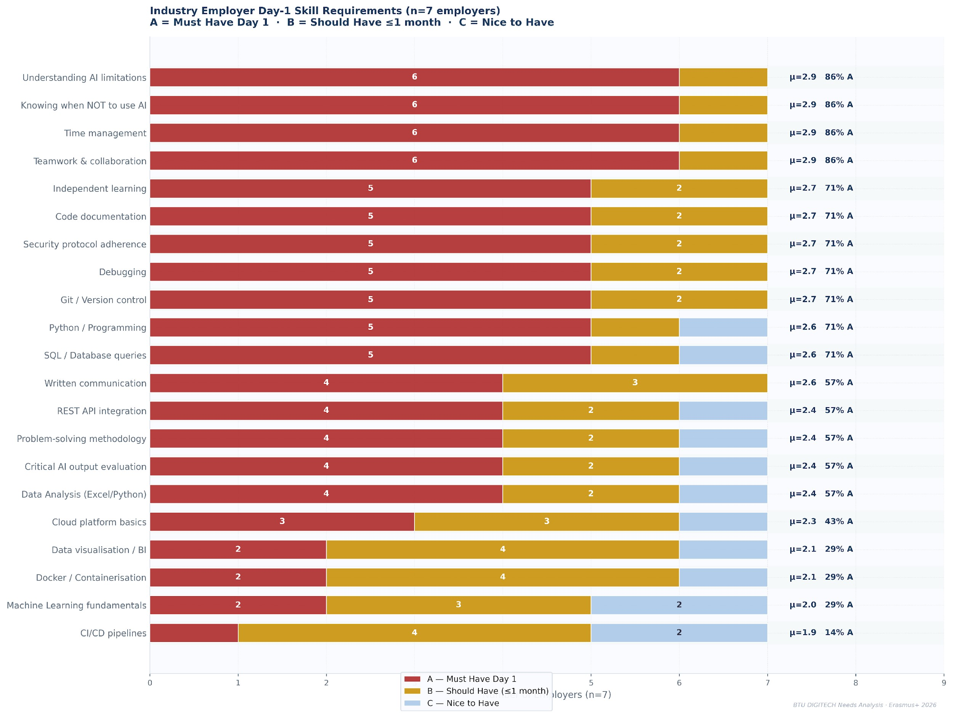
Figure 6.1 Day-1 readiness requirements across 21 skills (n=7 employers). Bars show A/B/C counts; annotations show mean importance score (μ) and the share rating the skill as Must Have.

Key Findings

Top priority skills.
Four skills jointly receive the highest importance score (μ = 2.9): Understanding AI limitations, Knowing when not to use AI, Time management, and Teamwork & collaboration. Each was rated Must Have by 6 of 7 employers, indicating that both AI literacy and core professional competencies are expected from graduates at the point of entry into employment.
Curriculum–industry gap.
SQL / database queries and Git / version control are rated Must Have by 5 of 7 employers, yet 43–44% of BTU technical students score ≤2 (low confidence) on these competencies in the DIGITECH student survey. This represents the largest observed gap between employer expectations and student capability in the analysis.
Soft-skill parity with technical skills.
Employers place time management, teamwork, and independent learning on par with technical competencies. Independent learning is rated Must Have by 5 employers, highlighting the importance of graduates’ ability to continuously acquire new skills in rapidly evolving technology environments. At the same time, several respondents noted that many of these competencies are difficult to fully acquire through formal coursework alone. However, they also indicated that courses addressing soft skills can still play an important role in strengthening students’ awareness and development of these abilities, helping graduates build a stronger foundation for leadership and collaborative work in professional environments.
Risk awareness over technical AI expertise.
The two highest-ranked AI-related skills concern responsible AI use rather than AI development itself: understanding AI limitations and knowing when AI outputs should not be relied upon. This suggests that employers perceive operational misuse of AI systems as a greater risk than a lack of specialized AI development skills.
Several employers also emphasised that they do not necessarily expect graduates to possess the exact AI tools or platform-specific skills used within their organisations at the moment of hiring. Instead, they highlighted the importance of a broad foundational understanding of AI concepts and digital workflows. According to these respondents, company-specific tools, frameworks or platforms are typically introduced through internal training after recruitment.
Additional evidence from BTU’s employer ecosystem reinforces the growing importance of generative AI skills for graduates. A market analysis conducted for the development of BTU’s new English-language BBA program surveyed 16 potential employer partners regarding priority competencies for business graduates. The results indicate that 69% of employers consider the ability to use generative AI tools for business productivity to be a priority skill for those BBA graduates. This finding suggests that familiarity with AI-assisted workflows is becoming an expected capability not only in technical roles but also in business-oriented positions. In parallel, a separate employer consultation conducted for the design of BTU’s English-language Computer Science and AI program identified governance and responsibility aspects of AI as key concerns. Among 11 participating employers, 45% identified AI ethics and responsible innovation as a priority skill for graduates, while the same share (45%) highlighted auditability and explainability of AI decisions as a critical operational concern for their organizations (BTU Employer Analysis, October 2025).
Although the employer sample size is limited (n=7), the findings strongly align with global macroeconomic labor trends. The World Economic Forum (WEF) Future of Jobs Report 2023 highlights AI and Big Data analytics, along with analytical and creative thinking, as the fastest-growing skill demands worldwide. Additionally, local employers’ emphasis on Git/version control and cloud platforms as "Day-1 Must-Haves" reflects international software engineering standards, where cloud-native deployments and collaborative CI/CD pipelines have largely replaced isolated local development workflows. This external validation confirms that the skill gaps identified at BTU are not merely local anomalies but systemic deficiencies in preparing graduates for the globalized Industry 4.0 labor market.

Overall Interpretation
The results converge on three capability clusters:
- Responsible AI literacy — understanding limitations and appropriate use of AI systems
- Core engineering workflow skills — SQL, Git, debugging, and practical development practices
- Professional execution skills — teamwork, time management, and independent learning
This profile reinforces the broader findings of the DIGITECH analysis: graduate readiness depends as much on judgment and engineering workflow competence as on advanced technical specialization.
The industry results also closely mirror patterns observed in the student and lecturer analyses, particularly the gap between AI familiarity and systematic verification practices identified in Section 4.

6.2 Technologies Active in Production
Cloud platforms are the most widely deployed infrastructure among respondent companies, with 6 of 7 organizations reporting active production use. AI/ML tools and REST APIs are each used by five companies, indicating that modern application architectures and data-driven services are already common across the partner ecosystem.
Python is deployed by four companies, while Docker, Git/GitHub, and PostgreSQL/MySQL are each used by three firms. These technologies correspond closely to the skills that employers identified as Must Have on Day 1 in the previous analysis, reinforcing the alignment between hiring expectations and production engineering workflows.
Lower levels of adoption are observed for JavaScript/Node.js and Kubernetes (two companies each), while Kafka/streaming infrastructure appears in only one company’s production environment.
Overall, the production technology profile suggests that cloud-native application architectures, API-based systems, and Python-centered data workflows form the core technical environment in which BTU graduates are expected to operate.
▸ 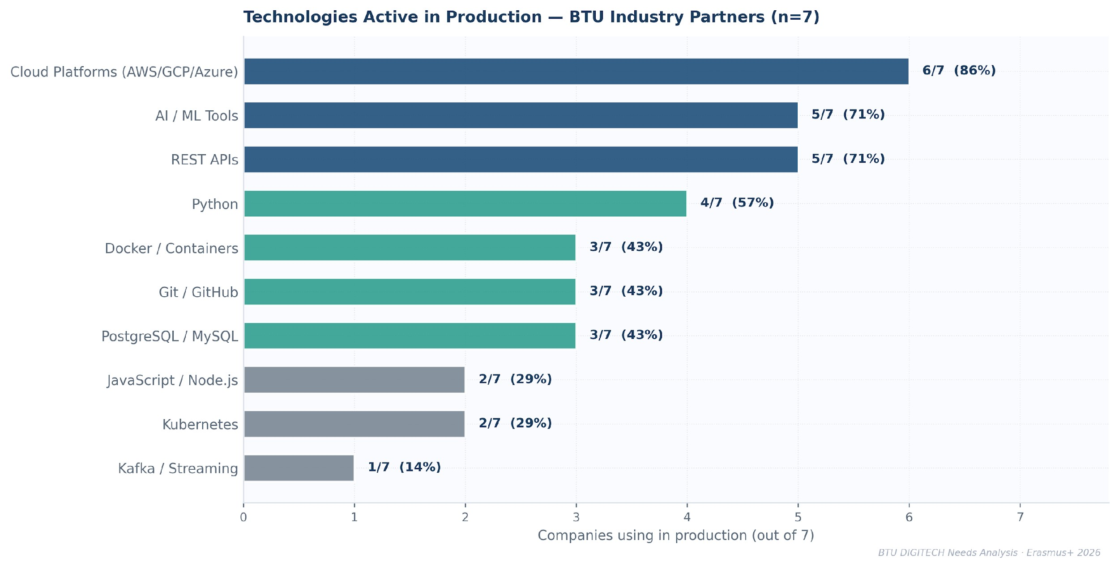
Figure 6.2 Technologies used in production today by BTU industry partners (n=7).

6.3 AI Impact on Hiring
AI adoption appears to be influencing hiring dynamics among the respondent companies. Three of seven employers report hiring fewer junior staff, while two report hiring more and the remainder report no change or did not provide an answer. Several respondents indicated that AI systems now perform tasks previously assigned to entry-level roles, contributing to changes in junior hiring patterns.
Skill expectations have also shifted. Four employers report higher skill expectations and two report qualitatively different requirements, while one reports no change. This suggests that AI adoption is increasing the importance of stronger foundational skills and more adaptable technical profiles in early-career candidates.
Training time appears to have decreased in several organizations: four respondents report shorter onboarding periods, while two report no change. At the same time, five employers report increased employee productivity, suggesting that AI tools are already contributing to efficiency gains in day-to-day work.
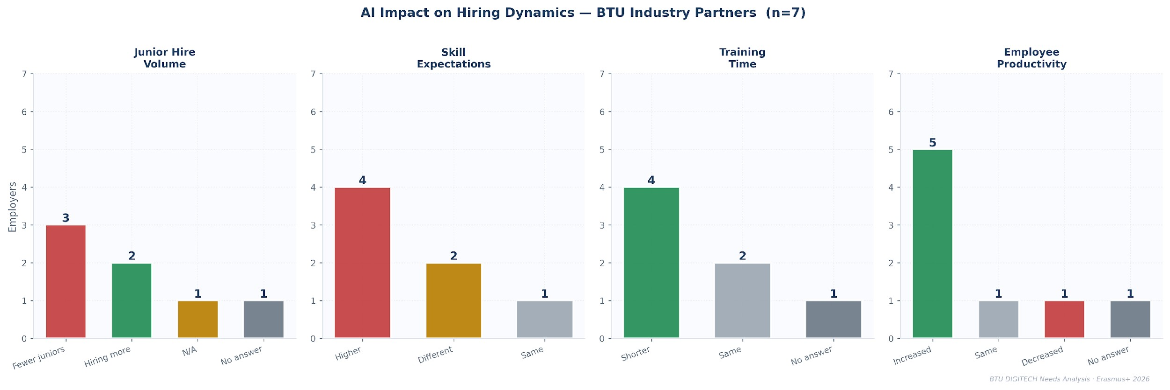
▸ Figure 6.3 AI impact on hiring: junior hire volume, skill expectations, training time, and productivity (n=7).
A further qualitative shift is emerging in candidate evaluation itself. Several respondents noted that AI-assisted CV generation has increased the volume of polished but shallow applications, placing greater weight on interview-stage technical and domain testing. At the same time, automated screening tools allow companies to process larger applicant volumes, although respondents reported that distinguishing genuine capability from AI-assisted presentation has become more challenging.

6.4 Hiring Signal Priorities
When asked to rank six candidate evaluation criteria (n=4 complete responses), employers consistently placed problem-solving ability and communication skills as the most important signals when evaluating graduates. University credentials ranked lowest for most respondents, indicating that formal degrees play a limited role compared with demonstrated capability.
Portfolio / GitHub projects and internship experience form a second tier of signals, both receiving similar average rankings. These results suggest that employers place substantial weight on demonstrated practical work and real-world experience when assessing early-career candidates.
AI-native capability shows the widest variation across respondents. One employer ranked it as the most important signal, while another ranked it last. This dispersion indicates that industry has not yet converged on a common evaluation standard for AI fluency, reflecting the rapidly evolving role of AI tools in professional workflows.
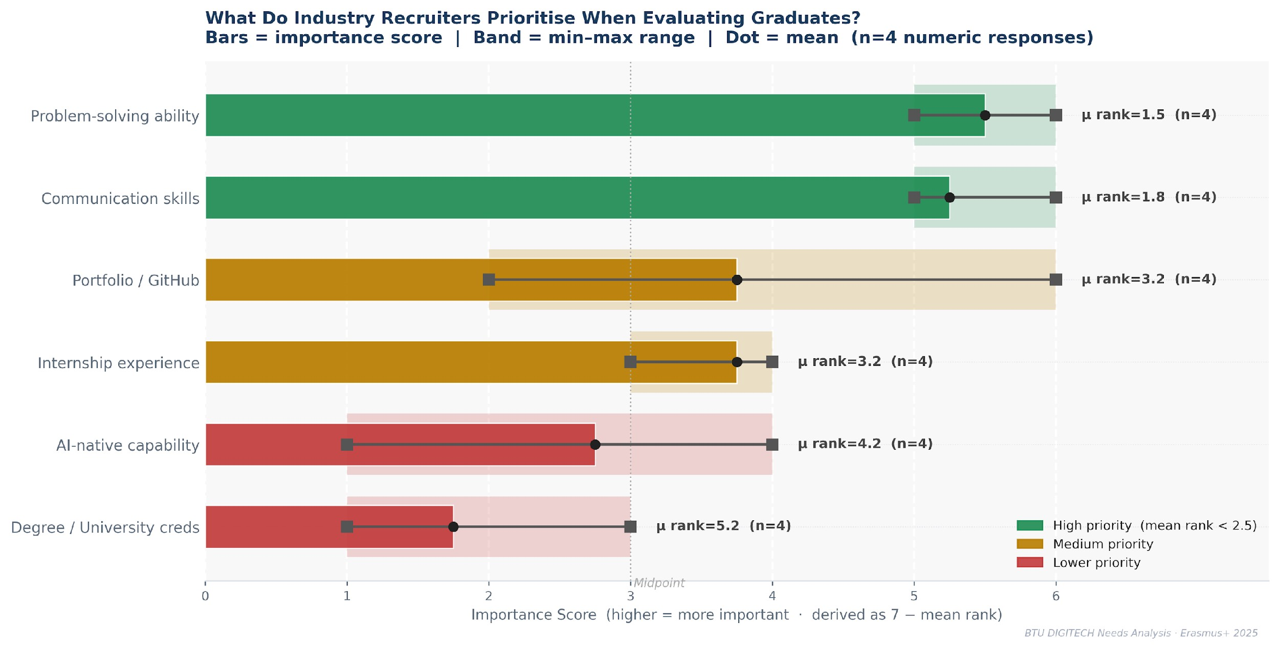
▸ Figure 6.4 Hiring signal rankings (1 = most important, 6 = least important). Bars show importance score derived from mean rank (7 − mean rank). The shaded band indicates the min–max range across respondents, and the dot marks the mean ranking.

6.5 What Employers Wish Universities Taught Better
Practical and project-based experience was cited most frequently (4 mentions), followed by communication skills and problem-solving practice (3 mentions each). Several respondents also highlighted portfolio culture, security awareness, and responsible AI use (2 mentions each). Overall, the responses indicate that employers expect universities to strengthen applied learning environments that combine technical capability with workplace communication and collaborative problem-solving skills.
▸ 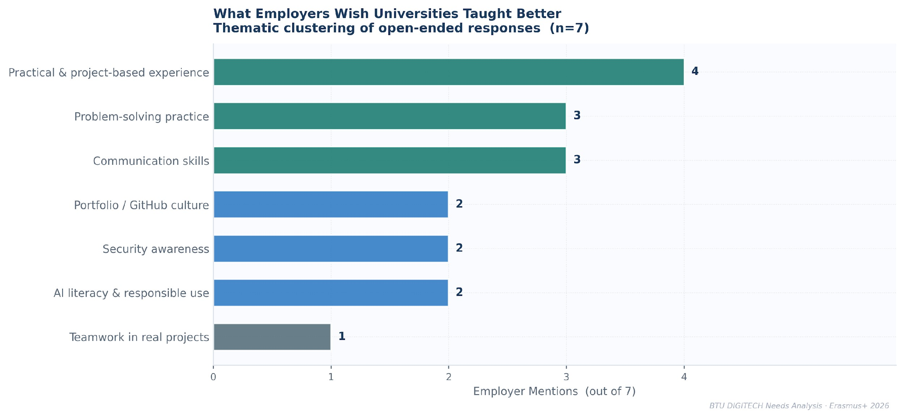
Figure 6.5 Thematic clustering of employer responses to open-ended question on curriculum improvement.

6.6 CV Screening Failures and Early Employment Struggles
Domain knowledge gaps — where candidates appear strong in CV screening but fail technical interviews
— were the most frequently cited screening failure (5 mentions), aligning with the phenomenon of AI-polished CVs lacking substantive depth. Early employment struggles are concentrated around independent problem-solving (5 mentions) and team communication (4), followed by handling ambiguous requirements and effort estimation (3 each). These patterns indicate that many graduates struggle with autonomous work and real project coordination despite meeting formal technical requirements.
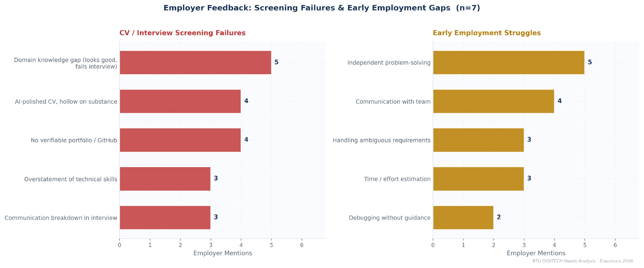
▸ Figure 6.6 Most common CV-interview performance gaps and early employment struggle categories (qualitative clustering, n=7).

7. Workshop Scenario Performance
Three diagnostic workshop scenarios were administered to three BTU student groups. Each scenario evaluated applied problem-solving in realistic technical situations, including AI hallucination detection, phishing attack analysis, and identification of software security vulnerabilities.
Lecturers submitted predictions about expected student performance before the workshop. This allows comparison between predicted and actual outcomes, providing insight into how accurately instructors estimate student capabilities.
Scenario A tested AI hallucination detection: students were given a Python code snippet that called a plausible but non-existent library and asked to identify the problem and describe their verification process. Scenario C presented a deepfake business email compromise (BEC): students received a realistic phishing email impersonating a senior executive and were asked to identify the attack vector and appropriate response. Scenario E involved a regex ReDoS (regular expression denial-of-service) vulnerability: students reviewed a code fragment containing a catastrophically backtracking pattern and were asked to identify the security risk and propose a safe alternative. All three groups completed all three scenarios; completion times were recorded.

7.1 Lecturer Prediction Accuracy
Comparison of lecturer predictions with actual workshop outcomes reveals a consistent pattern of underestimation. In most checkpoints, lecturers predicted lower student performance than was observed.
The largest gaps appear in security-related tasks, including identification of attack types and detection of software vulnerabilities, where actual student performance substantially exceeded pre-workshop lecturer predictions.
▸ 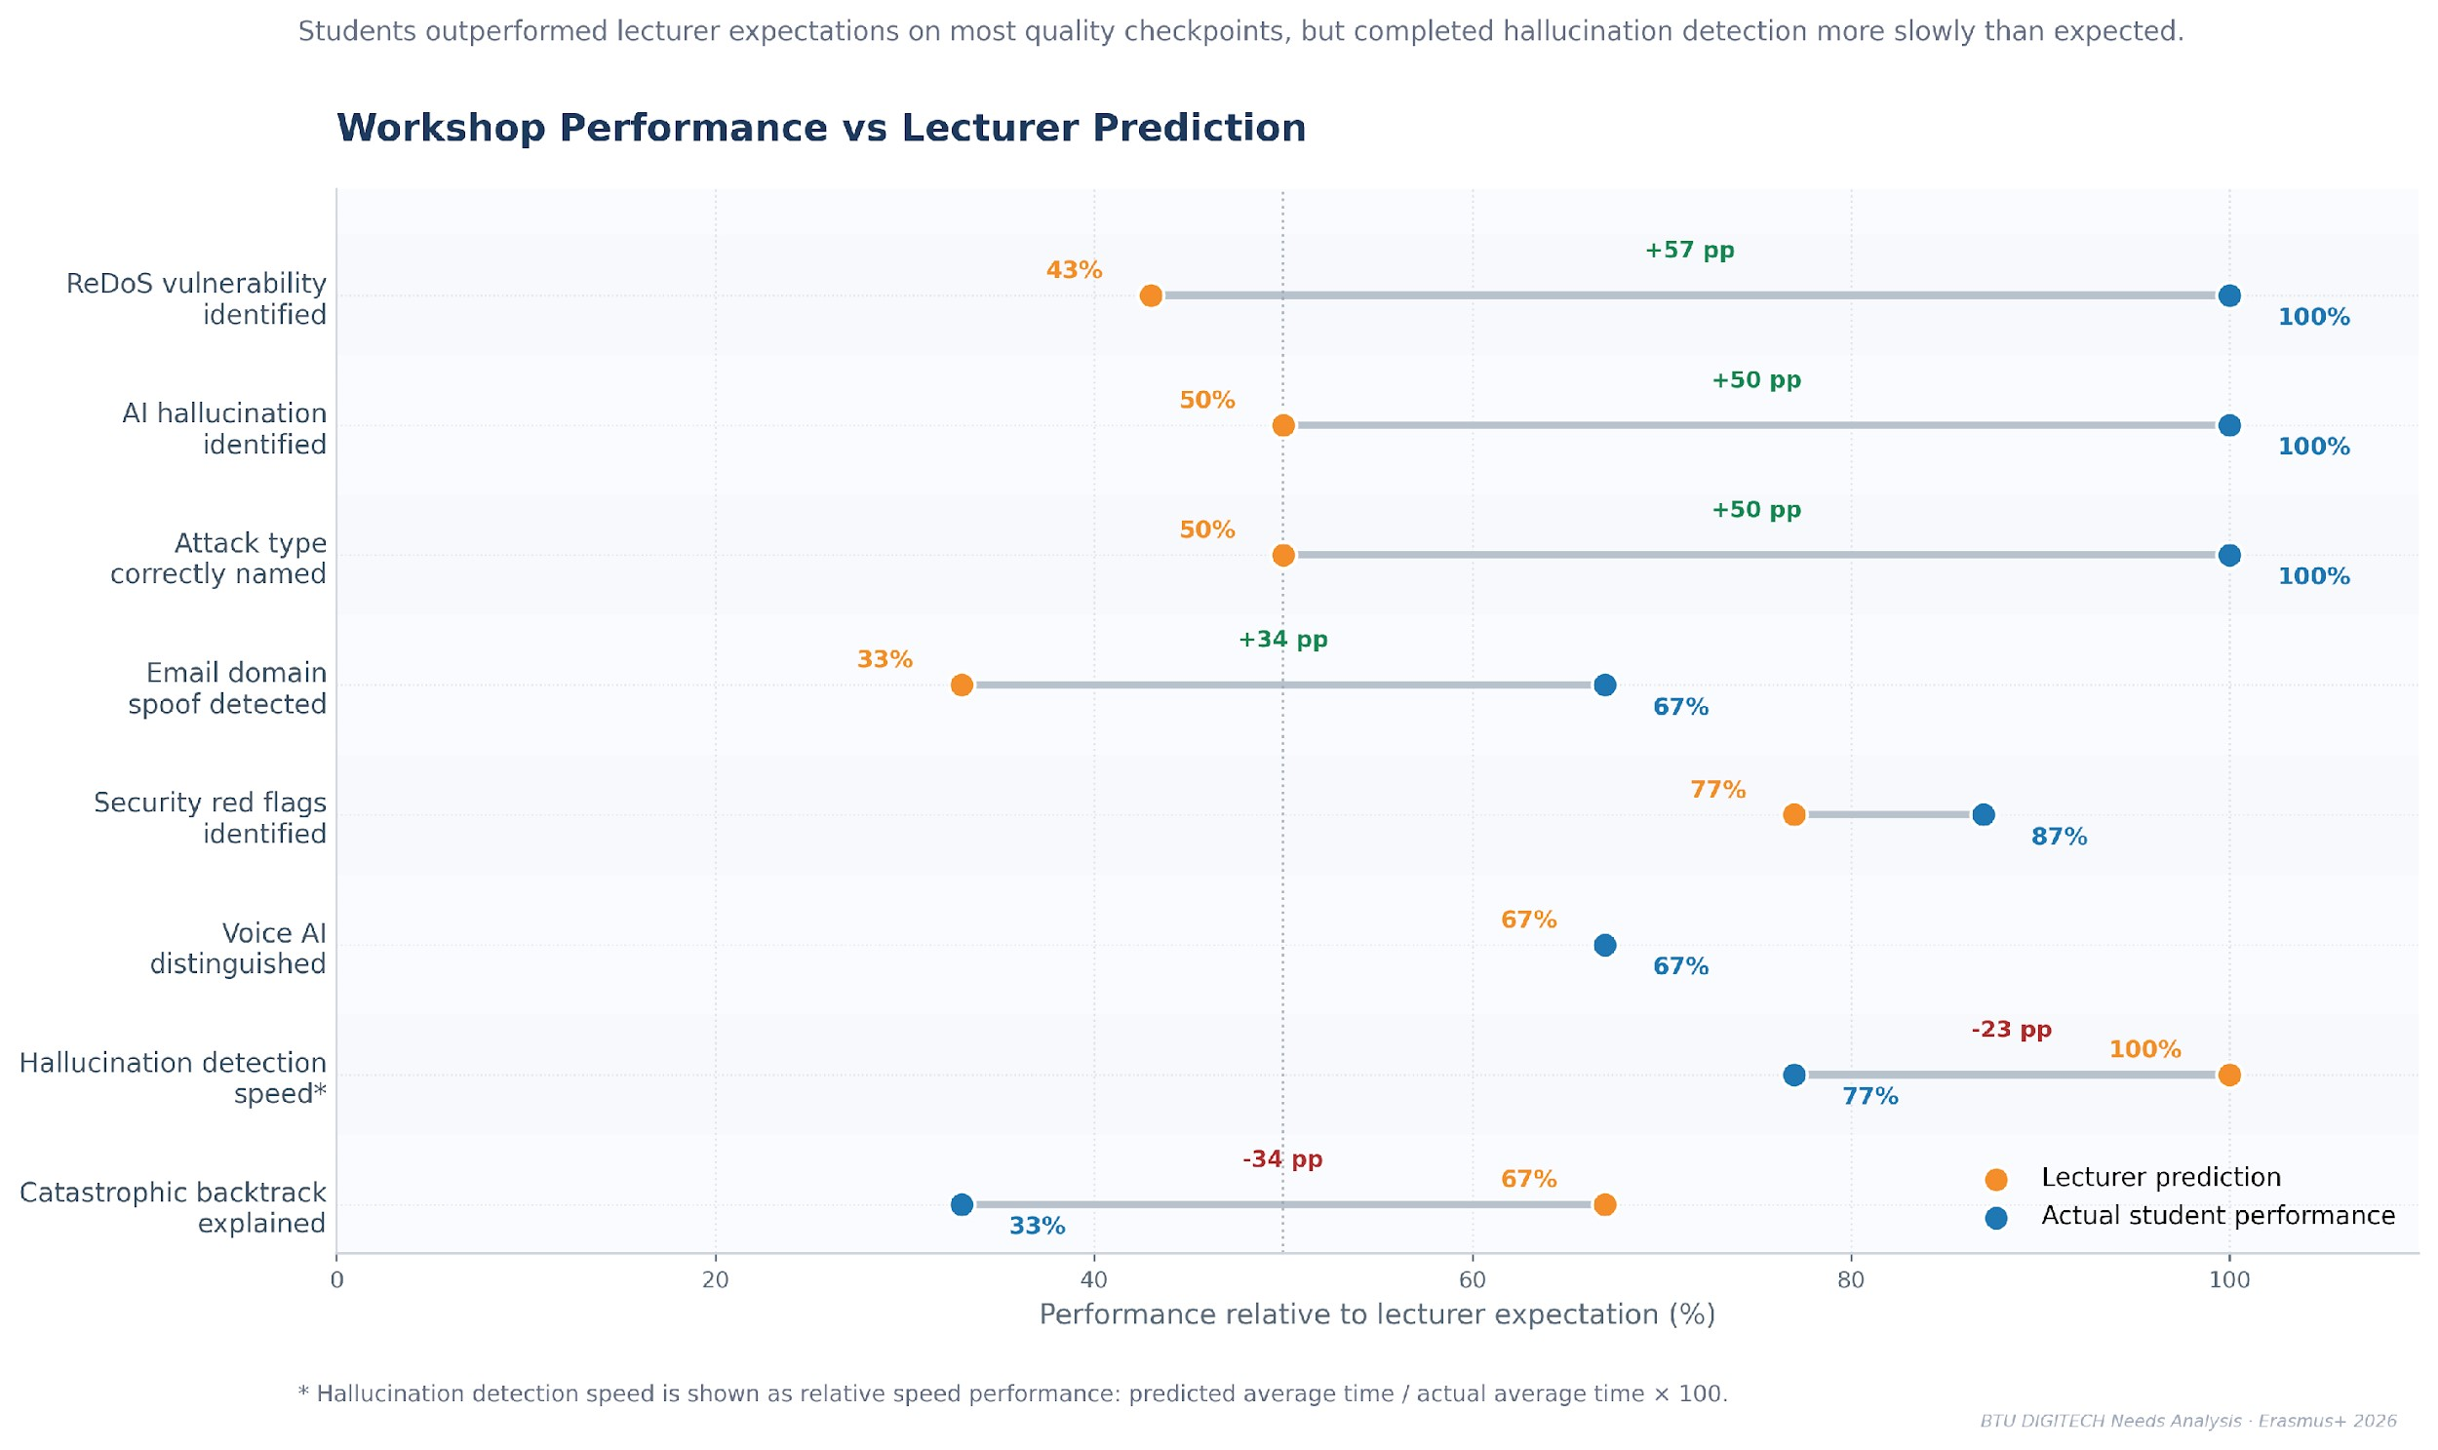
Figure 7.1 Lecturer predictions vs actual student performance across key workshop checkpoints.

7.2 Workshop Completion Times
Completion times varied across scenarios depending on task complexity. Simpler pattern-recognition tasks were resolved quickly, while the vulnerability analysis scenario required longer reasoning and debugging.
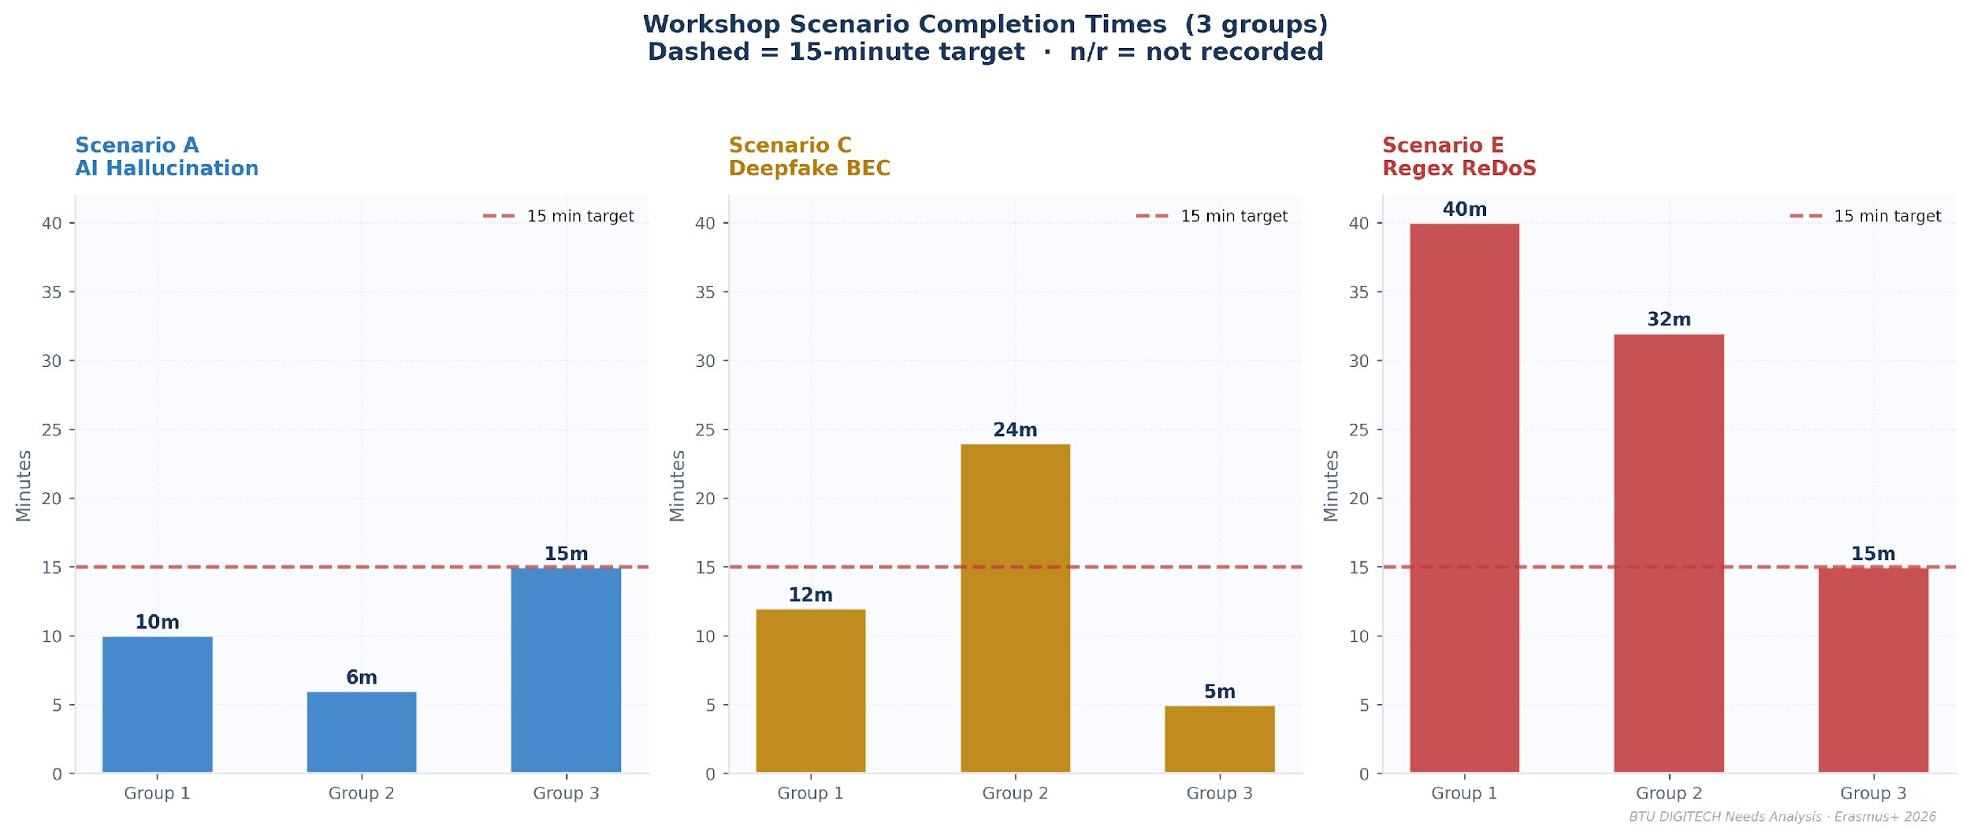

▸ Figure 7.2 Workshop scenario completion times by student group (3 groups). Dashed line = 15-minute target.

7.3 Cross-Workshop Synthesis
Taken together, the workshop exercises provide exploratory insight into how students apply technical reasoning in realistic scenarios. Across the three scenarios, students were generally able to identify the core technical issue, particularly in cybersecurity pattern recognition and debugging tasks. In several checkpoints, student performance exceeded lecturer expectations, indicating that instructors may underestimate students’ practical exposure to contemporary digital tools and threat patterns.
At the same time, the exercises also revealed areas where reasoning depth and workflow discipline were less consistent. While students frequently identified the correct technical problem, their reasoning process sometimes relied on exploratory trial-and-error or tool assistance rather than a structured verification workflow.
These observations broadly align with signals identified in the industry consultation and survey data. Employers emphasise responsible AI usage, debugging ability, and cybersecurity awareness as key early-career competencies, while survey responses suggest that these capabilities are present but unevenly developed among students.
Given the small sample size of the workshop exercises, these results should be interpreted as exploratory observations rather than statistically representative findings. However, they provide useful qualitative insight into how students approach real-world technical problems and where curriculum reinforcement may be beneficial.

8. Strategic Priority Analysis

8.1 Triangulated Priority Matrix
The strategic priority matrix combines two empirical indicators derived from the BTU needs analysis datasets. The horizontal axis represents the percentage of Technical students reporting low confidence (scores ≤3 on a five-point scale; note this threshold differs from the ≤2 cutoff used in Chapter 2, reflecting the broader diagnostic purpose of the matrix), while the vertical axis represents the lecturer-reported frequency of student struggle for related competencies.
Bubble size reflects the divergence between student confidence and reported usage frequency, highlighting areas where perceived capability may not align with actual practice.
By combining these indicators, the matrix provides a comparative overview of where student self-assessment and lecturer observations converge. Competencies located in the upper-right quadrant indicate areas where both student-reported difficulty and lecturer-observed struggle are relatively high, suggesting domains that may warrant additional instructional attention.
The matrix should be interpreted as a strategic diagnostic tool rather than a statistical ranking, helping to identify domains where curriculum reinforcement or instructional design adjustments may be beneficial.
▸ 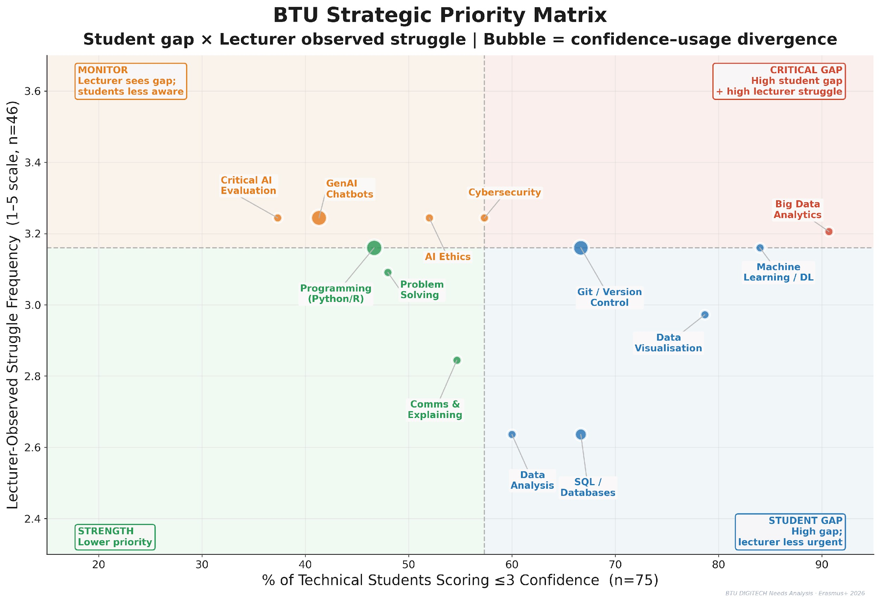
Figure 8.1 BTU Strategic Priority Matrix. Upper-right (Critical Gap) = high student gap + high lecturer-observed struggle. All values computed from actual BTU data.

Critical Gap (upper-right quadrant)
Big Data Analytics appears in the critical gap quadrant. In this area both student self-assessment and lecturer observations indicate relatively higher levels of difficulty compared to other competencies. The alignment of these indicators suggests that Big Data Analytics may warrant additional curricular attention, potentially through expanded applied data analytics components and stronger integration across relevant modules.

Monitor (upper-left quadrant)
Several competencies fall into the monitoring category, including Critical AI Evaluation, Generative AI Chatbots, Cybersecurity, and AI Ethics. In these areas lecturers report relatively frequent student struggle, while students report comparatively higher confidence levels. This divergence may indicate that students underestimate the complexity of these domains or that their perceived competence does not fully align with observed performance in instructional contexts.

Curriculum Gap (lower-right quadrant)
The lower-right quadrant highlights competencies where student confidence gaps are relatively high but lecturer-observed struggle is comparatively lower. These include Machine Learning / Deep Learning, Git / Version Control, Data Visualisation, Data Analysis, and SQL / Databases. This pattern suggests that students find these topics personally challenging but the difficulty does not consistently surface as persistent struggle in classroom observation — pointing to a transfer gap rather than an instructional failure.

Relative Strength (lower-left quadrant)
Programming (Python/R), general problem-solving ability, and communication skills fall within the relative strength quadrant. Both student responses and lecturer observations indicate comparatively lower levels of difficulty in these areas. These competencies therefore represent existing strengths within the BTU learning environment and may serve as a foundation for developing more advanced analytical and AI-related skills.

8.2 Cross-Layer Convergence Summary
The DIGITECH needs analysis integrates evidence from four independent sources:
(1) student survey responses, (2) lecturer observations, (3) industry consultation results, and (4) scenario-based workshop exercises. The table below summarizes where signals across these layers converge or diverge for key competency domains.

Skill Domain | Cross-Layer Evidence Summary
SQL / Databases | Student survey indicates moderate confidence gaps (44% low confidence). Lecturers report moderate learning difficulty. Employers frequently identified database skills as essential (5 of 7 responses). Workshop exercises did not directly assess this competency.
Git / Version Control | 43% of technical students reported low confidence. Lecturers note recurring programming workflow difficulties. Employers strongly emphasised version control as a required skill (5 of 7 responses). Workshop tasks involved indirect exposure through coding activities.
Machine Learning / Deep Learning | Student confidence gaps are relatively high (64% reporting low confidence). Lecturers report moderate-to-high levels of struggle. Employers emphasised the importance of practical AI tools and model understanding. Workshop Scenario A partially engaged related reasoning tasks.
AI Hallucination Detection | Students report high confidence in evaluating AI outputs (77% confident), while lecturers express concern about potential overestimation of this capability. Employers emphasised the importance of understanding AI limitations. All 3 groups correctly identified the hallucinated output; however, reasoning approaches and verification processes varied, with no group demonstrating a coherent structured workflow.
Cybersecurity / BEC Awareness | 37% of students report low confidence. Lecturers noted that student performance exceeded expectations during workshop exercises. Employers highlighted cybersecurity awareness and secure practices as essential competencies. In the workshop scenario, 67% of students correctly identified the phishing attack.
Regex / Secure Coding Reasoning | Student coding confidence appears relatively strong, though lecturers and employers emphasise deeper secure-coding knowledge. Workshop results showed that students were able to identify the ReDoS vulnerability, though explanations of the underlying mechanism varied.
Problem-Solving | Student self-assessment indicates moderate confidence (mean ≈3.5). Lecturer observations suggest moderate levels of difficulty (≈3.09). Employers consistently ranked problem-solving ability as a top hiring priority. Workshop exercises required problem-solving across all scenarios.
Communication Skills | Students report relatively high confidence (mean >3.7). Lecturers observe moderate difficulty in explaining reasoning processes. Employers ranked communication skills as the second most important hiring factor. Workshop exercises included explanation and reasoning tasks.

8.3 Strategic Implications for Curriculum Development
The strategic priority matrix highlights several areas where curriculum development should be prioritised. The analysis combines student confidence data with lecturer observations of learning difficulty, enabling the identification of competencies that require structural improvement within the program.

Immediate curriculum priorities
The strongest convergence between student-reported difficulty and lecturer-observed struggle occurs in areas related to data engineering and advanced AI competencies. These skills represent foundational capabilities for modern digital professions, yet both evidence sources indicate that students currently experience substantial difficulty applying them in practice.
Addressing these gaps will likely require structural curriculum changes rather than incremental improvements. Possible interventions include introducing dedicated modules, expanding hands-on project work, and ensuring that these competencies are reinforced across multiple courses rather than appearing only in isolated classes.

Competencies requiring close monitoring
Some skills demonstrate a notable divergence between student self-perception and lecturer observations. In these cases, students tend to rate their own capabilities relatively highly despite lecturers reporting frequent difficulties when these skills are applied during coursework.
This pattern may reflect overconfidence associated with the accessibility of modern AI tools. While students may feel comfortable interacting with AI systems, they may lack the analytical and verification skills necessary to critically evaluate AI outputs or systematically troubleshoot technical problems. Strengthening assessment methods that emphasise reasoning, validation, and error analysis may help address this issue.

Areas indicating curriculum transfer gaps
Another group of competencies shows relatively high student confidence gaps but lower lecturer urgency. This pattern suggests that students may struggle to apply certain skills beyond structured classroom exercises. In practice-oriented environments, these competencies require stronger cross-course integration and project-based application to bridge the gap between classroom exposure and independent use.
Confirmed strengths
Finally, the analysis indicates that several transversal competencies appear to be well developed among students. These include communication skills and teamwork. Since these skills already perform relatively strongly across the evidence layers, they should be maintained as part of the curriculum but do not currently require substantial additional investment compared with the higher-priority areas identified above.
Under the DIGITECH hype detection criteria, these competencies — particularly Generative AI chatbots and Critical AI Evaluation — are classified as potential hype signals: students report high confidence, but workshop performance and lecturer observations indicate the confidence is not fully substantiated. Curriculum response should focus on verification and reasoning practice rather than expanding AI tool exposure.

9. Recommendations

9.1 Curriculum Redesign Priorities
Based on the combined findings of the student survey, lecturer observations, industry consultation, and workshop exercises, the following curriculum adjustments are recommended in priority order.
Priority | Action
1 — Critical (immediate) | Strengthen the existing Practical Data Engineering module by deepening applied coverage of Big Data processing, SQL databases, Git-based version control, API integration, and cloud command-line tools. These competencies show one of the strongest alignments between employer expectations and the student confidence gaps identified in the analysis.  [Linked findings: F3 (Git/SQL low but reliable), F4 (programming self-report gap), F11 (employer convergence). Evidence layers: student survey + lecturer survey + employer focus group. Status: addresses a Confirmed deficit at BTU (Git/SQL marked ✓ under F3 traceability for employer evidence; 43–44% low-confidence student signal aligns with 5/7 employer Must-Have rating).]
2 — Critical (immediate) | Integrate an AI Verification Protocol across courses. Students should consistently follow a verify → understand → use workflow when working with AI tools. This behaviour should be formalised as an explicit learning outcome.  [Linked findings: F1 (AI chatbot overreliance), F5 (AI eval confidence vs. practice), F6 (AI as default problem solver). Evidence layers: student survey + lecturer survey + workshop (all 3 BTU groups identified hallucination but no coherent verification workflow). Status: addresses a Confirmed deficit at BTU.]
3 — High (next cycle) | Strengthen security-first thinking across programming courses. Workshop exercises indicate that students can identify security threats when prompted, but they do not consistently apply this reasoning proactively during development.  [Linked findings: F9 (theory–practice gap; Partial at BTU). Evidence layers: lecturer survey + workshop (BTU scenarios C and E). Status: addresses a Partial-evidence signal at BTU — workshop performance exceeded lecturer predictions, suggesting calibration issue alongside applied-reasoning gap; treat as targeted curriculum reinforcement rather than structural deficit.]
4 — High (next cycle) | Further enrich the Applied Machine Learning module by expanding hands-on activities in model development, experimentation, evaluation, and operationalisation of ML systems to complement the existing theoretical coverage. Student survey responses indicate comparatively low confidence in ML competencies, suggesting the need for additional applied practice.  [Linked findings: F4 (programming self-report gap; Partial at BTU), F9 (theory–practice gap; Partial at BTU). Evidence layers: student survey (64% low ML confidence) + lecturer survey + employer focus group. Status: addresses a Confirmed within-BTU deficit on ML confidence; sequence behind Git/SQL since employer day-1 priority is lower.]
5 — Medium (12 months) | Establish a Digital Twin / Industry 4.0 laboratory track within the Technical program. Student interest is high while exposure to Industry 4.0 technologies remains limited. Note that Digital Twins is classified as an Emerging-level skill in the DIGITECH taxonomy and was not reported as a current production technology by any of the seven employer respondents. The recommendation is therefore based on forward-looking student demand and industry trajectory rather than current employer deficit signals, and should be treated as a medium-term investment rather than an immediate gap response.  [Linked findings: DT (Digital Twins implication — forward-looking, not a current deficit), F10 (infrastructure/capacity deficit; Partial at BTU). Evidence layers: student survey only. Status: medium-term investment, NOT a confirmed day-1 employer gap; see What Not To Do guardrail and Part I evidence-classification note.]
6 — Medium (12 months) | Introduce a structured portfolio and GitHub development track. Employers consistently emphasise portfolio evidence and project repositories as key hiring signals, yet BTU currently lacks formal portfolio milestones.  [Linked findings: F3 (Git/SQL low but reliable), F7 (self-learning dominates — needs formal structuring), F11 (employer priority convergence on portfolio & project evidence). Evidence layers: student survey + employer focus group (hiring-signal ranking). Status: addresses a Confirmed deficit at BTU.]
7 — Medium (12-18 months) | To bridge the gap between traditional university degrees and the evolving needs of employers , who ranked university credentials lowest among hiring signals, BTU should develop a system of micro-credentials or digital badges aligned with the 2022 Council of the European Union Recommendation on Micro-credentials. Specifically, BTU could introduce micro-credentials such as "DIGITECH AI Verification" or "Cloud & Git Practitioner". These short, rigorously assessed, and industry-endorsed certifications will provide students with verifiable proof of their "Day-1" readiness, directly addressing the issue of "AI-polished, hollow CVs" identified by industry partners.  [Linked findings: F8 (no formal AI training received), F11 (employer priority convergence; university credentials ranked lowest as hiring signal). Evidence layers: student survey + employer focus group. Status: medium-term investment — institutional credentialing innovation that complements the Confirmed Git/SQL/AI-verification curriculum actions above.]

9.2 Pedagogical Recommendations
- Recalibrate lecturer expectations regarding student capability. Workshop exercises suggest that lecturers may occasionally underestimate student performance in some cybersecurity tasks. Assessment design and difficulty calibration should therefore be periodically reviewed.
- Shift assessment from knowledge recall toward decision-making practice. Industry consultation consistently highlights problem-solving and communication as key hiring signals. Scenario-based and case-driven assessments may therefore provide stronger preparation than traditional recall-based testing formats.
- Introduce peer-reviewed portfolio milestones. Structured GitHub portfolio checkpoints (e.g., Year 2, Year 3, and capstone stage) can support the development of demonstrable project experience aligned with employer expectations.
- Strengthen curriculum design literacy in lecturer development programs. Lecturer surveys indicate moderate uncertainty in areas such as learning outcome specification and competency alignment. Faculty development initiatives may therefore support more effective implementation of competency-based curricula.
- Formalise the AI Verification Protocol as a transferable skill standard. The verify → understand → use workflow should appear explicitly in course learning outcomes and be assessed across multiple modules.

9.3 Industry Engagement
- formalise the employer advisory structure. The seven participating industry partners could be organized into an annual advisory panel supporting program review and curriculum alignment.
- Co-design industry-sponsored capstone projects. Employer participation in capstone supervision can strengthen practical learning while simultaneously addressing portfolio and real-world project experience gaps.
- Pilot an AI-literacy diagnostic at program entry. Given the observed differences between perceived and demonstrated AI-evaluation skills, a short diagnostic assessment may help identify students requiring additional foundational training.
These recommendations collectively aim to strengthen alignment between student skill development, instructional practice, and evolving industry expectations while preserving existing strengths within the BTU learning environment and supporting gradual curriculum evolution.

Appendix A: Methodology Notes

A.1 Scale Encoding
Variable | Encoding
Student tool confidence | 1–5 Likert (1 = No confidence, 5 = Expert)
Usage frequency | 1 = Never, 2 = Monthly, 3.5 = Weekly, 5 = Daily (linear interpolation)
Lecturer struggle | 1=Never, 2=Rarely, 3=Sometimes, 4=Often, 5=Very Often / Almost Always. Not Relevant excluded.
Industry day-1 readiness | A = 3 (Must Have), B = 2 (Should Have), C = 1 (Nice to Have)
Workshop performance | Count of groups out of 3 demonstrating each behaviour or reaching each checkpoint

A.2 BTU Data Filter
All student and lecturer data filtered by: "What is the name of your university?" == "Business and Technology University". Consortium-wide n=809 students, 142 lecturers. BTU n=203 students, 46 lecturers.

A.3 Data Integrity and Sources
Industry questionnaire: 7 respondents. Hiring signal rankings were completed by 4 respondents; the remaining 3 either used non-ranking response formats or did not complete the ranking section. Open-ended responses were thematically clustered by the analysis team.
Workshop data: Outcome counts are based on facilitator observation notes and group submission materials. No hardcoded or synthetic values appear in any figure in this report.
Local adaptations to the DIGITECH methodology: (1) The employer component was conducted via individual structured questionnaires rather than a focus group format; findings should be interpreted accordingly given the absence of group discussion dynamics. (2) The workshop component focused on Hands-On Scenario performance and lecturer prediction tracking; the Skill Mapping Discussion and Prioritisation Exercise components were not implemented in this cycle. These adaptations are documented here in accordance with the methodology's local adaptation guidelines.

A.4 Limitations
- Technical cohort n=75 produces confidence intervals of approximately ±0.3–0.4 on mean scores. Point estimates should be interpreted with this range in mind.
- Industry sample n=7 is small; findings should be treated as directional signals from engaged partners rather than representative of the Georgian employer landscape broadly.
- Workshop performance is based on 3 groups only. Patterns are indicative and require replication at scale to be generalisable.
- Self-report bias: Student confidence scores reflect perceived, not demonstrated, capability. Workshop data provides partial triangulation for three competency areas only.

Part III — Needs Analysis Methodology
DIGITECH Erasmus+ CBHE · Deliverable D2.1 · Task 2.1

Methodology for Needs Analysis
Erasmus+ CBHE DIGITECH
Project partners:
No. | Partner Name | Partner Abbreviation | Address | Country | Role
1 | OSH TECHNOLOGICAL UNIVERSITY | OshTU | ISANOVA STREET 81, 723503 OSH | Kyrgyzstan | Coordinator
2 | HOCHSCHULE FÜR ANGEWANDTE WISSENSCHAFTEN HAMBURG | HAW | BERLINER TOR 5, 20099 HAMBURG | Germany | Project member (EU)
3 | UNIVERZA V MARIBORU | UM | SLOMŠKOV TRG 15, 2000 MARIBOR | Slovenia | Project member (EU)
4 | KYRGYZ-GERMAN INSTITUTE OF APPLIED INFORMATICS | INAI.kg | LENINSKY DISTRICT, TIMIRY AZEV STREET 74, 720048 BISHKEK | Kyrgyzstan | Project member
5 | YEREVAN STATE UNIVERSITY FOUNDATION | YSU | 1A MANOOGIAN, 0025 YEREVAN | Armenia | Project member
6 | ARMENIAN STATE UNIVERSITY OF ECONOMICS | ASUE | NALBANDYAN 128 000, 0025 YEREVAN | Armenia | Project member
7 | GEORGIAN TECHNICAL UNIVERSITY | GTU | KOSTAVA 77, 0175 TBILISI | Georgia | Project member
8 | BUSINESS AND TECHNOLOGY UNIVERSITY LLC | BTU | CHAVCHAVADZE AVENUE 82, 0175 TBILISI | Georgia | Project member


Disclaimer: Views and opinions expressed are those of the author(s) only and do not necessarily reflect those of the European Union or the European Education and Culture Executive Agency. Neither the EU nor the granting authority can be held responsible for them.
Document metadata:
Deliverable title | Needs Analysis Methodology
Deliverable number | D2.1
Contractual date of delivery | M6 (1st April, 2026)
Actual date of delivery
Nature of deliverable | Report
Dissemination level | Public
Work Package | WP2
Task(s) | Task 2.1
Partner responsible | BTU
Abstract | Deliverable D2.1 defines the common methodology for conducting the DIGITECH needs analysis in the project’s non-EU partner countries, ensuring that local priorities are captured while results remain comparable across the consortium. The methodology identifies real, labour-market relevant digital and Industry 4.0 skill gaps and reduces “hype-driven” bias by separating stated needs from revealed behaviour and demonstrated ability. The outputs guide context-appropriate curriculum modernization and capacity-building actions in non-EU partner institutions under WP2.
Keywords | Needs analysis; Skills gap assessment; Digital competencies; AI readiness; Industry 4.0; Triangulation; Curriculum modernization; Hype vs. reality

Change log & version history:
Version: | Publication date | Changes | Author(s)
1.0 | 13th January 2026 | Initial version approved by JCC

1. Overview
This methodology provides a unified framework for conducting comprehensive needs analysis across all partner institutions in the DIGITECH project. The methodology is designed to identify genuine skill gaps while accounting for the tendency of stakeholders to express hype-driven expectations.

1.1 Core Principle: Hype vs. Reality
A critical challenge in needs assessment is that stakeholders often express hype-driven expectations rather than actual skill gaps. Students report interest in trending topics they have seen in the media. Employers state they need "AI talent" because it sounds strategic. Universities include "digital transformation" in documents because it attracts funding.
To address this, the methodology distinguishes between:
- Stated preferences: What stakeholders say they want or need (hype-prone)
- Revealed behavior: What stakeholders actually do in practice (reality-grounded)
- Demonstrated ability: What stakeholders can show through practical tasks (objective)

1.2 Three Assessment Components
Component | Method | Target | Data Type
Students | Online questionnaire + Workshop | Min 15% response (Primary) | Quantitative + Qualitative
Lecturers | Online questionnaire | Min 15% response | Quantitative + Qualitative
Employers | Focus group / Interviews + Mini-workshop | 5-8 organizations | Qualitative

2. Target Groups
To ensure relevance and achieve required response rates, students and programs are categorized into two target groups based on their relationship to project goals.

2.1 Primary Target Group (Technical Programs)
Programs directly preparing students for technical roles involving Industry 4.0 technologies, data analytics, AI, and automation.
Response rate requirement: Minimum 15% from selected audience.
Example programs:
- Automation of technological processes and production/ Mechatronics
- Robotics
- Computer Science
- Artificial Intelligence
- Information Technology
- Information Systems
- Software Engineering
- Data Science
- Cybersecurity
- Mechanical Engineering and Technology
- Industrial Engineering

2.2 Secondary Target Group
Programs preparing students for business or other analytical roles where digital and AI literacy is increasingly important, but not the primary focus.
Response rate: Desirable but not mandatory to reach 15%. Results analyzed if sufficient responses are received.
Example programs:
- Business Administration
- Economics
- Psychology
- International Security
- Sociology
- Political Science
- Media and Communication Studies
- Public Policy Analysis
- Health and Life Sciences (where technology/data focus exists)

2.3 Partner Institution Mapping
Each partner institution must:
- List all relevant programs offered
- Categorize each program as Primary or Secondary
- Document student enrollment numbers per program
- Prioritize Primary group for achieving 15% response rate

3. Skills Taxonomy
The skills taxonomy is structured around industry role clusters and organized by skill maturity level. This ensures assessment is aligned with actual labor market demands rather than academic categorizations.

3.1 Role Clusters
Skills are organized by the industry roles that graduates typically enter:
Role Cluster | Entry-Level Roles | Typical Programs
DATA & ANALYSIS | Business Analyst, Data Analyst, Financial Analyst, Marketing Analyst, BI Analyst | Business Admin, Finance, Marketing, Economics, Analytics
TECHNICAL | Junior Developer, DevOps Engineer, QA Engineer, Data Engineer, IT Administration, Automation Engineer | Computer Science, IT, Software Engineering, Information Systems, Mechanical Engineering and Technology, Industrial Engineering, Automation of Technological Processes and Production / Mechatronics, Robotics
BUSINESS OPERATIONS | Operations Specialist, Project Coordinator, Product Assistant, Account Manager | Management, Business Admin, non-technical programs

3.2 Skill Levels
Level | Definition | Characteristics
FUNDAMENTAL (F) | Essential skills expected of any graduate on Day 1 of employment | Stable 10+ years; Often overlooked; High actual deficit frequency
APPLIED (A) | Professional skills required for specific job functions | Stable 5+ years; Production-validated; Employer-demanded
EMERGING (E) | New technologies and approaches gaining market adoption | High media attention; Rapidly evolving; Hype-prone

3.3 Technology Domain Taxonomy
For questionnaire construction, technologies are grouped by target audience:

3.3.1 Core Technologies (Priority for Technical Programs)
- Machine Learning (ML) & Deep Learning
- Big Data Analytics
- Industrial Automation / IoT /PLC-SCADA Systems
- Process Automation & Control Systems
- Sensor/Actuator Integration & Embedded Systems
- Cloud Computing & DevOps
- Digital Twins & Simulation

3.3.2 Business & Applied Technologies (Priority for Business Programs)
- Data-Driven Decision Making
- AI Tools for Business (GenAI, automation)
- Digital Process Management
- Business Intelligence & Analytics

3.3.3 Cross-Cutting (All Programs)
- Responsible AI & Ethics
- AI Output Verification & Critical Evaluation
- Cybersecurity Fundamentals
- Real-World Case Application

3.3.4 Soft Skills (All Programs)
Essential interpersonal and cognitive skills required alongside technical competencies:
- Communication (written and oral, technical and non-technical audiences)
- Teamwork & Collaboration (including remote/distributed teams)
- Problem-Solving & Critical Thinking
- Time Management & Self-Organization
- Adaptability & Continuous Learning
- Presentation & Visualization of Information

3.4 Skills by Operational Context

3.4.1 Data & Analysis Cluster
Context | Specific Capability | Level
Receive Data | Open and navigate CSV, Excel, database exports | F
 | Recognize file formats, encodings, delimiters | F
 | Run provided SQL query, export results | A
Assess Quality | Identify missing values, duplicates, outliers | F
 | Question data source and collection method | F
 | Validate data against business logic | A
Transform | Filter, sort, deduplicate data | F
 | Create pivot table from raw data | A
 | Merge datasets using lookup/JOIN | A
 | Write SQL SELECT with WHERE, GROUP BY | A
Analyze | Calculate and interpret descriptive statistics | F
 | Distinguish correlation from causation | F
 | Perform segment/cohort analysis | A
Visualize | Choose appropriate chart type for data | F
 | Identify misleading visualizations | F
 | Build functional dashboard | A
Report | Write findings for non-technical audience | F
 | Recommend actions based on evidence | A

3.4.2 Technical Cluster
Context | Specific Capability | Level
Navigate Code | Read and understand unfamiliar code | F
 | Search codebase effectively | F
Write Code | Write functions with clear inputs/outputs | F
 | Handle errors appropriately | A
 | Write tests for own code | A
Debug | Read and interpret error messages | F
 | Isolate problem through systematic testing | A
Version Control | Clone, commit, push, pull | F
 | Branch, merge, resolve simple conflicts | A
Data Operations | SQL: CRUD, JOINs, aggregations | A
 | Work with APIs (REST, JSON/XML) | A
Infrastructure | Command line proficiency | F
 | Basic cloud concepts (compute, storage) | A
 | Containerization basics (Docker) | A
 | CI/CD pipeline concepts | A
Industry 4.0 | Understand Digital Twin concepts | E
 | Industrial automation/  IoT/sensor integration basics | E

3.4.3 Business Operations Cluster
Context | Specific Capability | Level
Process Execution | Follow documented procedures accurately | F
 | Recognize edge cases not covered | A
Documentation | Write emails with clear action items | F
 | Document decisions, owners, deadlines | F
 | Create procedures others can follow | A
Data Handling | Spreadsheet proficiency for tracking/reporting | F
 | Validate data before submission | F
Systems | Learn new software independently | F
 | Navigate CRM/ERP systems | A
 | Use project management tools | A
Communication | Translate technical ↔ business language | A
 | Escalate issues appropriately | F

3.4.4 AI Readiness (Cross-Cutting)
Required for all clusters:
Capability | Why It Matters | Level
Write effective prompt (useful output in 2-3 tries) | Productive AI usage | F
Identify factual errors in AI output | Quality control | F
Recognize AI hallucination/confabulation | Risk mitigation | F
Explain AI limitations to non-technical person | Appropriate expectations | F
Verify AI output against reliable sources | Professional responsibility | A
Judge when AI is appropriate vs. not | Appropriate use | A
Identify ethical concerns (bias, privacy, attribution) | Responsible AI | A

4. Student Questionnaire
Estimated completion time: 10-12 minutes
The questionnaire captures both stated preferences (confidence, wishes) and revealed behavior (actual usage). This enables comparison to detect hype-driven responses.
Note: Questions 4-5 use differentiated tool lists based on target group (Technical vs Business).

4.1 Section A: Demographics
1. What is the name of your university?
(List of Universities)
2. What study program are you enrolled in?
- Business Administration (Finance, Marketing, Management)
- Economics
- Artificial Intelligence
- Computer Science
- Information Technology
- Information Systems
- Software Engineering
- Data Science
- Mechanical Engineering
- Industrial Engineering
- Psychology
- Sociology
- Political Science
- Media and Communication Studies
- Public Policy
- Health and Life Sciences
- International Security
- Automation of Technological Processes and Production / Mechatronics
- Robotics
- Other
What is your age?
(Open numeric field: _____ years)
3. What is your gender?
○ Male ○ Female ○ Prefer not to say
4. What is your study mode?
○ Full-time ○ Part-time ○ Other
5. What is your current study level?
○ Bachelor's ○ Master's ○ Other
6. Year within your current level
○ 1st year ○ 2nd year ○ 3rd year ○ 4th year ○ N/A (returning/irregular)
7. How would you rate your overall digital/technical skill level?
○ Beginner ○ Basic ○ Intermediate ○ Advanced ○ Highly Advanced

4.2 Section B: Self-Assessed Confidence (Stated)
Scale: 1 = Not confident at all, 5 = Very confident
8. How confident are you in using or understanding the following tools?
All students:
- Generative AI chatbots (ChatGPT, Gemini, Claude etc.) [1] [2] [3] [4] [5]
- AI image or data generation tools [1] [2] [3] [4] [5]
- Data analysis tools (Excel advanced features, Python platforms/libraries) [1] [2] [3] [4] [5]
- Data visualization tools (Excel charts, Tableau, Power BI, Python platforms/libraries) [1] [2] [3] [4] [5]
- Cloud platforms (Google Cloud Platform, Microsoft Azure, Amazon Web Services, Databricks) [1] [2] [3] [4] [5]
For Technical programs only (Core Technologies):
- Programming tools (Python, R) [1] [2] [3] [4] [5]
- Machine Learning / Deep Learning tools/frameworks [1] [2] [3] [4] [5]
- Big Data Analytics platforms [1] [2] [3] [4] [5]
- Cloud Computing & DevOps tools [1] [2] [3] [4] [5]
- Industrial Automation / IoT / PLC-SCADA technologies [1] [2] [3] [4] [5]
- Process Automation & Control Systems [1] [2] [3] [4] [5]
- Version control (Git, GitHub, GitLab) [1] [2] [3] [4] [5]
- SQL / Database queries [1] [2] [3] [4] [5]
- Working with APIs (consuming, building)
For Business and Other programs only (Applied Technologies):
- Data-Driven Decision Making tools [1] [2] [3] [4] [5]
- AI Tools for Business (automation, assistants) [1] [2] [3] [4] [5]
- Digital Process Management systems [1] [2] [3] [4] [5]
- ERP systems (SAP, Oracle, Microsoft Dynamics etc.) [1] [2] [3] [4] [5]
9. How confident are you in performing these tasks?
- Evaluating whether information generated by AI is accurate [1] [2] [3] [4] [5]
- Applying basic AI ethics principles (privacy, fairness, responsible use) [1] [2] [3] [4] [5]
- Creating effective prompts for AI tools [1] [2] [3] [4] [5]
- Managing and completing digital tasks in group projects [1] [2] [3] [4] [5]
- Creating clear digital presentations or visual materials [1] [2] [3] [4] [5]
- Describing a simple automated or digital process in your own words [1] [2] [3] [4] [5]
- Troubleshooting basic technical issues independently [1] [2] [3] [4] [5]
- Learning a new digital skill without guidance [1] [2] [3] [4] [5]
- Following safe cybersecurity practices [1] [2] [3] [4] [5]
10. How confident are you in these soft skills?
- Communicating technical concepts to non-technical audiences [1] [2] [3] [4] [5]
- Working effectively in teams (including remote collaboration) [1] [2] [3] [4] [5]
- Managing time and meeting deadlines independently [1] [2] [3] [4] [5]
- Adapting to new tools or methods quickly [1] [2] [3] [4] [5]
- Presenting information clearly (oral and written) [1] [2] [3] [4] [5]

4.3 Section C: Actual Tool Usage (Revealed)
These questions measure what you actually do, not what you want.
11. In your course projects or assignments this semester , which tools/frameworks did you actually use?
(Select all that apply)
□ Excel / Google Sheets
□ Python
□ R
□ SQL / Database queries
□ Git / Version control
□ ChatGPT / Claude / Gemini / other AI
□ Data visualization tools (Tableau, Power BI)
□ Cloud platforms (Google Cloud Platform, Microsoft Azure, Amazon Web Services, Databricks)
□ APIs (consuming or building web services)
□ None of these
12. How often do you use each of the following in your studies?
(Never / Monthly / Weekly / Daily)
- Spreadsheets (Excel/Google Sheets): Never ○ Monthly ○ Weekly ○ Daily ○
- Programming languages: Never ○ Monthly ○ Weekly ○ Daily ○
- AI chatbots: Never ○ Monthly ○ Weekly ○ Daily ○
- Querying Databases (SQL): Never / Monthly / Weekly / Daily
- Version control (Git): Never ○ Monthly ○ Weekly ○ Daily ○
- Cloud platforms: Never ○ Monthly ○ Weekly ○ Daily ○

4.4 Section D: Industry 4.0 Readiness (Technical Programs Only)
These questions assess preparedness for highly automated work environments.
13. To what extent do your current courses cover practical applications of Industry 4.0 technologies (e.g., AI integration with physical systems, connecting software with hardware/sensors, automation)?
○ Not at all ○ Minimally ○ Somewhat ○ Extensively ○ Very extensively
14. How prepared do you feel to work in a highly automated environment where AI agents or Digital Twins (virtual replicas of physical systems used for simulation and monitoring) are part of the workflow?
○ Not prepared at all ○ Slightly prepared ○ Moderately prepared ○ Well prepared ○ Very well prepared
15. Would you be interested in a specialized laboratory course focused on Digital Twins (virtual replicas of physical systems), where you simulate real-world industrial processes?
○ Not interested ○ Slightly interested ○ Moderately interested ○ Very interested ○ Extremely interested
16. How familiar are you with industrial automation concepts (PLC programming, SCADA systems, process control)?
○ Not familiar at all ○ Slightly familiar ○ Moderately familiar ○ Very familiar ○ Expert level

4.5 Section E: Friction Points
17. Describe a specific moment in your coursework where you felt stuck due to a technical or digital skill gap. What was the obstacle?
(Open response)
18. When you encounter a technical problem during coursework, what do you typically do FIRST?
○ Ask a classmate ○ Search online ○ Use AI chatbot ○ Ask instructor ○ Give up/skip ○ Other

4.6 Section F: Learning Sources & Wishes
19. What are your main sources for developing digital/AI skills?
(Select all that apply)
- □ University courses
- □ University-provided training or workshops
- □ Self-learning (YouTube, online tutorials, articles, books, other)
- □ Online courses (Coursera, Udemy, edX, other)
- □ Training from external organizations or companies
- □ Friends, classmates, or colleagues
- □ Social media
- □ I have not developed these skills yet
20. If you have received any training, what specific topics or skills did it cover?
(Open response)
21. What additional digital, AI, or technological skills would you like to develop to better prepare for your studies or career?
(Open response - Note: This captures wishes; will be compared with revealed behavior and employer needs)

5. Lecturer Questionnaire
Estimated completion time: 10-12 minutes
The lecturer questionnaire captures both personal development needs and third-party observations of student deficits—a critical triangulation source.

5.1 Section A: Profile
- Name and Surname
(Open response)
- What is your Age?
○ Under 30 ○ 30-59 ○ 60+
- What is your gender?
○ Male ○ Female ○ Prefer not to say
- What is your employment type in University?
○ Full-time ○ Part-time ○ Adjunct/Visiting ○ Other
- What subject area or direction do you primarily teach?
(Select one)
  - Computer Science / IT
  - Engineering (Mechanical, Industrial, Electrical)
  - Business / Management / Administration
  - Economics / Finance
  - Mathematics / Statistics
  - Natural Sciences
  - Social Sciences
  - Health and Life Sciences
  - Other (please specify): _____
- How many years of teaching experience do you have?
(Open numeric field: _____ years)
- How would you describe your approach to technology in teaching?
○ Early adopter (try new tools quickly) ○ Mainstream (adopt when proven) ○ Cautious (prefer established methods)

5.2 Section B: Teaching Challenges
- What are the main challenges you face in providing students with technologically up-to-date education?
(Open response)
- Are there limitations in your study program structure that restrict integration of digital/AI content?-
(Open response)
- Are there infrastructural barriers (e.g. hardware, software, connectivity, access to external services/APIs) that make technology-enhanced teaching difficult?
(Open response)

5.3 Section C: Observed Student Deficits
These questions capture your observations of students—providing third-party validation of skill gaps.
- What skill deficits do you observe most frequently in students during practical assignments?
(Open response)
- What prerequisite knowledge or skills are students most commonly lacking when they enter your course?
(Open response)
- How often do students struggle with each of the following in your courses?
(Not Relevant for my course / Never / Rarely / Sometimes / Often / Very Often)
- Basic data handling (Excel, CSV, JSON files, databases): Never ○ Rarely ○ Sometimes ○ Often ○ Very Often ○ Not Relevant for my course ○
- Statistical interpretation: Never ○ Rarely ○ Sometimes ○ Often ○ Very Often ○Not Relevant for my course ○
- Programming logic: Never ○ Rarely ○ Sometimes ○ Often ○ Very Often ○ Not Relevant for my course ○
- Documentation and reporting: Never ○ Rarely ○ Sometimes ○ Often ○ Very Often ○ Not Relevant for my course ○
- Critical evaluation of sources/AI outputs: Never ○ Rarely ○ Sometimes ○ Often ○ Very Often ○
- Independent problem-solving: Never ○ Rarely ○ Sometimes ○ Often ○ Very Often ○
- Communication skills (written/oral): Never ○ Rarely ○ Sometimes ○ Often ○ Very Often ○
- Teamwork and collaboration: Never ○ Rarely ○ Sometimes ○ Often ○ Very Often ○
- Time management: Never ○ Rarely ○ Sometimes ○ Often ○ Very Often ○

5.4 Section D: Technology Domain Assessment (Two-Stage Ranking)
Stage 1: Domain Prioritization
- Please rank these four technology domains by how much improvement your students need overall.
(1 = most improvement needed, 4 = least improvement needed)
Rank | Domain
___ | A. AI & Data Intelligence (ML, Big Data, Analytics, AI Tools)
___ | B. Industrial & Process Technology (Automation, IoT, Digital Twins, Process Management)
___ | C. Digital Infrastructure (Cloud/DevOps, Cybersecurity, Data Handling, Programming)
___ | D. Governance & Human Skills (Responsible AI, Soft Skills)

Stage 2: Within-Domain Prioritization
- Within each domain, rank the specific competencies by improvement needed.
(1 = most improvement needed)
A. AI & Data Intelligence (rank 1-4)
Rank | Competency
___ | Machine Learning / Deep Learning
___ | Big Data Analytics
___ | Data-Driven Decision Making
___ | AI Tools for Business
B. Industrial & Process Technology (rank 1-4)
Rank | Competency
___ | Industrial Automation / IoT / PLC-SCADA
___ | Process Automation & Control Systems
___ | Digital Twins & Simulation
___ | Digital Process Management
C. Digital Infrastructure (rank 1-4)
Rank | Competency
___ | Cloud Computing & DevOps
___ | Cybersecurity Fundamentals
___ | Basic Data Handling (Excel, databases, APIs)
___ | Programming Fundamentals
D. Governance & Human Skills (rank 1-2)
Rank | Competency
___ | Responsible AI & Ethics
___ | Soft Skills (communication, teamwork, time management)

5.5 Section E: Personal Development Needs
- In which areas do you personally need upskilling to better integrate digital/AI components into your teaching?
(Open response)
- What do you currently do to develop your own digital/AI skills?
(Open response)
- What support or resources would help you most in improving the technological component of your teaching?
(Open response)

5.6 Section F: Curriculum Design Competencies
- How confident are you in the following curriculum design tasks?
(Scale: 1 = Not confident at all, 5 = Very confident)
- Structuring a study program (what to teach in which year/semester) [1] [2] [3] [4] [5]
- Horizontal integration of courses (courses within same semester) [1] [2] [3] [4] [5]
- Vertical integration of courses (sequential progression across years) [1] [2] [3] [4] [5]
- Integrating electives and free electives into curriculum [1] [2] [3] [4] [5]
- Using Bloom's taxonomy when designing learning outcomes [1] [2] [3] [4] [5]
- Writing clear and measurable learning outcomes [1] [2] [3] [4] [5]
- Converting student workload hours into credit points (e.g. ECTS) [1] [2] [3] [4] [5]
- Specifying course objectives clearly [1] [2] [3] [4] [5]
- Defining prerequisite competencies for course entry [1] [2] [3] [4] [5]
- Defining competencies obtained after course completion [1] [2] [3] [4] [5]
- Selecting appropriate teaching methods for content [1] [2] [3] [4] [5]
- Designing effective assessment/grading methods [1] [2] [3] [4] [5]
- In which curriculum design areas would you benefit from additional training?
(Open response)

6. Employer Focus Group Protocol
Duration: 45-60 minutes | Format: Focus group (5-8 participants) or individual interviews

6.1 Participant Selection
Critical requirement: Participants must be hiring managers or supervisors who directly work with entry-level employees not HR generalists or executives.
Recommended mix:
- Large organizations (250+ employees): 2 representatives
- SMEs (10-249 employees): 3 representatives
- Startups (<10 employees): 2 representatives
- Public sector: 1 representative

6.2 Baseline Data Integration
Before the focus group, review any existing employer data from the institution (e.g., partner company surveys, industry advisory board feedback). Use this as a baseline for discussion—validate, deepen, and update findings.

6.3 Discussion Questions

Part 1: Grounding in Reality (10 min)
- How many entry-level employees have you hired in the past 12 months?
- Can you describe a specific recent hire who struggled with digital/technical tasks? What exactly couldn't they do?

Part 2: Retrospective Deficit Analysis (20 min)
- Which specific digital skills do you find most lacking among recent graduates? How do these gaps affect day-to-day work?
- Which tools or software do graduates struggle with most when they start? What difficulties do you observe?
- What should graduates be able to do on Day 1 but typically cannot?
- Beyond technical skills, which soft skills (e.g. communication, teamwork, time management) do graduates most commonly lack?

Part 3: Hype Filter (10 min)
- For each technology area, indicate your organization's status:
(Using NOW in production / Planning to next year / Planning in 2-5 years / Planning in 5+ years / Not relevant)
- Generative AI (ChatGPT, Gemini, Claude etc.)
- Machine Learning / Predictive models
- Cloud platforms (Google Cloud Platform, Microsoft Azure, Amazon Web Services, Databricks)
- Data analytics / BI tools
- Process automation
- Digital Twins / Industrial simulation
- Industrial Automation / IoT / PLC-SCADA
- For technologies you're using NOW: Do entry-level employees need to use them, or only specialists?

Part 4: Forward Look (10 min)
- As Industry 4.0 technologies evolve, which specific skills and competencies do you expect to become more important for young employees in the next year / in 2-5 years / in 5+ years?
- Which specific technical and soft skills should universities prioritize in training?

7. Workshop Component
Purpose: Direct observation of skills to validate self-reported confidence. This is the most hype-proof assessment method.
The workshop provides a structured environment to deepen and verify the findings from questionnaires and focus groups. It relies on scenario-based practical activities that reflect real tasks within each academic discipline, allowing the project team to observe how participants engage with digital and AI-related challenges relevant to their programs. The workshop is not an assessment but a guided exploration of applied competencies, designed to capture skill gaps that self-reports alone cannot reveal.

7.1 Implementation
Each partner institution conducts a 60–90 minute workshop involving students and lecturers (and employers, where feasible). The session consists of:
- Skill Mapping Discussion – Participants review a discipline-specific list of digital and AI competencies and identify areas they use, areas they lack, and areas they consider critical for their studies or professional roles.
- Hands-On Scenario Work – Small groups work through short, realistic scenarios aligned with their discipline’s taxonomy. Tasks involve interpreting information, evaluating AI-generated outputs, identifying risks or inconsistencies, and making decisions based on incomplete or imperfect digital inputs.
- Prioritization Exercise – Participants collectively determine which competencies require the most urgent training attention, using simple voting or ranking methods.

7.2 Scenario Tasks by Discipline Cluster
The following tasks and program clusters are provided as illustrative examples. Each institution selects or adapts scenarios appropriate for its own programs. The tasks reflect the competencies measured in the questionnaires and align with the applied and emerging skills defined in the taxonomy.
- Business Administration–related Programs
Groups analyze a small dataset, identify inconsistencies, evaluate an AI-generated summary, and formulate a justified decision. This reveals proficiency in data handling, digital judgment, and verification of AI outputs.
- Computer Science–related Programs
Groups examine a simplified system diagram and a problematic log excerpt, identify a plausible failure point, and correct AI-generated explanations where necessary. This highlights systems reasoning, debugging logic, and awareness of AI limitations.
- Engineering–related Programs
Groups analyze a simplified production process diagram with sensor data, identify inefficiencies or anomalies, evaluate an AI-generated optimization suggestion, and assess feasibility. This reveals systems thinking, data interpretation for physical processes, and critical evaluation of AI recommendations in industrial contexts.

7.3 Output Collection
Facilitators gather:
- group observations from task sheets,
- difficulty indicators for each scenario step,
- notes on tools or competencies participants wished they had,
- final ranked lists of priority skills.
These materials provide direct evidence of skill gaps and support the alignment of questionnaire data with employer expectations.

7.4 Role in the Needs Assessment
The workshop findings constitute the third validation layer in the methodology. They are integrated with:
- quantitative questionnaire results,
- qualitative lecturer and employer insights,
- discipline-specific taxonomies.

8. Analysis Framework

8.1 Gap Analysis Matrix
Compare data across three dimensions to identify genuine needs vs. hype:
Stakeholder | Stated (What they say) | Revealed (What they do) | Demonstrated
Students | Q8-9: Confidence; Q21: Wishlist | Q11-12: Actual tool usage | Workshop scores
Lecturers | Q16-18: Upskilling desires | Q8-11: Observed deficits | N/A
Employers | Part 4: Future predictions | Parts 1-2: Retrospective deficits | Part 3: Current production use

8.2 Hype Detection Criteria
A skill/topic is flagged as POTENTIAL HYPE if:
  - High student interest (wishlist) BUT low actual usage (revealed behavior)
  - Employers say "important for future" BUT <25% using NOW in production
  - High self-assessed confidence BUT low workshop performance
  - Mentioned primarily in open-ended wishes, not in friction/deficit questions
  - Appearing in Emerging (E) skill tier but not corroborated by employer current usage

8.3 Triangulation Validation
A finding is HIGH CONFIDENCE if corroborated by 2+ independent sources:
Source A | Source B | Validation Question
Student self-confidence | Workshop performance | Do confident students actually perform better?
Lecturer-observed gaps | Student friction points | Do lecturers and students identify same problem areas?
Employer requirements | Lecturer observations | Do industry needs match academic observations?
Student wishlist | Employer current usage | Are student wishes aligned with real market demand?

8.4 Hypothesis to Test
Expected finding: Fundamental skills (e.g. Excel, SQL basics, documentation, data quality awareness) will be undervalued in stated preferences but over-represented in actual deficits reported by employers and observed by lecturers. Emerging skills (e.g. GenAI, prompt engineering, Digital Twins) will show the opposite pattern—high stated interest but lower actual operational need at entry level.

9. Implementation Timeline (3 Weeks)
Week | Dates | Activities | Deliverables
1 | Dec 5-10 | Finalize instruments; Set up online forms; Brief local coordinators; Schedule focus groups; Deploy questionnaires | Final instruments; Live questionnaires
2 | Dec 10-22 | Collect responses; Monitor rates; Send reminders; Conduct employer focus groups with mini-workshop; Targeted recruitment for Primary group if needed | Response data; Focus group transcripts; Workshop scores
3 | Dec 23-30 | Close surveys; Data cleaning; Gap analysis; Hype detection; Cross-validation; Draft preliminary report; Final consolidation | D2.1 Needs Analysis Report draft

9.1 Quality Thresholds
  - Student questionnaire (Primary): Minimum 15% response rate; >80% completion rate
  - Student questionnaire (Secondary): Collect all available; analyze if n≥30
  - Lecturer questionnaire: Minimum 15% response rate
  - Employer component: 5-8 organizations
  - Workshop: Minimum 10 participants if standalone; or integrated into focus group

9.2 Response Rate Monitoring
Check response rates on days 3, 5, and 7 of Week 2. If Primary group is below 10%:
  - Send targeted reminder through department channels
  - Activate in-class announcements
  - Consider brief incentive (within ethical guidelines)

10. Local Adaptation Guidelines
While core methodology is standardized for cross-institution comparability, partner institutions may make limited adaptations.

10.1 Permitted Adaptations
  - Add institution-specific programs to target group mapping
  - Add context-specific questions (clearly marked as local additions)
  - Adjust tool names to local equivalents (document mapping)
  - Include additional employer sectors relevant to local economy
  - Leverage existing institutional data as baseline (document sources)

10.2 Not Permitted
  - Remove or substantially modify core questions
  - Change the skills taxonomy categories or levels
  - Skip the revealed behavior questions (Section C of student questionnaire)
  - Use only stated preference data without revealed behavior validation
  - Skip employer focus group component
  - Change response rate thresholds for Primary target group

10.3 Documentation Requirements
Each partner must document:
- Program-to-target-group mapping
- Any local questions added (with rationale)
- Any tool name substitutions
- Baseline data sources used
- Final response rates achieved

Appendix A: Detailed Skills Reference Tables
Complete skills with IDs for survey construction and analysis.

A.1 Data & Analysis Skills
ID | Skill | Level | Assessment
DA.F1 | Open CSV/Excel, identify column types | F | Task
DA.F2 | Spot data quality issues (blanks, duplicates, outliers) | F | Task
DA.F3 | Calculate mean, median, count; interpret correctly | F | Task + Survey
DA.F4 | Choose appropriate chart type | F | Task
DA.F5 | Identify misleading visualization | F | Task
DA.F6 | Write finding for non-technical reader | F | Task
DA.A1 | Create pivot table from transactional data | A | Task
DA.A2 | Merge datasets using lookup function | A | Task
DA.A3 | Write SQL SELECT with WHERE, GROUP BY | A | Task
DA.A4 | Write SQL JOIN between two tables | A | Task
DA.A5 | Perform cohort/segment analysis | A | Task
DA.E1 | Use BI platform (PowerBI, Tableau, Looker) | E | Survey
DA.E2 | Identify appropriate AI/ML use case | E | Survey

A.2 Technical Skills
ID | Skill | Level | Assessment
TC.F1 | Write function with parameters and return value | F | Task
TC.F2 | Use loops and conditionals correctly | F | Task
TC.F3 | Read error message, identify problem location | F | Task
TC.F4 | Clone repository, make commit, push | F | Task
TC.F5 | Navigate command line (cd, ls, cat, grep) | F | Task
TC.A1 | Write SQL with JOINs and aggregations | A | Task
TC.A2 | Consume REST API, parse JSON response | A | Task
TC.A3 | Write unit test for function | A | Task
TC.A4 | Create branch, merge, resolve conflict | A | Task
TC.E1 | Understand Digital Twin concepts | E | Survey
TC.E2 | Use cloud services (compute, storage, serverless) | E | Task/Survey
TC.E3 | Industrial automation/  IoT/sensor integration basics | E | Survey

A.3 AI Readiness Skills
ID | Skill | Level | Assessment
AI.F1 | Write prompt that produces useful output | F | Task
AI.F2 | Identify factual error in AI-generated text | F | Task
AI.F3 | Recognize AI hallucination/confabulation | F | Task
AI.F4 | Explain AI limitations to colleague | F | Survey
AI.A1 | Reformulate prompt when output is poor | A | Task
AI.A2 | Verify AI output against reliable source | A | Task
AI.A3 | Use AI for domain-specific task | A | Survey
AI.A4 | Judge when AI is appropriate vs. not | A | Survey
AI.A5 | Identify ethical concerns (bias, privacy) | A | Survey

Confidence gap figures reflect the ≤2 (low confidence) threshold used in Chapter 2.

